Management Plan: Beechwood Circle  Whitney Bailey  Director of Stewardship | 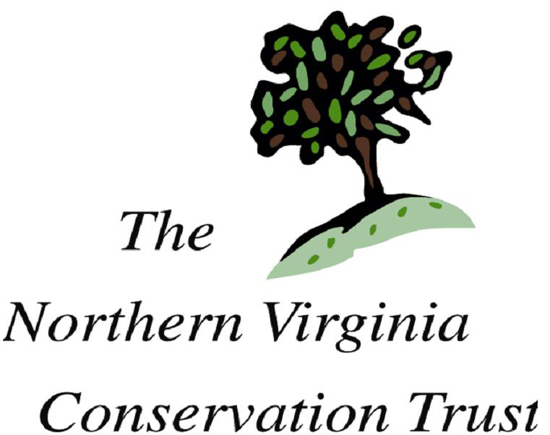

Current Condition
Natural features
Beechwood Circle is 1 acre of mature forested land in an urban neighborhood, across the street from the Henriksen property, which is adjacent to Potomac Overlook Regional Park.

This parcel sits primarily on a north-facing downhill slope. Beech and Oak predominate, the latter including Northern Red, Southern Red, White, and Chestnut Oaks. Virginia Pine, Red Maple, Tulip Poplar, Black Locust, Black Cherry, American Holly, Ash spp., Hickory spp. and Walnut spp. are also present.

Other likely species:
Hackberry
Sycamore
Persimmon
Dogwood
Redbud
Boxwood

Understory plants include Spicebush, Viburnum, Wild Ginger, Violets, various ferns and flowering plants.

Invasives
This parcel is relatively free of invasive species, though a small patch of vinca has begun to grow on the southeastern border, across the street from the Henriksen property. Japanese Stiltgrass grows in some of the sunny areas. Additionally, small patches of English Ivy have grown at the edges and few scattered multiflora rose bushes are present.

Management Goals
- Maintain as mature hardwood forest, encouraging old-growth characteristics
- Encourage native plant growth, especially the herbaceous layer
- Encourage tree variety and stand regeneration
Workplan
- Remove invasive species while their presence is still manageable
  - Have invasive removal events once or twice a year until invasives are controlled or eradicated
- Plant native trees and shrubs as necessary to enhance diversity and wildlife value.
- Collaborate with local youth group (possibly boy scouts) to develop interpretative signs and benches.

