SUBMERGED AQUATIC VEGETATION IN POHICK BAY

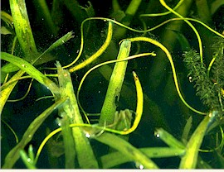
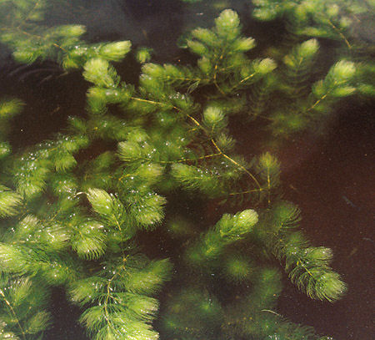
Submerged aquatic vegetation (S.A.V.) is an important part of any healthy estuary. It provides habitat and shelter for fish, and is an important link in the food web. There are several common species of S.A.V. at Pohick Bay. Some species are native, and others are exotic invaders that have negatively impacted Pohick Bay.

Coontail Eelgrass

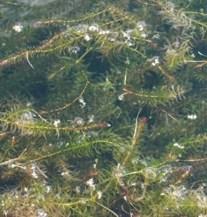
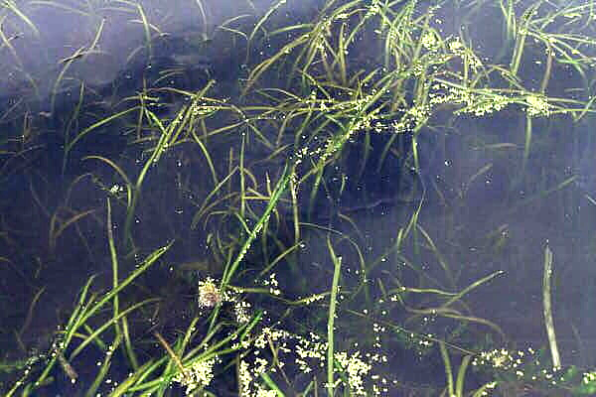

Water celery

Hydrilla

