COMMON TREES ALONG THE BANKS OF POHICK BAY

As you might expect, the trees growing close to the water’s edge tend to like wet conditions! More than just pretty sights, these trees provide habitat for birds and other wildlife, shade that cools the water, and basking places for reptiles and amphibians as logs and roots in the water. Below are four of the most common species…
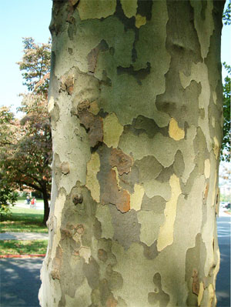
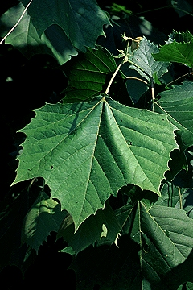
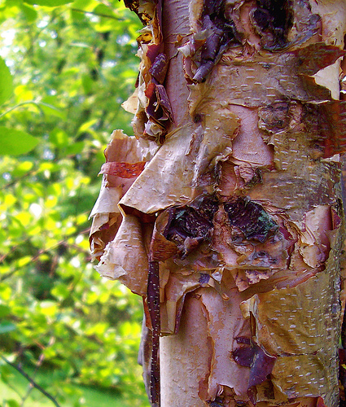
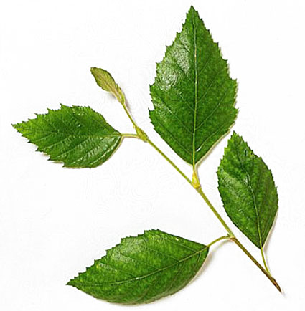

American sycamore River birch

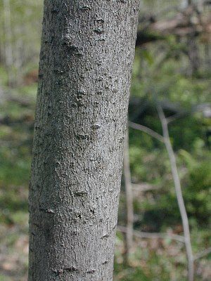
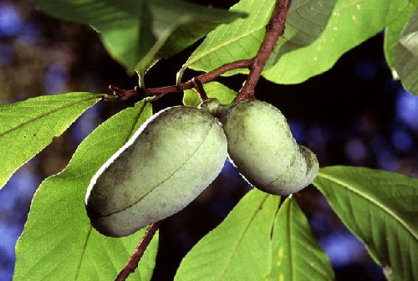
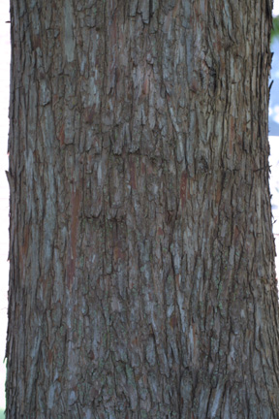
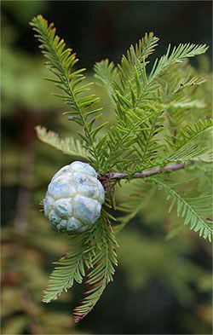

Pawpaw Bald cypress

The bald cypress trees at Pohick Bay, while not common, are unique in that they represent one of the northernmost stands of this species. They also provide breeding habitat for prothonotary warblers – an uncommon summer bird species in our area.

