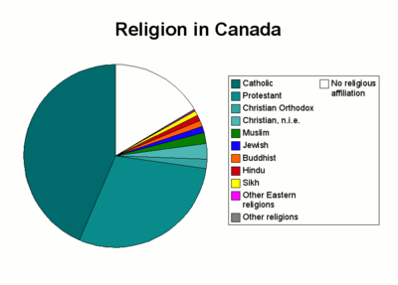
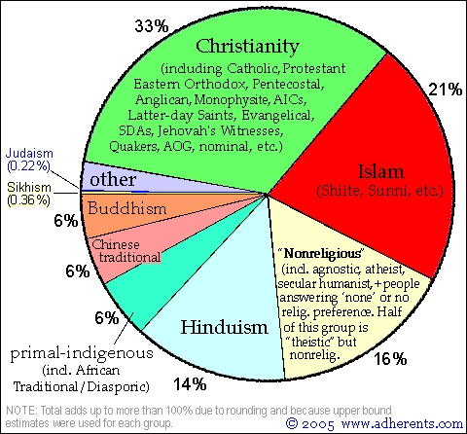
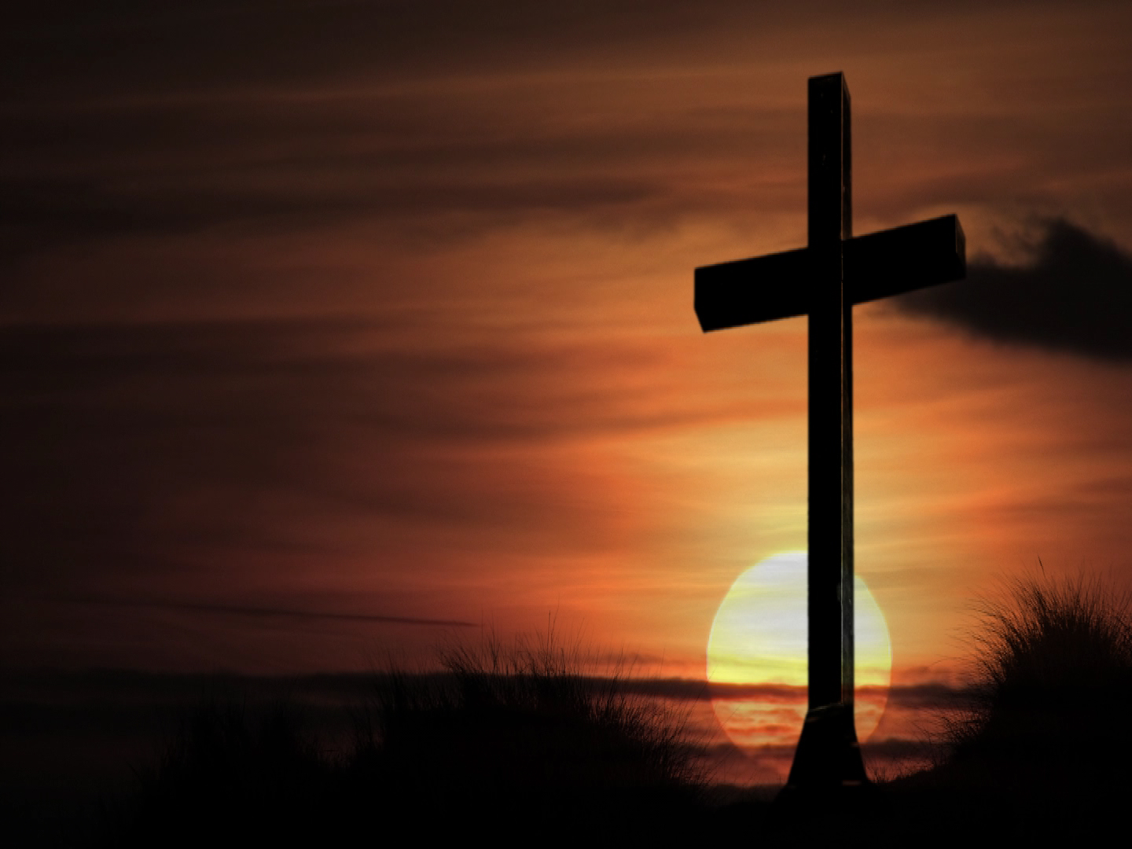
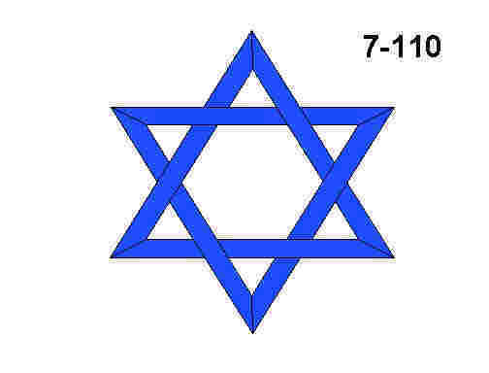
Religious Images of Canada


Works Cited
“Predeath Protocols.” The Canadian Encyclopedia. Historica Foundation. 12 Oct 2008. <http://thecanadianencyclopedia.com/index.cfm?PgNm=TCE&Params=A1SEC821010>.
“Religion in Canada.” Wikipedia. Wikipedia Foundation, Inc. 16 Oct 2008. <http://en.wikipedia.org/wiki/Religion_in_Canada>.

