Food, Clothing, and Shelter

“Canidan Food” Food Reference Website 9 Oct 2008 http://www.foodreference.com/html/artcanadianfoods.html
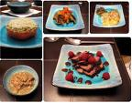

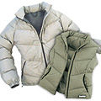

International Student Handbook 13 Oct 2008 http://www.unbf.ca/isao/handbook/clothing.html

