
The pictures to
the right is a painted
picutes by William
Baker.


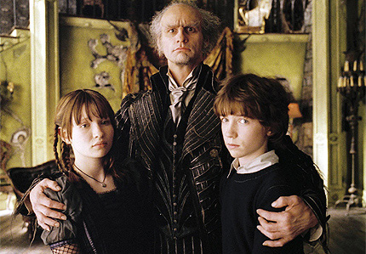
Avril Lavigne

Jim Carrey as “Count Olaf”
in A Series of Unfortunate Events

Cirque De Soleil's Icon

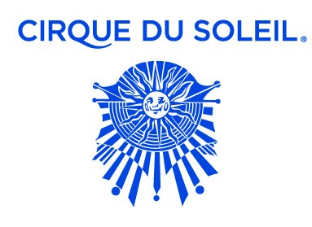


Picture of Sum 41

