Family and Kin
There is all different types of families in Canada.
- there is 78%of the family in Quebec take up 64% of the families in Quebec.
- More families have become more diverse because of divorce and separation and remarriage.
- There is a decrease in the amount of children being born.
- There are different types of family structures across Canada.
- Even though there is an increase of different types of family structures (married couple families still are more popular) 74% of the families take up most of the families in Canada.
- More Canadian adults have gotten married later than they used to and there is an increase in the amount of couples that choose to be married.
- Common law marriage is increasing. About 31% of families are common law marriage .
- 22% of families are loan parent families and that most loan parent families are headed by women.
- 26% of the people live alone
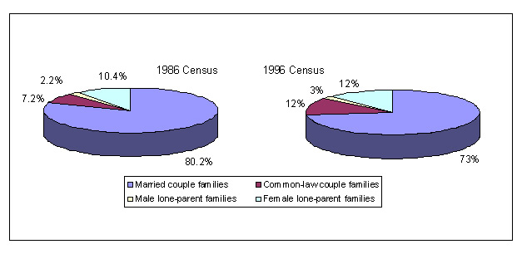
- since 1986 married couple families have decreased from 80% to 74%.
- 78% of all families were married couples in Newfoundland which was the highest proportion.
- On the other hand, the lowest proportion was in Quebec with 64%.
- During the depression was the lowest time for marriage, at rate of 6 marriages per 1000.
- In the 1960s it went up to 950 per 1000.
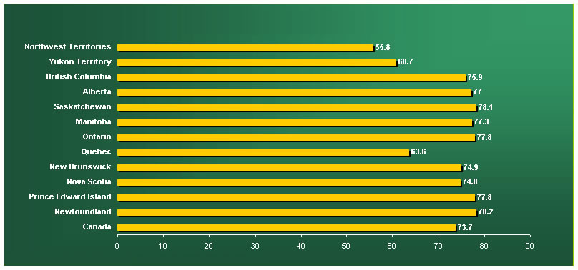

- for the households, the baby boomers were likely to have grown up in a home with only one telephone.
- They remember sharing rooms with their brother or sister.
- Today it is different. Most likely kids will remember growing up having their own rooms with their own phone.
- They will also probably have a computer with Internet access.
- The average Canadian family size decreased from 3.9 people in 1961 to 3.0 people in 2001.
- Only a few households have three generations living in them.
- In 2001 the percentage was only 2%.
- 75% of the children were raised by two parents at home in 2002. The remainder percentage had one parent raising them.

