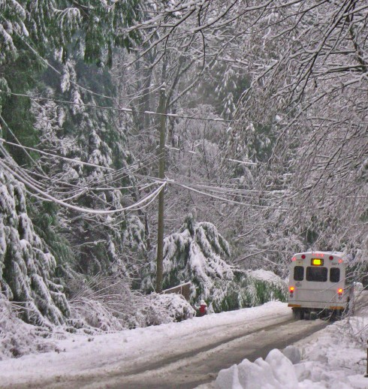

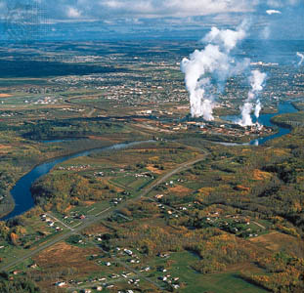

Canada in the winter.
This is Ontario, Canada many of the farmland has been knocked down to
provide room for urban life.

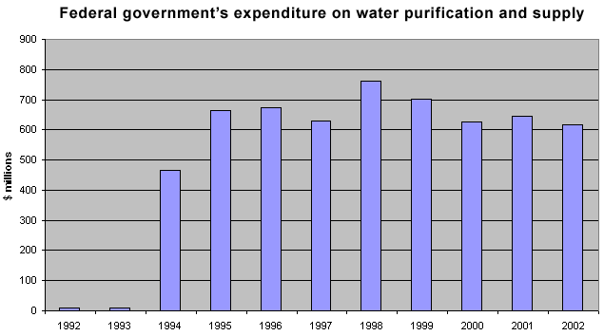

This is a chart of the amount
of water purification in Canada
in the years 1992-2002.

