Location:
Canada is located to the north of the U.S. and to the east of Russia. Ottawa, the capital of Canada, is located at 45 degrees north and 75 degrees west. Winnipeg, another city in Canada, is 50 degrees north and 97 degrees west. Canada is made up of the northern part of North America, except for Alaska and two small French islands called St. Pierre and Miquelon. Canada covers an area of 9,976,140 square kilometers and is the second largest country in the world, after Russia. Canada borders three different oceans. The north Atlantic Ocean is on the east, the Arctic Ocean is on the north, and the north Pacific Ocean is on the west. Below Canada, in the south, is Canada's neighbor, the U.S. In Canada, there are 9.9 square kilometers of land, with 755, 170 square kilometers of that land being water.

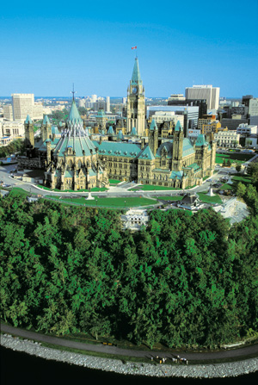
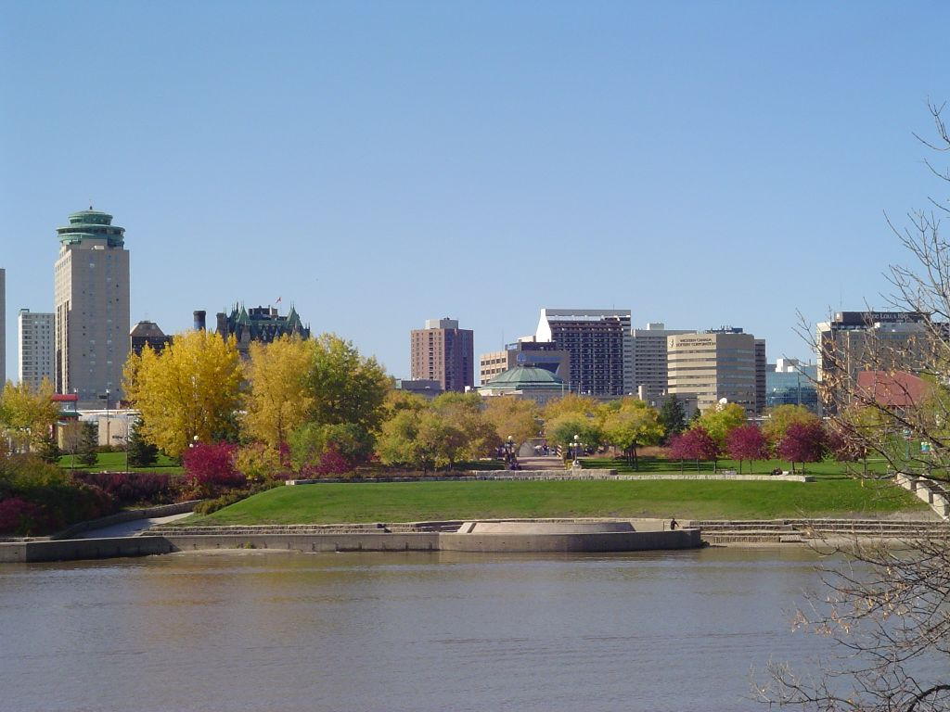
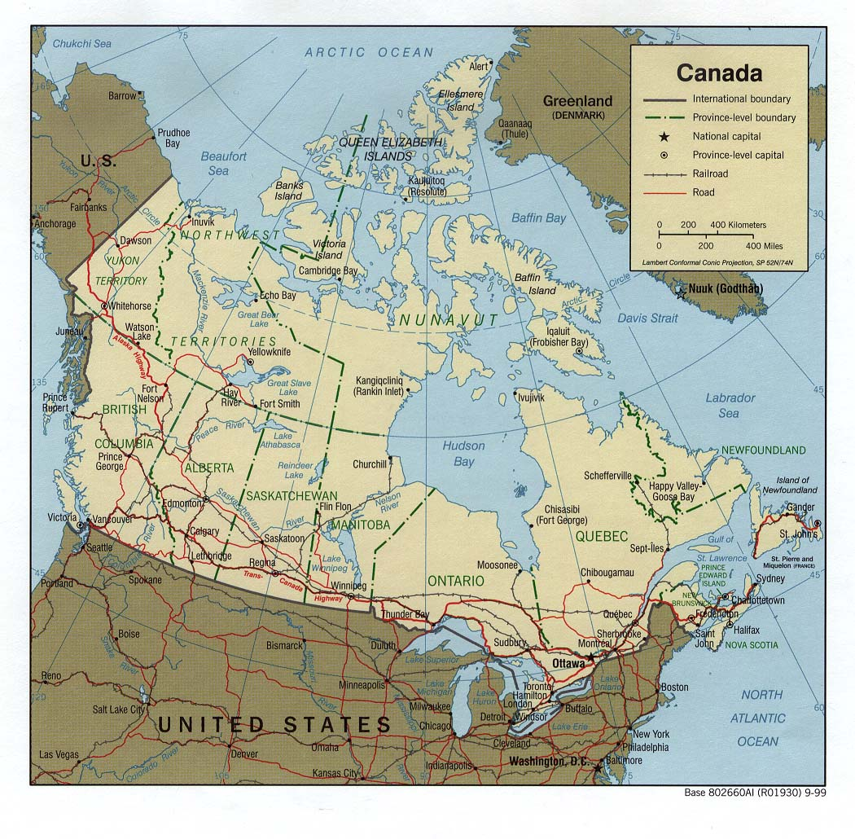

Ottawa Winnipeg Canada

