Emily Loucks
10/13
Canada: Communication and Location

Communication:
In Canada, there are over 100 different spoken languages. The two main languages spoken in Canada are English and French. 59% of people in Canada speak English, and 29% speak French. After English and French, the next most spoken languages are Chinese, Italian, and German. Arabic, Spanish, and Punjabi are becoming more and more popular in Canada. 18% of the people, in 2001, in Canada say that they are bilingual, with French and English being the two languages that they speak. For most of the immigrants in Canada, French or English is used for school or work, so French or English becomes their children/grand children's first language. English and French are the “official” languages of Canada, says the Constitution of Canada. Other, unofficial, languages of Canada are Vietnamese, Polish, Korean, and Greek. There are over 100 other unofficial languages that are spoken in Canada. Canada uses the metric system for its number system, just like most of the other countries in the world.
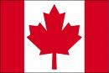
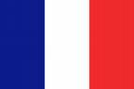
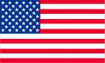

Canada's Flag France's Flag America's Flag

