Canada Pictures

A curling stone A Calgary Roughnecks game in the NNL
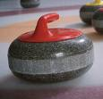
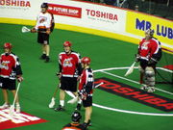

A Toronto Maple Leafs Poster The Canadian Football League Logo




The Canada National Hockey Team Logo The Toronto Blue Jays Logo




Hockey Hall Of Fame The Air Canada Centre where the Toronto Raptors Play

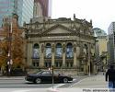

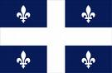
The Quebec Flag

