Casey Brown and Bridget Sarr
Movement
Movement is the act, process, or result of moving. The traditions and inventions that come from Canada have been moved around the world. Hockey was first played in Canada. People that moved into new country's or states that used to live in Canada would introduce people to their inventions and traditions such as Hockey. Since Hockey has been shared and played all around the world it makes the game very popular. Canadians created maple syrup. They made maple syrup out of the sap from the maple trees. It was so sweet and delicious that it became very popular in Canada. Canada shared their maple syrup with others, and now It is noticed all around the world. Besides sharing and introducing, movement can also mean trading. Trading is considered movement because when people trade things it gets introduced by other countries. Canada and U.S.A. are the biggest trading partners. Canada trades 85% of their goods for 25% of U.S.A's goods. Movement can also mean sharing religions. Canadians have their own different religions. They have shared their religions with others.
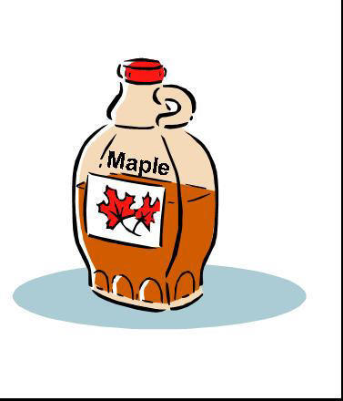


Canadian maple syrup Canadian hockey player
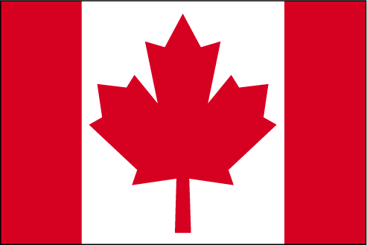


Canada's Flag Canada's sports hall of fame

Works Cited
“Canada” (10/15/08) “Canada-United States Relationship” http://en.wikipedia.org/wiki/Canada%E2%80%93UnitedStatesrelations
“Canadian hockey” (10/15/08) “An American Guide to Canada: Sport”
http://americansguide.ca/sport.htm
“Canada hockey” (10/15/08) “Canadian Culture”
http://www.vec.ca/english/2/culture.cfm

