My things is the sports in Canada. Such as Canada basketball, Canada Hockey, and Canada Rugby. The reason why choose these sports is because they are my favorite sports that I wish I could play, expect basketball I play that.

Rugby Canada
Rugby football has a long history in Canada dating back to its initial appearance in the 1860's. Introduction of the game and its early growth is generally credited to immigrants, members of the regimental armies, and to the Royal Navy in Halifax, NS and Esquimalt, BC. . The first game of rugby recorded in Canada took place in Montreal among artillery men in 1864. That same year, Trinity College in Toronto, published the first set of rules for the game of rugby in Canada. In 1868, the first club, the Montreal Football Club was formed. It was six years later, in 1874 when the first North American international game took place in Cambridge, MA between McGill and Harvard Universities. Later that year, Ontario and Quebec played the first interprovincial match in Canada.

One of the team is the amazing New Zealand.
The warm up in the most toughest http://www.youtube.com/watch?v=z4LNjNXt1yM
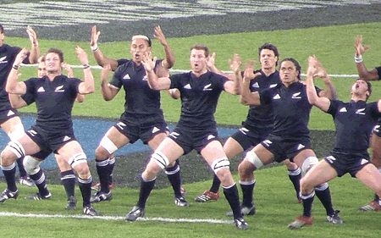
this a picture of New Zealand doing there warm up. Every game they do this. For a warm up.


Canada Hockey

The Ice Hockey is unknown to the rest of the world, however, ice hockey probably evolved from the game of field hockey that has been played in Northern Europe for centuries. The rules of modern ice hockey were devised by Canadian J G A Creighton. In 1875, the first game of ice hockey with Creighton's rules was played in Montreal, Canada. Today ice hockey is very important to the world because many people are trying to get more people on there team or money is very important too. Back in the day the puck was a strong rubber that was very hard. The first artificial ice rink was built in 1876, at Chelsea, London England. It was named the Glaciarium. It was built near the King's Road in London by John Gamgee. Today, modern ice rinks are kept clean and smooth by the use of machine called the zamboni.

Canada Basketball

James Naismith was the Canadian physical education instructor who invented basketball in 1891. James Naismith was born in Almonte, Ontario and educated at McGill University and Presbyterian College in Montreal. He was the physical education teacher at McGill University (1887 to 1890) and at Springfield College in Springfield, Massachusetts (1890 to 1895). At Springfield College (which was then the Y.M.C.A. training school), James Naismith, under the direction of American phys-ed specialist Luther Halsey Gulick, invented the indoor sport of basketball. The first formal rules were devised in 1892. Initially, players dribbled a soccer ball up and down a court of unspecified dimensions. Points were earned by landing the ball in a peach basket. Iron hoops and a hammock-style basket were introduced in 1893. Another decade passed, however, before the innovation of open-ended nets put an end to the practice of manually retrieving the ball from the basket each time a goal was scored.
This is a picture of James Naismith
