The results of the 1996 show that “married couple families” are still a large majority of the families. Ever since 1986, the proportion has gone from 80 percentile range to the 74 percentile range due to the substantial increases of both the common law and the lone parent families. In 1996 there were over 5.8 million married couples living in Canada.
Although legal marriage's still is still a prefered lifestyle of the majority of Canadian adults, however, marriage is now taking place later on in a persons life. There has also been the increase in the couples who have not married at all. Research has indicated the fluctuating marriages rate has been taking the place with the social and economic indicators over the past seventy years. This has caused some people to go without financial security to allow people to postpone or not marry at all. This also happened during the depressions when there was the lowest marriage rate where it would be 6 people out of a 1000 instead something like 425 people out of 1000 people. The highest was in 1960 were it was 950 out of 1000 people.
The common law union marriages have been more likely to be found in the New Brunswick area were there is a larger population where they speak French. Another area where there is a large amount of French speaking people where there is 25 percent of the French speaking people. One of the lower parts that speak French is in Ontario. Their has been an increase in the amount of Common law couples from 8 percent to 25 percent.
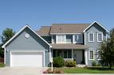
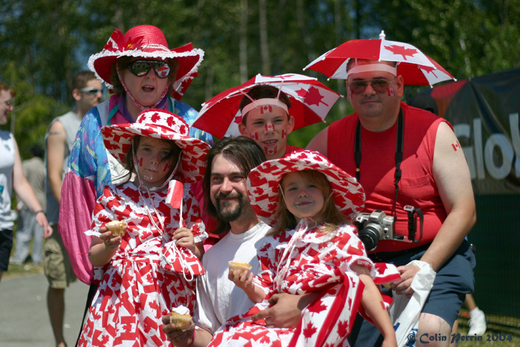

Canadian House Canadian Families

Family and Kin http://atlas.nrca.gov.ca/. Canadian government (10/15/08)
<http://atlas.nrcan.gc.ca/site/english/maps/peopleandsociety/family/family1996/familystructure/1>

