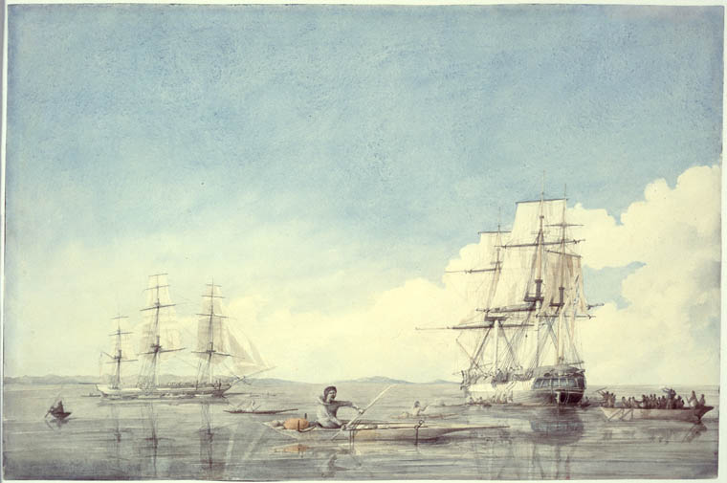
Canadian art work was first made mostly by British solder posted there in ther off time. The solders sent most of there work back to Britain where they were bought by people who wanted pictures of the colonies. George Heriot was one of the firs artist solders in Canada and he produced a work of prints called Travels Through the Canadas in the year 1807.
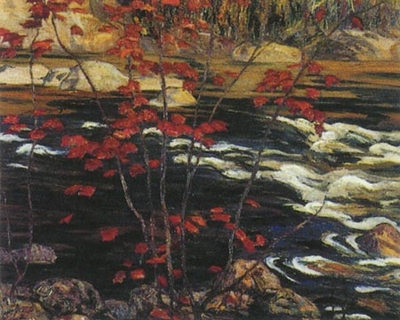
most of the early works of Canadian art flowed the European styles, Cornelius Krieghoff, a dutch artist in in Quebec, painted art about Canadian farmers in the mid 1800's.
Meany artists where sent to Canada to make maps and record the land. These pieces of art where valuable because photos had not yet bean invented and all maps had to be made by hand. Having to make maps by hand was a long task and required lots of traveling because the map makers had to see everything that they wished to include on there maps. The first explores of parts had two make crewed maps of where they went, so that people who could spend more time could follow their rough and make beater maps of it.

Meany people believe that there is little to no Canadian literature from the 1800s. This is not true. People believe this because during this time an uprising about northern and southern Canada ended up in the burning of Parliament. At that time Parliament war where most of the writings had bean stored and burning it down destroyed most o the writing from that time.
It was also during the lower Canada rebellion that a type of writing called French Canadian fiction was turning up from place to place. This form of writing was mostly to be blamed on the modern system of primary school education that had started and the rebellion that was going under way then.
It was not until WWII that French Canadian literature was becoming wide spread and industrialized. But it was not until 1950s and 60s Canadian literature became noticed on a global scale.

work cited
“Canadian art.”Wikipedia.the free encyclopedia(10/15/08)
http://en.wikipedia.org/wiki/Art_in_Canada

“Canadian literature.”Wikipedia.the free encyclopedia(10/15/08)
http://en.wikipedia.org/wiki/Canadian_literature

