Canada's Government

The Canadian government is similar to Great Britain, because it is a parliament and it is run by a queen.

Canada became a confederation on July the 1st of 1867.
Canada has a confederation with a parliamentary democracy.

The Branches of the government are the Queen Elizabeth II (represented by a governor general). Then a prime minister a head of government. Another branch is the cabinet. Then the Legislative-bicameral parliament. The parliament is split up into the House of Commons which has 301 members, and will be 308 members as of the June 28, 2004 elections. The other part of parliament is the Judicial-Supreme Court. Then other parts of the government are the: Federal- level political parties, Liberal Party, Bloc Quebecios, New Democracy Party, Conservative Party of Canada.

There are ten provinces and 3 territories in Canada.
The 1982 Charter of Rights guarantees basic rights for many Canadians.
Canada is a monarchy with a federal system.
Canada also has strong democratic traditions.
Canada's criminal is largely based on British law.
Civil law is also based on British law.
You serve in the Senate till the age of 75.
In the House of Commons, you can only serve for 5 years.
There are ten provinces and they all are governed by an elected chamber and a premier t hat is appointed by the governor.
A premier is like a prime minister.
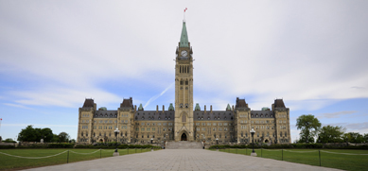

This is the capitol building of Canada.

