Canada's Religion

There is no official religion in Canada, but there are two religions that dominate the population in Canada. The Roman Catholic Church and the Protestant Church are the two most popular. Sixteen percent of the Canadian population is non religious.
There are many traditions and rituals in Canada. In almost all of the religions, marriage is a huge milestone. In the 1800's, marriage was considered a very important religious ritual. The Catholic and Protestant followers in Canada believe that marriage is intended for a lifetime.
Funerals in Canada are usually prearranged before a death. In Canada there is a law about donating a corpse to scientific research. If a family of a recently dead person wishes for the corpse to be buried, even though the person who died wished to be donated to research, the family can overrule the wishes and bury the body. Canada wants its people to be laid to rest in the way their religion or family wants them to.
There was a big controversy over the word “God” in the Canadian Constitution and the Canadian National Anthem. About 36,000 non religious people in Canada signed a petition to a parliament member to remove the word, but the petition was ignored. The French version of “O Canada” has a part which talks about carrying a cross, which many non religious people fought hard on, but that was also ignored.
The people in Canada range from being very Orthodox to being strictly non-religious. There is a wide variety of religious beliefs in Canada.

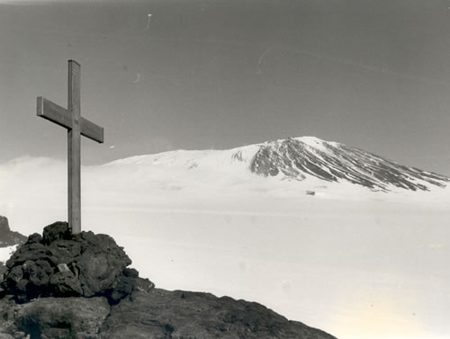

This is the cross, the Christian religion symbol.

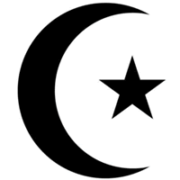

This is the crescent moon, the Islamic religion symbol.

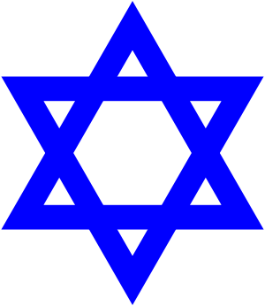
This is the Star of David, the Jewish religion symbol.

