Canada
There are two types of location. There is absolute location and relative location.
The Absolute location of Cities in Canada is
Quebec, Canada-
Latitude: 45° to 63° N
Longitude: 57° to 80° W
Montreal, Canada-
Latitude: 45° 30′ 0″ N
Longitude: 73° 40′ 0″ W
Vancouver, Canada-
Latitude: 49° 13° N
Longitude: 123° 06°W
Toronto Ontario, Canada-
Latitude: 43° 40° N
Longitude: 79° 24° W

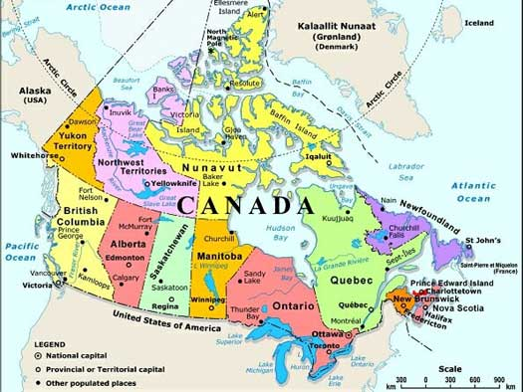
The relative location of Canada is Canada is north of the United States. It is West of Europe. It is East of Asia. It is South of the Arctic Circle.
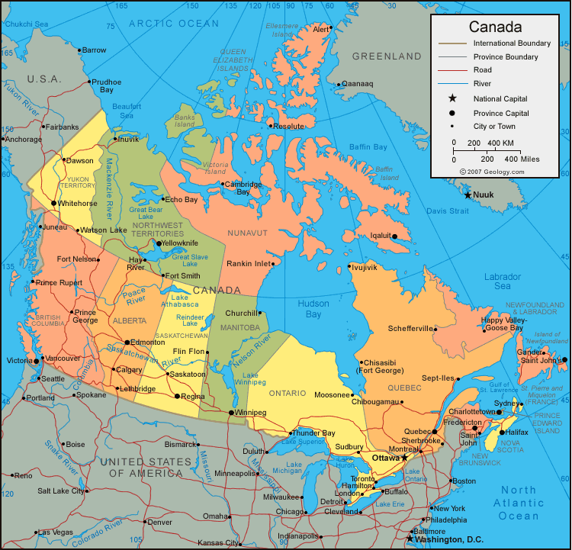



The Niagara Falls:
43 degrees north and 78 degrees west.

