Location of Canada:
Canada is located on the continent of North America. It is the northern section of the continent and borders the North Atlantic Ocean on the East side and on the West side it borders the North Pacific Ocean. Also to the North, Canada borders the Arctic Ocean. Canada consists of all of the North American continent north of America not including Alaska. Canada is the second largest country in the world, second to Russia. The geographic coordinates of Canada are around 60.00 N and 95.00 W.
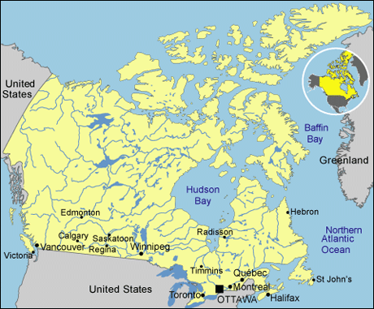

Citations:

“Canada Location” CIA. The World Fact Book, October 24, 2008.
https://www.cia.gov/library/publications/the-world-factbook/print/ca.html

