Canada Project
Communication and Location
Caroline and Avery

Communication:

Language:
Canada's proffered languages are English and French. 59% of all Canadians speak English Canadian constitution states that English and French are the “official languages,” (Wikipedia). All of the Canadian laws are written in both languages. There are also very many other languages but very few people speak them. Chinese, Punjabi, Spanish, Italian, Arabic and Aboriginal languages are spoken few Canadians. There are also many other languages spoken by the people of Canada. In all of the provinces except Quebec, English is the most used language. New Brunswick is the home to most of the French speaking citizens.

Canadian Alphabet and Numerical Systems:
The Canadian alphabet consists of 27 letters. When the first 26 were decided (A-Z), they decided to add another letter. They added the question mark.
Eh, B, C, D, E, F, G, H, I, J, K, L, M, N, O, P, Q, R, S, T, U, V, W, X, Y, Zed and ?
When saying the letter “Z” they pronounce it “Zed” and at times will draw a line through it, “Z”. Also in the alphabet the letter “A” is said as “Eh”. The metric system is used in Canada it is the Legal Standard. Thee Number seven in Canada is written with a line through it: 7
Communication through technology:
There are 1456 television broadcast stations in Canada. According to a 1997 census there are 32.3 million radios in Canada. 67% of 16 to 60 of Canadians use their cellular phones on a regular basis and one third of the Canadian population does not own a mobile phone.
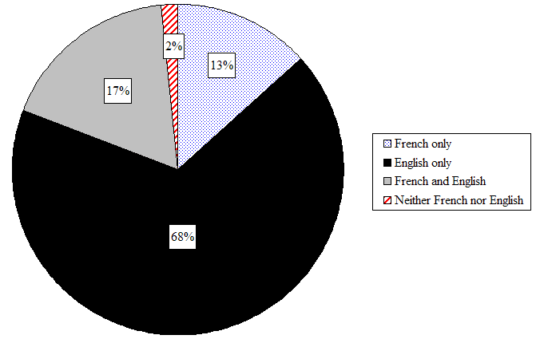
Graph of the languages spoken by Canadian Citizens

“Canadian Languages” Wikipedia. Wikipedia Foundation Inc., October 24, 2008. http://en.wikipedia.org/wiki/Canadian_language.
“Canadian-French languages” Wikipedia. Wikipedia Foundation Inc., October 24, 2008.
http://en.wikipedia.org/wiki/French_language_in_Canada.

“Canadian Languages” Google. Google., October 24, 2008.
http://www.google.com/search?hl=en&q=canadian+languages&btnG=Google+Search&aq=f&oq=

