Food:
Canada eats different foods but, they sometimes eat the same food we eat. Some of the different meat Canada eats are: polar bear, reindeer, porcupine, skunk and many other interesting things. Some cheeses are: Okra, Brie, Camembert, Triple cream. They also eat back bacon (Canadian bacon) and piecemeal bacon. Canada eat many different foods than America but they also meat some of the same food to. There clothing is the same for us but for different seasons they wear different things. For winter Canadian people wear heavy winter coats, boots, a hat or hood, scarf and gloves, sweaters and warm slacks, and Thermal underwear. For Fall they wear basically the same things we war in the fall. In the Spring they wear a raincoat with hood, lightweight jacket, and sweaters. In the Summer Canadian people wear also what America wears in the Summer. Students dress more causally. They usually wear jeans or slacks, except for formal occasions. Most people live in homes, apartments and condos. They live like we do but in homes they have a lot more land for each house.
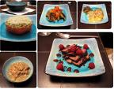

This is some different food that Canada eats
“Canadian Food” Food Reference Website 9 Oct 2008 http://www.foodreference.com/html/artcanadianfoods.html
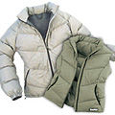

Some winter coats that they wear in the winter
International Student Handbook 13 Oct 2008 http://www.unbf.ca/isao/handbook/clothing.html
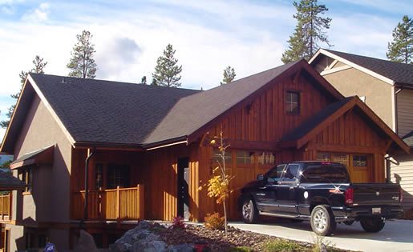
A home in Canada.

