Maraya Boman
History

Canada – Arts and Aesthetics

Canada has a lot of arts. Acting, visual, music, and may more. Canada came up with Folk art. Folk art comes in the forms painting, sculpture, baskets and more, normally made by people with certain cultures, religion, or just made by people that have no experience in art. William Baker is one of the many Canadian artists that liked to carve/paint Folk Art.
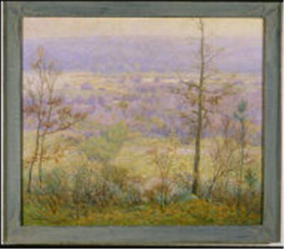
The picture to
the right is a painting by
William Baker.

A few of the actors that were born in Canada are Carrie Anne Moss, Jim Carrey, and Art Linkletter.
Carrie Anne Moss is a famous Canadian actress. She is well known in her part in the movie “The Matrix Trilogy” as Trinity. She was also casted in previous sequel(s) to the Matrix.
Jim Carrey is an comedian from Newmarket, Ontario. Jim Carrey is well known for his crazy/hyper performances as a comedian and preforming in the following movies: Dumb and Dumber, The Mask, Bruce Almighty, A Series of Unfortunate Events, and many more.
Art Linkletter is a man who hosed two of the longest TV shows in history, “House Party” and “People are Funny”.
Some of the famous artist and bands that we know today in the U.S. Are from Canada. A few of the artists are Avril Lavigne, Bryan Adams, Shania Twain, and Celine Dion. A few of the famous bands from Canada are Finger Eleven, Nickleback, Simple Plan, and Sum 41.
The famous Cirque du Soleil was first founded in Montréal, Québec by two street preformers, Guy Laliberté and Daniel Gauthier. Guy Laliberté was a accordion player, a still-walker (where people would stand on high sticks of narrow wood and walk around), and a fire-eatter. Later on he met a man named Daniel Gauthier who was a normal artist who liked to draw comic-books and cartoon-like things. Once the two men met, they started their circus which is now a big success.


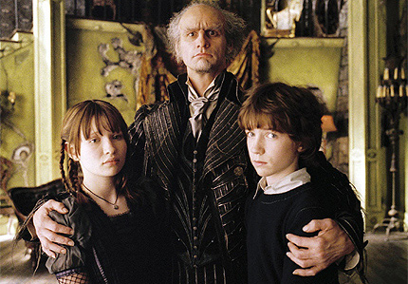
Avril Lavigne
an music artist who writes her
own songs

Jim Carrey as “Count Olaf”
in A Series of Unfortunate Events

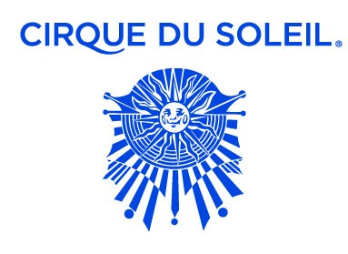
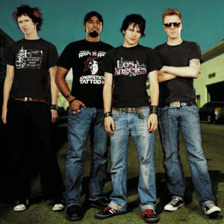
Cirque De Soleil's Icon

Picture of Sum 41
a band that sings pop-punk
kind of music

Work Cited
“People Music” www.canadiancontent.net
(10-15-08) http://www.canadiancontent.net/people/music/

“People Actors” www.canadiancontent.net
(10-15-08) http://www.canadiancontent.net/people/actors/

“Canadian Arts” www.askart.com
(10-15-08) http://www.askart.com/AskART/assets/artist/129639/WCBaker.jpg

“Cirque du Soleil” www.wikipedia.org
(10-15-08) http://en.wikipedia.org/wiki/Cirque_du_Soleil

Images:
http://images.starpulse.com/Photos/Previews/Avril-Lavigne-rca13.jpg
http://www.100xr.com/100_XR/Artists/S/Sum_41/Sum.41-band-2004.jpg
http://www.theage.com.au/ffximage/2004/12/07/carrey,0.jpg

