Marriage

Marriage in Canada has varied between the years with same sex marriage, different sex marriage, marriage relationships and how each person(s) raise their children. Families have an avarage of 3 children per a family. The marriage in Canada had went down by nearly 2,000 marriages but had risen back up higher than before. In 2006-2007 the divorce percentage had gone up by 5%. There were as many as 1,500,000 single-parent families but more of the single-parents family homes were lead by the mother of the children. More than one third of the marriages end in divorce before they can make it to their 13th anniversary.

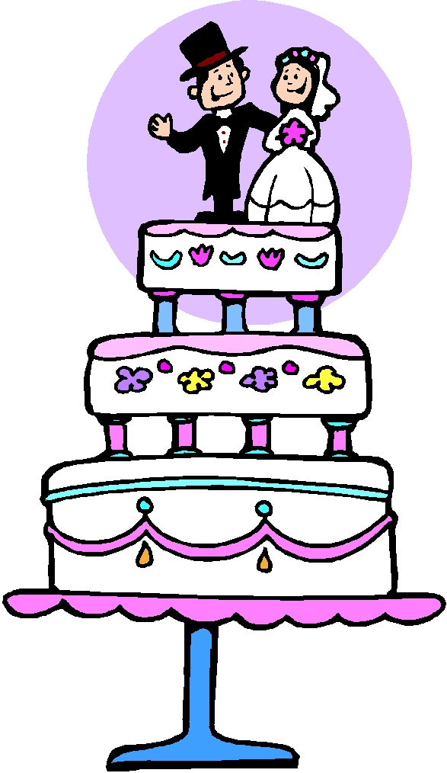

Family Roles

Family roles are based on how the parents raise then children. The womens labor force dramatically increase between 1981 and present. More women are going into the work force the more time goes on and it has increased to 51%. For a man in the family, if the women works it is a failure for the man. The traditional role of the money-maker or the person who brings home all the money should be the man. However, for women, work, motherhood, and career have been becoming normal. In other words, these men escape from their fatherly roles, or challenge to adapt fatherhood within a family. Children believe that the father has more power than the mother. Housework includes cooking, washing dishes, cleaning, gardening, washing the vehicles, taking out the trash, repairing household items, buying food, and others.


Kids

Kids in Canada 50 years ago filled out a poll and more than 20% of Canadian children lived with at least five brothers or sisters. That was normal then. Everyone had a big family with lots of siblings and cousins, not what you would see today. Nowadays most of the Canadian children have only one sibling, or remain as an only child. In 2001 only 18% of families had three or more children whereas 39% had two and 43% only had one.

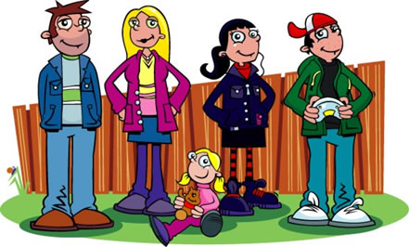

Citations

“Canada.” Wikipedia. Wikipedia Foundation, Inc 15 October 2008. <http://en.wikipedia.org/wiki/Canada>

“Canadian Families.” UBCWiki. 20 October 2006. <http://wiki.elearning.ubc.ca/FamilyRoles>

“Children.” 7 February 2006. <http://www43.statcan.ca/02/02d/02d_002_e.htm>

“Human Enviorment Interaction” <http://snowclimb.tripod.com/id10.html>

