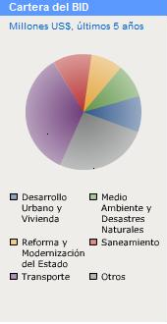

93.6
114.8
100.1

364.1 105.2

269.8

