Acclaro DFSS screen shoots
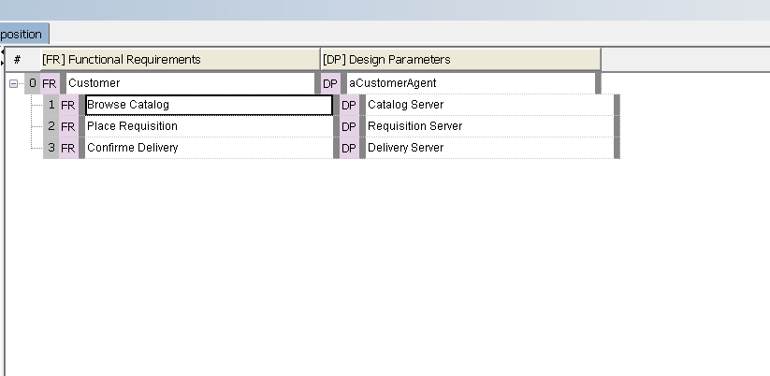
Figure 1 – FR-DP Decomposition

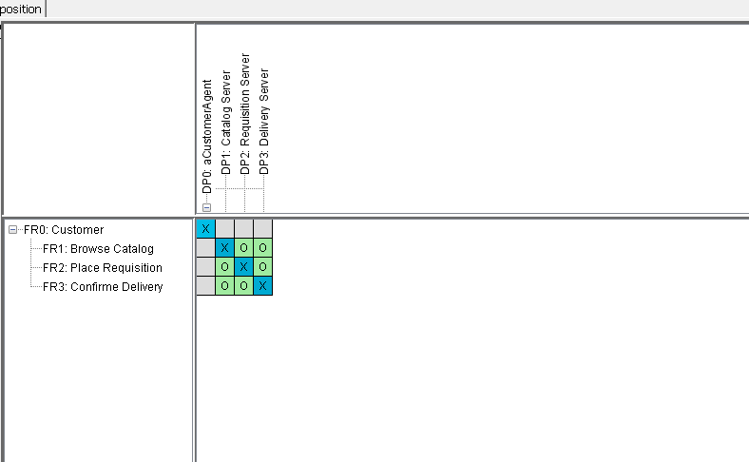
Figure 2 – Design Matrix

