Visio screen shoots
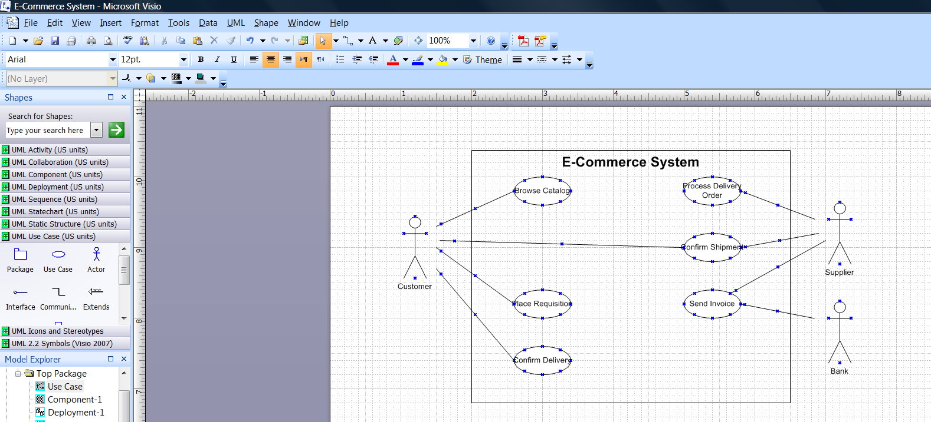
Figure 1 – Use Cases
Figure 2 – Use Cases from Visio
Figure 3 - Collaboration diagram for Browse Catalog use case

Figure 4 - Agent-based Electronic Commerce System: conceptual view

