James was born in 1984. Listen to his conversation with parents and complete the sentences. Then listen again and check.

1984 … the year I was born
James was born on 24 January, 1984, in Hong Kong. His parents ________________ Hong Kong that year and ________________ back to Britain. His father ________________ a job in London.
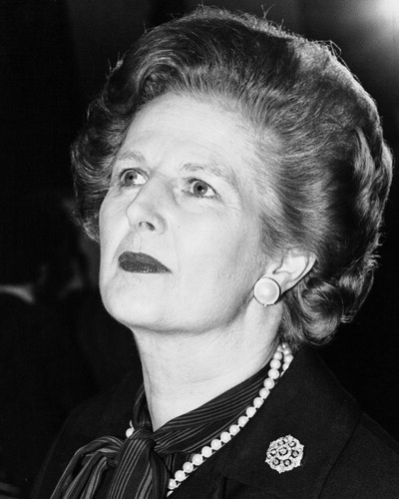 | POLITICS  In Britain, Margaret Thatcher ________________ Europe’s first woman prime minister. US president Ronald Reagan ________________ another four years in the White House. The Soviet leader Yuri Andropov ________________ after only a year as a leader. |  | 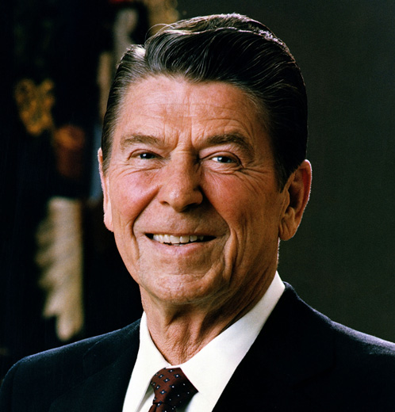
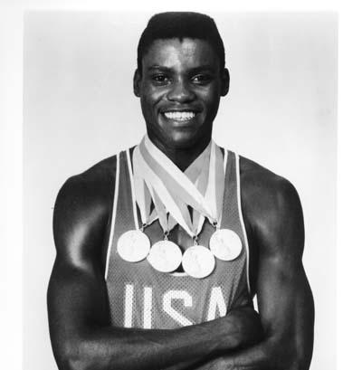 | SPORTS  American athlete Carl Lewis ________________ four gold medals at the Los Angeles Olympics. The Soviet Union didn’t go to the Olympics that year. Tiger Woods ________________ junior golf champion at the age of eight. |  | 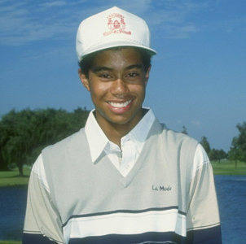
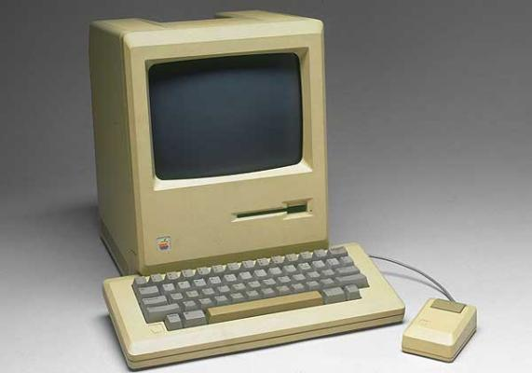 |  | SCIENCE  Apple Macintosh ________________ a new personal computer and millions of people ________________ one.
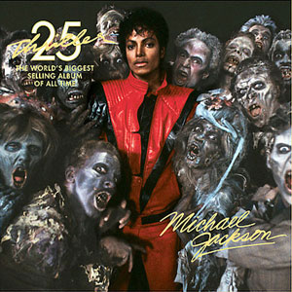 | MUSIC  Michael’s Jackson Thriller ________________ 43 million albums. Madonna ________________ Holiday. And Paul McCartney, Tina Turner and David Bowie all ________________ hit records that year. |  | 