LESSON 8: CONJUNCTIONS

GRAMMAR ROCK: CONJUNCTIONS

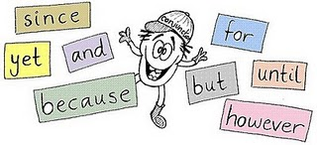
Conjunctions, like prepositions, are also joining words or connectives. Conjunctions are used to join words, phrases, or clauses. Conjunctions can be found in any position in a sentence except the very end.

For the purpose of this module, you can use the elimination method to find conjunctions. It works like this: identify all the words you can in a sentence, those that are left over are probably conjunctions. Look at these examples.

When | lightning | struck | the | old | barn, | it | burned | quickly
? | noun | verb | adj | adj | noun | pronoun | verb | adverb

The word when looks like it might be an adverb, but does it tell you at what time?
No, the word itself doesn’t add any new information. What it does do is introduce a group of words that tells specifically when something happened.

Joe | and | Mike | followed | the | young | cub, | but | they | could | not | catch | it.
noun | ? | noun | verb | adj. | adj. | noun | ? | pro | verb | adv | verb | pro

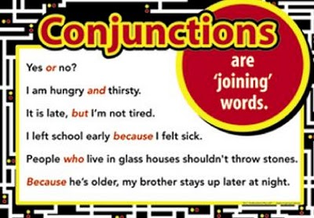
The words and and but are conjunctions. And joins two nouns; but joins two complete ideas.

Exercise 14: Conjunctions

Copy these sentences in your notebook. Underline the conjunctions. Then indicate whether they are joining words, or groups of words (phrases), or complete ideas (clauses).

1. Apples and oranges are good for you.
2. It was a life and death situation.
3. Look under the table and in the closet
4. I wanted to travel quickly and cheaply, but I couldn’t get a ride.
5. We bought the tickets, so we went to the concert.
6. After we saw a deer, we drove to Doaktown.
7. Before he gets sicker, he should go to the doctor.
8. We sent you a full and complete refund when you asked for it.
9. We ran home because it was raining.
10. Until the snow melts, we will have to stay home.

Exercise 15 Conjunctions

Copy these sentences in your notebook and then underline the conjunctions.

1. Although she missed the bus, she and Lily still arrived on time.
2. Andy bought it because he liked it yet he never wore it.
3. Betty or Fran will bring the books which you wanted.
4. The waiter who served our lunch was really nice but slow.
5. I saw the nests that the robins built both on the porch and in the tree.
6. Until we see it, we won’t believe it.
7. If you are ready, we can leave so we will be on time.
8. When they had finished, they gave it to the teacher.
9. Roller blades and skateboards are very popular.
10. CDs are great because they have good quality sound.

