CRC
WEEKLY DoD Civilian & Contractor Class
SAMPLE SEQUENCE OF EVENTS
Day 1 – 0800hrs Clip board sign in sheet. Welcome Brief, Medical initial visit; extensive data entry session; CAC Info/review; Gear Size trials & Supply info, Inspection of Orders. Secure by 1700hrs if on schedule.
Day 2 - Med. Follow up time (extensive); Begin Self Courses: ATFP SERE100 , NBC Gas Mask Training Brief, MRI Brief, Secure by 1700hrs if on schedule.
Day 3 - Gas Mask Issue & testing, Region Specific Health Risk Brief(s), Trauma First Aid Knowledge Refresher/Awareness Brief, Med Follow up and Admin, SERE 100/ATFP –computer self pace time. Secure by 1700hrs if on schedule.
Day 4 - Gear Draw, Med Follow up, Laws of war brief, Combat Stress &Suicide Awareness/Prevention Brief, SERE 100 –computer self pace time. CAC, License, Passport, Visa spot checks. DD93 and 11000 inspections. Secure by 1700hrs if on schedule.
Day 5 – File collection & final inspection: verification of equipment, certificates, and other listed documents/items required. Creation of and completion of DPC Endorsements and Certificate of DPC Completion issuance. Classroom field-day. Typically Released by 1700hrs.
*This is provided as a typical example. The dates of each actual task will vary based on scheduling requirements and individual class dynamics. Class hours will vary each day based on specific needs of command and class.

COURSE SYLLABUS
COURSE TITLE | DELIVERY TYPE | Location of Training Course
- ATFP | Online | https://atlevel1.dtic.mil
- Convoys | Instructed via Power Point Presentation | Bldg 309 CRC Classroom
- Demob Instructions Brief | Instructed via Power Point Presentation | Bldg 309 CRC Classroom
- First Day Welcome Aboard Brief | Instructed via Power Point Presentation | Bldg 309 CRC Classroom
- ISOPREP Brief | Instructed via Power Point Presentation | Bldg 309 CRC Classroom
- Heat/MET Training Brief | Instructed via Power Point Presentation | Bldg 309 CRC Classroom
- NBC Gas Mask Training | Instructed via Power Point Presentation | Bldg 309 CRC Classroom
- SERE 100 | CD Based Computer Course | Bldg 309 CRC Classroom (via in class CD)
- Unexploded Ordinance and IED | Instructed via Power Point Presentation | Bldg 309 CRC Classroom
- Combat Stress and Suicide Prevention | Instructed via Power Point Presentation | Bldg 309 CRC Classroom
- FCM, Passport, & Visa Brief | Instructed via Power Point Presentation | Bldg 309 CRC Classroom
- Geographical Medical Risks Brief | Instructed via Power Point Presentation | Bldg 309 CRC Classroom
- Laws of War Brief | Instructed via Power Point Presentation | Bldg 309 CRC Classroom
- Moderate Risk of Isolation Brief | Instructed via Power Point Presentation | Bldg 309 CRC Classroom
- Trauma First Aid Refresher Brief | Instructed via Power Point Presentation | Bldg 309 CRC Classroom

Pre-Deployment Responsibilities Checklist (updated as of: 8 Dec, 2010)
- This checklist summarizes the pre-deployment requirements to the CRC OIC’s best knowledge as of the date specified on this document. It is not legal guidance, however it is intended as a useful starting guide to preparing for deployment as a DoD Civilian or Contractor.

- Since individual requirements may vary, your specific requirements may be different then are listed.
- Since policy changes and updates at various levels of Government are common, this is intended to be a living document. Insure that you have the newest versions prior to use.
- The CRC OIC is providing this as a starting tool to help begin you on your analysis of the various policies that you must adhere to. The CRC is not staffed with a legal department and does not represent or intend for this document to be used as policy or to circumvent any existing policy.
- The contracting company remains responsible for insuring that they are in compliance with all requirements regardless of whether they are found on this list.
- If you find any errors or omissions or have any recommendations on how to improve future versions of this document please contact the CRC POC.

PLEASE CONTACT THE POC FOR A CURRENT VERSION PRIOR TO USE.
MANDATORY REQUIREMENTS TO COMPLETE DEPLOYMENT PROCESSING
Item | Contractor  /Civilian  provides: | DPC-E/RSU  provides
Medical: Per DOD Deployment Policy Messages and DPC-E Medical Officer Requirements.
Verify no symptoms of Flu (fever, cough, sore throat, runny or stuffy nose, body aches, headache) prior to sending to CRC. If any symptoms of flu exist during CRC you will be immediately dropped and asked to reschedule for a later week. Please be prepared for this should it occur. A returning reservation request due to an illness will be accommodated as much as possible. | X
Illness Plan of Action. The DPC-E wants you to be aware that we recently experienced H₁N₁ Flu attacks. Our Commands transient nature makes such viruses challenging and requires a quick response by us all. Please understand your company’s, Command’s, and/or personal plan/procedure should you become ill during your processing. Please be prepared to implement that plan on short notice should it be needed. We recommend you take into consideration such things as Medical care, housing, transportation, and communication and how a contagious illness such as H₁N₁ Flu would affect you and others. | (Recommendation only)

Item | Contractor  /Civilian  provides: | DPC-E/RSU  provides
Complete Form:  NAVMED 1300/4 EXPEDITIONARY MEDICAL and DENTAL SCREENING  (see page below that discusses in detail) | X
Select AOR you will deploy to and complete the related addendum  - NAVMED 1300/5, Pacific Command (PACOM).  - NAVMED 1300/6, Korean Peninsula.  - NAVMED 1300/7, European Command (EUCOM).  - NAVMED 1300/8, Africa Command (AFRICOM).  - NAVMED 1300/9, Joint Task Force (JTF) Guantanamo Bay (GTMO).  - NAVMED 1300/10, West Pacific & Okinawa, (With Extended Field Exposure). | X
EDHA Pre Deployment (Medical) Survey [DD Form 2795]  Use the attached EDHA Instruction sheet included near the bottom of this document or the detailed instructions on the actual website to complete this online required survey PRIOR TO ARRIVAL but no sooner then 30 days before CRC Arrival date.  Site Location: https://data.nmcphc.med.navy.mil/EDHA/  Passphrase use: “Activenavy1#” or “Rifleman1st#”  HELP DESK at (757) 953-0717 or for password issues call (757) 953-0677 | X (online prior to arrival)
Medical review of DD Form 2795 (Pre-Deployment Health Assessment) |  | X (reviewed by medical after arrival)
DD Form 2807-1 (Report of Medical History)  [your Doctor to complete in full, NOTHING IS OPTIONAL OR “N/E”] | X
DD Form 2808 DPC Medical Officer Required Addendum 1: When completing the DD2808 Medical Exam(below), ensure that the Doctor screens for diabetes using at minimum a fasting glucose test (or better) and attaches results/findings to the DD 2808. | X
DD Form 2808 DPC Medical Officer Required Addendum 2: When completing the DD2808 Medical Exam (Below), ensure that the Doctor screens for cardiac risk using at least a lipid panel test (or better) and attaches results/findings to the DD 2808. | X
DD Form 2808 (Report of Medical Examination)  [Your Doctor to complete in full, NOTHING IS OPTIONAL OR “N/E”] | X
Eye Exam [Completion of Sect 61 of 2808 is acceptable , if glasses required have two pair with you (not contacts)] | X
Hearing Exam –consisting of audiometric testing within 90days | X
RSU Form 1 (replaced) – instead use: NAVMED 1300/4 (Rev. 4-2010) | - | -
Note 1: LIVE VIRUS shots have special requirements; most must be given in same 24 hour period or 28+ days apart!
Note 2: Varicella is a live virus and proof of receiving is now required for all persons processing (Per MOD10). It is the Contractors responsibility to have this complete. It is a LIVE VIRUS that can NOT be given within 28 days of the smallpox vaccine.
Dental: (Per DOD CENTCOM Deployment Policy Messages)
Dental Class I or II (DD Form 2813) | X
Provide Current Dental Panograph (clear paper copies ok) | X
Other Documents:
SPOT LOA (CONTRACTORS) (mandatory for all Contractors to arrive with this document in hand or they will be turned away) 3 copies | X
TDY/TDA Travel orders (DOD CIVILIAN) (DoD Civilian Employees only, mandatory to arrive with some type of official orders indicating where and when you will be traveling and ordering you to attend CRC for deployment processing | X
ISOPREP prepared per your Security managers and supporting commands directions and process. Provide CRC ONLY a confirming letter of completion. DO NOT BRING ISOPREP DOCUMENTS TO CRC!!  WARNING! The ISOPREP is a CLASSIFIED DOCUMENT ONCE COMPLETED. | X

Item | Contractor  /Civilian  provides: | DPC-E/RSU  provides
2 forms of ID (i.e. State ID Card and SSN Card, etc…) | X
NAC (National Agency Check) (or higher) available in and adjudicated in the ‘JPAS’ system UNDER the ADJUDICATED section. Must have the result/outcome specified in the adjudication section. | X
Training (Government Conducted)
NBC/CBE (To include familiarization with personal protective equipment). Proper Use, Removal maintenance, proper storage. |  | X
Region Specific Medical Briefs (Health Risk Communication) |  | X
Level I Anti-Terrorism / Force Protection Brief | Can be done prior to arrival | X
UNCLAS Foreign Intelligence (Provided in Country) |  | X
(MRI Brief 1) – to include cultural aspects and prohibitions, and Environmental & Personnel Recovery Brief & basic Country Specific information Brief |  | X
(MRI Brief 2) – Code of Conduct & Conduct after Captivity Brief |  | X
SERE 100 this is a long course, although we offer it within our classroom after class, we encourage those with access to obtain prior to arrival. | Can be done prior to arrival | X
COMBATING TRAFFICKING IN PERSONS ANNUAL TRAINING  MARADMIN 101/10 | X
The laws of War Brief (general brief) (further details should be provided in-Country as situation warrants.) |  | X
Basic first Aid Review/Refresher Brief*  (*assumes previous first aid training, intended as a refresher and critical info update brief. If detailed first aid training has not previously occurred and is warranted, please insure that the contracting company arranges completion outside CRC) |  | X
Combat Stress & Suicide Prevention Brief |  | X
Weapons Training and Qualifications: Please note that if your SPOT Loa indicates that you are Authorized Weapons, then you are required to have proof of recent weapons training in your T/O weapon(s) prior to arriving at DPC-E CRC. This training must be coordinated and approved through your supporting command. Deployment processing will not be provided until you can provide evidence of completion. Required training minimums:  T/O= Pistol: Pistol Range  T/O=Rifle: Table 3 Rifle Range | X  If Private training is authorized complete prior to arrival | X  If Govt training is authorized complete prior to arrival.

Item | Contractor  /Civilian  provides: | DPC-E/RSU  provides
Personal Equipment and Effects
Uniforms: A letter of authorization from the Combatant Commander or his authorized representatives is required authorizing the DoD civilian or contractor to wear a military uniform (due to the risks involved with international laws of war). When authorized the contract will indicate who will provide (contractor or govt). (If the contract indicates the govt. is to provide, then coordinate with your supporting command. Your supporting command should be able facilitate this issue via a request to the base CIF (civilian run) via the MEF chain of command (they command the CIF). | Depends | If Govt. issued complete outside DPC process.
Gas Mask (contractors should be directed to arrive clean shaven as masks are not intended to seal with facial hair).  [Note: Individuals must be able to use standard sizes of equipment issued and grooming requirements for gas mask wear] |  | X
MOPP Gear: (if required, must be coordinated and approved through your supporting command. Your supporting command may be able to facilitate this issue via a request to the Camp Lejeune Base IIF Facility. If pre-authorized they can pick up during our normal visit to the IIF. | X | X  Arrange prior to arrival.
Personal Clothing and personal safety equipment required to perform statement of work in the in-theater environment [NOTE: Uniform utilities should not be issued without Combatant Commanders written authority. If authorized either contractor or supporting unit should arrange] Otherwise clothing worn should not imply contractor is a member of the military or combatant | X
Arrive with proof that you have obtained and will deploy with a sufficient supply of Maleria Chemoprophylactic for entire deployment period for all areas indicating a current requirement to include but not limited to :Afghanistan (year round), Pakistan (year round), Tajikistan (May-Oct),Yemen (Year Round). | X | X (Medical Officer may offer a prescription if needed)
DEET Cream for use on all exposed skin (CENTCOM/AFRICOM) | X
Treat field uniforms with permethrin (CENTCOM/AFRICOM) | X
Mosquito nets for Bed in field conditions (CENTCOM/AFRICOM) | X
Identification:
Passport -[REQUIRED FOR ALL CONTRACTORS TO RE-ENTER THE USA and for virtually all Countries visited] [Bring PhotoCopy or original to CRC]  per DoD 4500.54-M, February 4, 2009 | X

Item | Contractor  /Civilian  provides: | DPC-E/RSU  provides
DoD Civilians require a Maroon “Official Passport” | X
Country Entrance/Exit Requirements  Please follow the Electronic Foreign Clearance Manual (FCM) formally called the (FCG) Guide Country requirements found at : https://www.fcg.pentagon.mil/  AND check the Depart of States website links http://www.travel.state.gov/ to obtain up-to-date information on requirements for Individual Country Entrance and Exit.  (Reqd. Per DoD 4500.54-M, February 4, 2009 )  Note: If the 2 web sources of information conflict, we recommend obtaining the more restrictive requirements to minimize the potential risks. | X
Visas: are required for contractors supporting the armed forces in many Countries! Contractors typically Do Not Fall under the Uniformed Militaries Visa Requirements look for the information specific to you (i.e. DoD Civilian or DoD contractor). Failure to comply with the individual Country’s requirements can cause adverse legal problems and in some cases has tarnished US Foreign Country relations.  DPC has begun conducting spot checks of visa’s that are to be acquired in CONUS to help insure Contractors comply with their requirement to comply with each specific Countries requirement. This spot check is not meant as a comprehensive inspection of all documents as some are obtained at the airports prior to entry etc… | X
Individual Country Clearance Requirements/Documents (As required by the DoD Electronic Foreign Clearance Manual (FCM) formally called (FCG). Company required to review requirements and insure compliance prior to arrival at DPC). | X
Applicable Licenses, Customs Duty (as required) | X
Valid US License (required for driving in many Countries or provide a Company letter waiving the need to drive a motor vehicle)  [Will be inspected at DPC] | X

Item | Contractor  /Civilian  provides: | DPC-E/RSU  provides
Important Note regarding CAC Card Issuance: DPC-E CRC stopped offering CVS Entry for CAC card support after Sept 7, 2009. All contractors will need to arrange these services through there supporting/requiring Command prior to arrival at CRC. This is a 5 step process requiring the contractor to: (#1) first insure that you have a current background adjudicated in JPAS (#2) locate your CVS Trusted Agent(TA) and request the TA to enter your deployment into CVS, (#3) the contractors then logs in to CVS using the user name/password provided by the TA and completes a self entry of further data, (#4) the TA logs in again and provides a final approval in CVS. You will know that the TA has completed the approval once you receive an automated email from CVS, sent to the email you entered during your CVS data entry, that states that your CVS entry is complete and directing you to go to any ID Card center for CAC issuance. (#5) Proceed to any Military Base ID with a copy of your orders and two forms of ID to obtain your CAC Card. If you do not have an ID Card center nearby you will be directed to our base ID center once you arrive. They will only be able to assist you if you have properly completed Steps #1-4 above. NOTE: Do not arrive more then 30 days prior to your deployment as the ID Card Center will not issue the ID any earlier. | X
Verify that you have the Proper Overseas CAC Card Issued:  Please do not assume that base ID will issue you the correct ID Card.  OPTION#1: (TYPICAL) This CAC card has the printed title “Geneva Convention Accompanying Forces ID” found at the bottom of the front of the card. You should obtain this card if you are deploying in support of a GWOT/OEF/OIF project or other contingency. The card must cover the entire deployment period as listed on your Spot Loa. This specific CAC Card is the only card available (to our knowledge) that has implicit Geneva Convention protective verbiage to help insure you are protected under Category 4 of the 1949 Geneva Convention Relative to the Treatment of Prisoners of War.  OPTION#2: This CAC card has the printed title “Identification and Privilege Card” found at the bottom of the front of the card. This card does not contain the implicit Geneva Convention protective verbiage. If you are a contractor or DOD Civilian working on a NON- GWOT/OEF/OIF/Contingency supporting project and are not in need of any protection under Category 4 under the Geneva Convention then this card may be an option in lieu of the above. | X
Local Unit Identification Cards (if applicable, will be provided in-theater) |  | X
Contractor’s Company Identification (if applicable) | X

Item | Contractor  /Civilian  provides: | DPC-E/RSU  provides
Additional Medical and Medical Support:
Medications as needed (minimum of 90 days supply) | X
Medical Alert Tag, if required (with replacement) | X
Current Prescription and (2) eyeglasses if vision requires. Includes safety glasses/goggles. [maybe spot checked in DPC medical dept] | X
Weight/Height Insure you are under a 40 BMI (Body Mass Index) | X
Personal Items/Equipment:
Personal Hygiene items | X
Gas Mask Optical Inserts (if required coordinate with IIF/Medical for support)
Hearing Aid (if required) and spare batteries | X
Sleeping bag and ISO mat | X
Kevlar Helmet and Flak vest w/inserts SAPI  [Note: Individuals must be able to use standard sizes of equipment issued or could be DQ ] |  | X
Ballistic Goggles |  | X
Canteens, first aid kit, web belt and harness (782 gear, if needed) | X

FAQS
What happens if I arrive at CRC without the required items complete? CRC no longer allows partial processing. CRC is currently turning away those that are not prepared for processing. If you are turned away you will need to request a new reservation prior to your return.
CAN YOU COMPLETE THIS PROCESS ON YOUR OWN OR ELSEWHERE AND HAVE DPC-E CRC VERIFY/AKNOWLEDGE THAT THE PROCESS HAS BEEN COMPLETED: DPC-E CRC does not offer self processing or verification of prior processing. All persons desiring deployment processing through the DPC-E CRC must reserve a seat and physically complete the full 5 day course.
YOUR SPECIAL CIRCUMSTANCE REQUIRES ADJUSTMENTS TO CLASS SCHEDULE: This is our most popular question/statement. In fact it seems that most people have special circumstances that make a change in our class schedule/time/days desirable. Unfortunately it is too time consuming and costly to process people individually. All student should expect to be here full days M-F.
ACCOMODATIONS & MEALS: DoD Civilians/Contractors are required to obtain their own accommodations and food. There are plenty of hotels located in Jacksonville, NC. Fast food restaurants are available on and off base.
TRANSPORTATION DURING CLASS EVENTS: We recommend that each group or each individual come with a vehicle so that they can travel to the many places they will be sent on and off base during the course of the week. If cost effective you may also have a hired driver standby at our location to drive larger groups as needed.
FLIGHT ARRANGEMENTS: We currently do not offer assistance with your flight arrangements; please contact your company or supporting command for assistance.
DRESS CODE: Conservative casual dress is ok. Please wear clothing respectful and without holes or rips and in-line with typical military base regulations. No uniforms unless authorized in writing by the supporting command, No shorts, No potentially offensive shirts, please minimize all jewelry. No gum, smoking, or drinking in classroom. No foul or lewd behavior and no sexually explicit content (electronic, paper, verbal etc…) are accepted in the classroom.
WHAT SHOULD I EXPECT THE WEEK TO BE LIKE: Due to manpower limits we process the class as a group. Subsequently, there may be varying times within the class that you will simply be waiting for others to complete a task that you have already completed. To insure that you are present once the class proceeds you will be required to remain with the class during these times as well. To prevent large holdbacks of the group, individuals not prepared or in compliance with the requirements, may be sent away and asked to re-contact CRC for a new reservation once they become compliant.
REQUIRED RESERVATIONS: It is a requirement to obtain a reservation confirmation prior to your arrival at DPC. To obtain a reservation send your request to your supporting/authorizing military command POC, requesting that they forward the reservation request by email to DPC-E CRC POC: Daniel.peralta@usmc.mil , steven.gordon@usmc.mil ,and cc scott.a.morrison@usmc.mil and obtain approval prior to making plans to arrive at DPC-E CRC. A reservation confirmation will be returned to you via your command normally within 72hours, after a review of JPAS for the required minimum of a NACI background adjudication. This reply email is the reservation receipt and is the only proof of reservation that is acceptable. NO VERBAL RESERVATIONS ARE AUTHORIZED and no one arriving without a reservation will be accepted. We prefer at least 30 days notice for scheduling ease, but will accept reservation requests 7-60 days in advance of your desired arrival start date. Requests outside of these date configurations will typically be denied. You MUST RECEIVE A CONFIRMATION EMAIL TO HAVE A VALID RESERVATION. Please do not assume we are open or have availability, instead make your reservations early in your process, as we occasionally shut down for a week for holidays, training, or other manpower needs within the command.
A Valid Reservation will originate from the Authorizing Military Command & the Request will contain the Following info:
- Attendee Full Name:
- Attendee Full SSN & DOB (JPAS will be checked for minimum of NACI Adjudication prior to reservation approval)
-(note: For PII purposes the SSN and DOB can be encrypted, password protected and/or broken into two separate emails)
- Attendee Contract Company or Specify DoD Employee:
- Attendee Contract Company's or Specified DoD Employee's Supervisor Name:
- Attendee Contract Company or Specify DoD Employee Supervisor Tel#:
- Attendee Contract Company or Specify DoD Employee Supervisor Email:
- Attendee Authorizing/Supporting Military Command:
- Attendee Authorizing/Supporting Military Command POC Name:
- Attendee Authorizing/Supporting Military Command POC Tel#:
- Attendee Authorizing/Supporting Military Command POC Email:
PARKING: Parking is often a problem, please park in legal areas along the adjacent roadways or in the parking lots at the end of H Street.
DATE & TIME: When operating, the CRC process always starts on Monday Mornings at DPC-E RSU in Main-Side Building 309, in the first floor CRC Classroom. You must be seated in the classroom by 0800hrs. Please allow for the typical 30 minutes of on-base morning base traffic to insure you will not be late.

FAQS (continued)
DIRECTIONS: We are located at main-side bldg 309. Entering Camp Lejeune from Hwy 24, follow signs towards the Camp Lejeune Main Gate. Proceed through the Main gate after clearing the Guard Shack and continue straight on Holcomb Blvd until you arrive at the first traffic circle which is at the intersection of Holcomb Blvd and McHugh. Turn Left onto McHugh (via a Rt. turn into & around the traffic circle 270°). Then proceed along on McHugh soon turning Rt onto H Street. Proceed a short distance on H and there will be a fork in the road, curve to the Rt. On the fork. When you see the DPC/RSU command building on the left, Bldg 309 will be on the Right of the roadway, behind Bldg 307. Parking along the roadway, in unmarked areas along H street is generally ok. A map is available on our website.

TARDINESS & ATTITUDE: You should arrive each day, to each event, as requested and with a proper attitude. Tardiness, Arguments, outburst, foul language, and or inappropriate disrespectful behavior will be grounds for immediate cancellation of your class reservation and you will be advised to return to your company for disciplinary action as they determine fit.
IS THERE A POLICY THAT SPECIFIES WHEN TO ATTEND CRC IN THE PRE-DEPLOYMENT TIME FRAME:
We are not aware of any Service Level policy that speaks of this as a whole, however there are a few items within the process that are discussed and that do create restrictions and logical guidance, the restrictions are listed below:
#1 must have a SPOT LOA to attend the process
#2 many of the training courses expire at one year.
#3 some medical requirements require updates at 3/6/9 months.
#4 theater requirements change often and going too early may not provide you coverage on emerging requirements.
#5 ID Card centers do not like to issue overseas CAC’s for deployment too early as they provide enhanced levels of privileges that are meant for the deployment periods only.
#6 Females capable of becoming pregnant require a pregnancy test within 30 days of deployment, subsequently their processing should occur during the 7-30 day period prior to deployment.
#7 Required Pre-deployment Medical Surveys are required to be completed no sooner then 60 days out, since these must be evaluated by our Medical Officer this requirement reduces the processing window for all to occur within 7-60days of deployment.

Based on these requirements, a recommended range would be within: 13 – 60 days prior to deployment.
WILL I HAVE TIME TO COMPLETE OTHER PRE-DEPLOYMENT TASKS UNRELATED TO CRC DURING THE WEEK OF MY TRAINING? The process is extensive and time consuming, you should not anticipate having any free time during the hours of 0700-1800 each day. If you need to handle other tasks arrange to arrive early or stay late to complete those tasks outside of the scheduled processing days.
CAN YOU PROVIDE ASSISTANCE IN COMPLETING ISOPREPS:
We do not support ISOPREP completion. Please contact your company or supporting military command for their specific ISOPREP
Procedures. We do not collect or provide ISOPREP support as we are not trained or equipped to assist in this. We do have an internal informal document that you can sign upon your arrival that acts as a self-confirmation-form indicating that you completed the
ISOPREP requirements as required through your company/command. Once you have completed the ISOPREP if you have not been provided proof of completion you can sign that and self confirm completion. A copy will be kept in your CRC File as evidence of compliance.
If your company and your military command are unable to provide assistance ask them to contact the POC below:
The military agency in charge of the ISOPREP system is:
Mailing Address:
Joint Personnel Recovery Agency
10244 Burbeck Road
Fort Belvoir, VA 22060-5212
Telephone (TRAINING AND SUPPORT)
Commercial (703) 704-2607 | DSN prefix: 654
Email: webmaster@jpra.jfcom.mil

FAQS (continued)
CAC ISSUANCE AND JPAS REQUIREMENTS: If you arrive with a valid overseas Geneva convention CAC card that will carry you through the deployment period indicated on your SPOT LOA then we currently do not need to verify JPAS info as it should have been verified by the TA issuing the CAC. When JPAS info needs to be verified by CRC, please insure that you have confirmed prior to arriving that the JPAS 'personal summary page' under the 'adjudication section' indicates that a 'NAC' (National Agency Check) or higher check has been 'completed' AND indicates the specific 'result' of the NAC. FAILURE TO HAVE THIS COMPLETED WILL PREVENT CAC ISSUANCE AND WILL PREVENT COMPLETION OF DPC PROCESSING.
What gear is issued during the CRC class at DPC-E :
We provide verification of and/or re-checkout of existing issued equipment AND will issue the following items if they are not currently in receipt of them:
- M40A1 Field Protective Mask (NBC GASK MASK) w/carrier
- Kevlar Helmet
- Ballistic Goggles
- Flak Jacket with inserts/SAPI plates
- One set of two dog tags
If any other items are being requested or required they should be arranged through your supporting command and the IIF (formerly the CIF), Armory, or other applicable facility directly.
Is there a required DEMOB PROCESS? Yes, all contractors and DoD Civilians who process through us for mobilization OCONUS must return to DPC-E at the end of their contract deployment date for a ½ - 2 day demob process. This process includes the return of all govt issued gear, return of any Govt ID (if applicable), and the required Medical demob processing. A final signature on the demob checkout sheet is verification that this requirement has been met.
Command/Contracting Company POC Distribution List: DPC CRC now maintains a Master POC list for distribution of DPC CRC information. Please request to be added to this list if you are a POC that needs to be updated on changes to DPC CRC processes and schedules.

Please complete one of the following so that we can catalog your information accordingly.

MILITARY COMMANDS:
RANK:
NAME:
COMMAND:
COMMAND TITLE:
EMAIL:
TEL:
- - - - - - - - - - - - - - - - - - - - - - - - - -
CONTRACT COMPANIES:
NAME:
COMPANY:
TITLE:
COMMAND SUPPORTING:
MILITARY COMMAND POC INFO:
RANK:
NAME:
COMMAND:
COMMAND TITLE:
EMAIL:
TEL:

FAQS (continued)
HOLIDAY WEEK & OTHER CLOSURES: Since the CRC process requires a full 5 days, and many multi-department and multi-facility involvements; the CRC is typically closed on weeks that contain a Federal Holiday. These holiday weeks are also used to provide CRC staff with time for administrative, TAD training, etc. If processing is desired during these weeks we can assist you in attempting to locate another CRC facility that is open during this period. Other closed periods will occur for various reasons (such as training, issues with other coordinating depts., urgent manpower needs in the command such as for IRR Recalls etc.). Early reservations are encouraged to prevent these unlisted closures from being an issue in your planning...

Liberty will be restricted to the immediate Jacksonville, NC area.
Seat belts must be worn by everyone in the vehicle at all times.
CELL PHONES: The driver must have a hands free device when using a cell phone on base.
COLORS: You will pull over and come to a complete stop during morning and evening colors.
DO NOT DRINK AND DRIVE – YOU WILL LOSE THE ARGUMENT
DELIVERIES: Should be done by overnight carrier such as
Fed-Ex, UPS, DHL, etc

Attn:

AND


DPC-E RSU CRC
(Main-side Bldg 309, first floor)
309 Holcomb Blvd
Camp Lejeune, NC 28542-0086
(910) 450-9307
DPC Duty phone numbers
910 - 526 - 7946 DPC OOD
DIAL 911 for Emergencies

REQUIRED PRE-DEPLOYMENT MEDICAL QUESTIONAIRE INSTRUCTIONS
COMPLETING A PRE-DEPLOYMENT MEDICAL QUESTIONNAIRE
[MUST BE COMPLETEDPRIOR TO ARRIVAL BUT NO SOONER THEN 30 days FROM CRC CLASS DATE]
(A more detailed PDF instruction manual is available for download within the system).

STEP 0: NOTE: When/If the system asks you for a “Passphrase” (not password) use: “Activenavy1#” or “Rifleman1st#”
STEP 1: go to the following website: https://data.nmcphc.med.navy.mil/EDHA/
STEP 2A: If you have logged in before and remember you account/password info login.
STEP 2B: If you have not logged in before then select the new user link and follow directions to setup an account.
STEP 2C: If the system indicates or you know that you have an existing account and don’t recall your login/password. Choose the Forgot your password” and follow the directions to obtain a new password. The Login Id should be your SSN#.
if you check "Forgot Your Password?" and it tells you that the information doesn't match, make sure your DOB is in the MM/DD/YYYY format and put your previous rank because the system only remembers the rank you had when you last used it.
STEP 2D: If the system will not allow you to reset your password then call the helpdesk and request that they reset your password. HELP DESK at (757) 953-0717 or if there is no answer or if you need password assistance please call (757) 953-0677 or email edha@nehc.mar.med.navy.mil. If you are a member of the Reserve Component, to complete this Assessment, you must contact the PDHRA CALL CENTER for a health care provider review: 1-888-PDHRA-99.
STEP 3: Once logged in choose the “Create a new Pre-Deployment Health Assessment Survey DD2795” and complete it, and submit it by clicking on the Save button (floppy disk icon).
STEP 4: Insure that the info saved by going back into the form and reviewing it. Then you may exit the system.
STEP 5: Once the form is complete you may log out, keep your login info as you will use this with the Medical Department at CRC during your week processing.
STEP 6: NOTE: Save your login info.The same login info will be utilized during the demob/checkout process to complete a similar Demob form online. Further instructions will be provided in the demob/checkout instructions document for that process.

EXAMPLE OF LOGIN SCREEN:

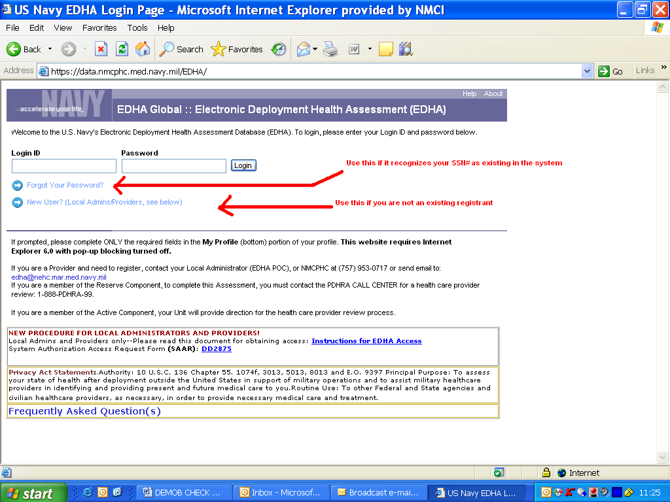
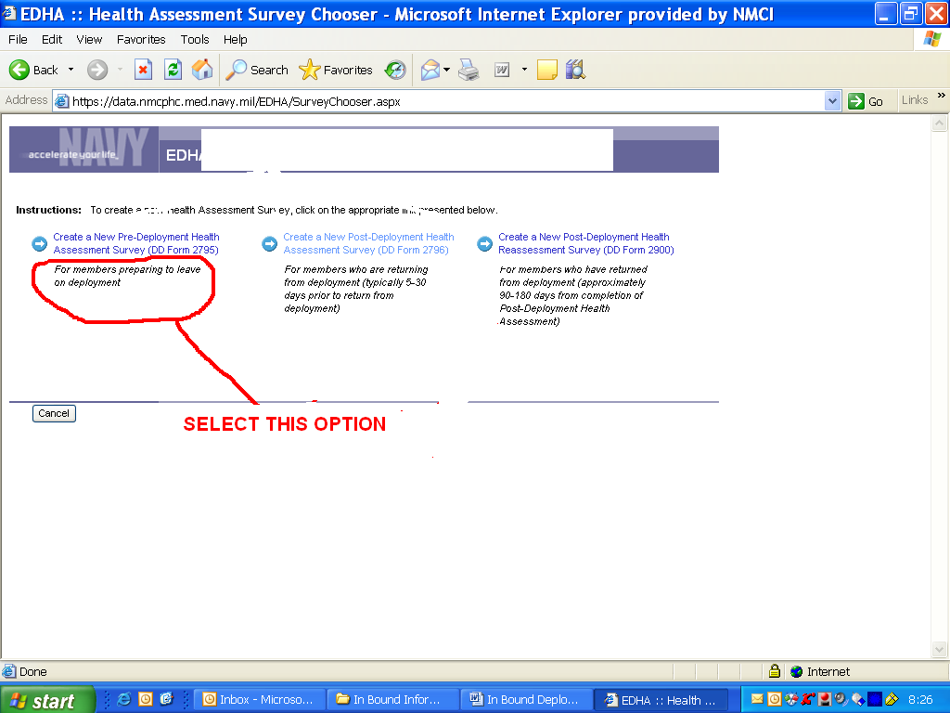

Anticipated Class Schedule for through 2010

Please note that this is the forecasted schedule, only an approved reservation by email guarantees availability for the weeks below.
December 06th-10th, 13th-17th

DPC-E CONTRACTOR CLASS DATES 2011
(Important Note: Dates are forecasted dates only and are subject to change to meet other mission requirements. Only a confirmed reservation received by email assures the forecasted processing dates actual availability.)

January 10th-14th, 24th-28th,
February 7th-11th, 14th-18th ,28th –march 4th
March 14th-18th, 28th-april 1st
April 11th-15th, 25th-29th
May 9th-13th, 23th-27th
June 6 th -10th, 20st-24th
July 11th-15th, 25th-29th
August 8th-12th, 22th-26th
September 12th-16th, 26th-30th
October 3rd-7th, 24th-28nd
November 14th-18th, 28th-December 2nd
December 5th-9th , 12th-16th

* Indicates abnormal start date

POC(s):

More CRC Questions? Please use these points of contact to get more information:


RSU DPC-E CRC
SNCOIC/ Troop Handler
Main-Side Bldg 309
PSC Box 20086
Camp Lejeune, NC 28542
Office: (910) 450-9307
Fax: (910) 451-6298
Daniel.peralta@usmc.mil
steven.gordon@usmc.mil
CRC OIC & Deputy Operations Officer
RSU DPC-E
Main-Side Bldg 341
PSC Box 20086
Camp Lejeune, NC 28542
Office: (910) 451-0544
Fax: (910) 451-0548
scott.a.morrison@usmc.mil

OTHER MEDICAL QUESTIONS?

HM1 Green (Medical POC)
RSU DPC-E Medical Section SNCOIC
(910) 450-9140
lee.green@usmc.mil

Capt McCune
Medical Officer (Medical Section Head)
RSU DPC-E Medical Officer
todd.mccune@usmc.mil

RSU- Form1 vers I
The RSU Form 1 has been replaced by the following medical requirements checklist(s):

- NAVMED 1300/4 (Rev. 4-2010) This Navy Medical document outlines all requirements for all Individual Augmentee (IA) and Support Assignments to Overseas Contingency Operations (OCO), temporary duty medical assignments, and UN Missions with members deployed Boots On the Ground (BOG) over 30 days. Although the form was initially crafted for Uniformed personnel we have been asked to utilize this for DoD Contractors and DoD Civilians to insure that Civilians/Contractors complete the same level of medical preparedness. This is a ‘living document’ which means it changes regularly, so please find the most current version available to insure you are preparing properly.

- Depending on where you are deploying to, you will need to complete the following AOR specific requirements which can be found on the following forms:
- UN Entry Examination Form MS2 (United Nations (UN) Missions) & NAVMED 1300/11, United Nations Mission.
- NAVMED 1300/5, Pacific Command (PACOM).
- NAVMED 1300/6, Korean Peninsula.
- NAVMED 1300/7, European Command (EUCOM).
- NAVMED 1300/8, Africa Command (AFRICOM).
- NAVMED 1300/9, Joint Task Force (JTF) Guantanamo Bay (GTMO).
- NAVMED 1300/10, West Pacific & Okinawa, (With Extended Field Exposure).

The following forms are also still required for medical processing:

- DD Form 2795, Pre-Deployment Health Assessment Questionnaire (This is the online questioner previously mentioned in our CRC checklist).

- DD Form 2807-1, Report of Medical History (to be completed by your medical doctor prior to arrival at CRC).

Have questions about which form to use or if you have the current version?

Please contact the ‘Medical POC’ listed in the POC Section of this document.

CURRENT CRC GEAR:

Nomenclature | Quantity
HELMET, LIGHT WEIGHT (LWH) W/PADS | 1
MTV--Modular Tactical Vest Complete | 1
SAPI Inserts, Enhanced Small Arms | 2
SAPI SIDE 6X8 PLATE | 2
GOGGLES, ESS Profile NVG | 1
ID Tags/Medical Tags (If known allergy) | 2
M40A1 Protective mask | 1
M40A1 Mask carrier | 1
M40A1 Protective Mask Canister (filter) | 1

