“How is a geologist like a detective?”

Google Earth

Concept Map Activity

FIGURE 7.14 The orientation of tectonic forces determines the style of continental deformation. [After John Suppe, Principles of Structural Geology. Upper Saddle River, N.J.: Prentice Hall, 1985.]
FIGURE 7.7 The orientation of tectonic forces determines the style of faulting. Dip-slip faulting (parts a–c) is caused by tensional and compressive forces. Strike-slip faulting (parts d–f) is caused by shearing forces.


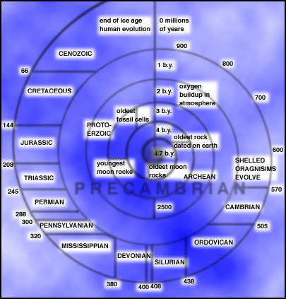

[http://www.globalchange.umich.edu/globalchange1/current/lectures/first_billion_years/onebych.jpg](http://www.lpi.usra.edu/education/timeline/)

FIGURE 8.13 The ribbon of geologic time shows the complete geologic time scale. All numbers are ages in millions of years ago. (The Tertiary and Quaternary periods are older divisions that have been largely replaced by the Paleogene and Neogene periods, but are still sometimes used by geologists.)


FIGURE 8.2 Layers of sedimentary rock in Marble Canyon, part of the Grand Canyon, illustrate Steno’s principles. The Grand Canyon was cut by the Colorado River through what is now northern Arizona, revealing layers that record millions of years of geologic history. Stratigraphy is the study of sedimentary sequences such as this one. [Fletcher and Baylis/ Photo Researchers.]


FIGURE 8.3 Fossils can be used to correlate rock layers in different outcrops.


Radioactive Decay

FIGURE 8.11 The radioactive decay of rubidium to strontium.


FIGURE 8.12 The number of radioactive atoms of any element in any mineral declines at a fixed rate over time. This rate of decay is given by the half-life of the isotope.


Half-Life Concept: Pennies/M&M’s activity

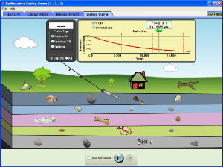

PHET: The Dating Game

<http://phet.colorado.edu/en/simulation/radioactive-dating-game>

FIGURE 9.17 The major tectonic provinces of North America reflect the processes that formed the continent.


K-T Impact

<http://www.psi.edu/projects/ktimpact/ktimpact.html>

<http://www.tufts.edu/as/wright_center/impact/impactc.html>

FIGURE 9.40 Knife marks a light-colored layer of clay containing both extraterrestrial materials and materials from local rocks at the Chicxulub impact site that accumulated in the Raton Basin of the southwestern United States following the asteroid impact that killed the dinosaurs. Such deposits have been found worldwide. [From David Kring and Daniel Dura, “The Day the World Burned,” Scientific American (December 2003): 104. © December 2003 by Scientific American. All rights reserved.]


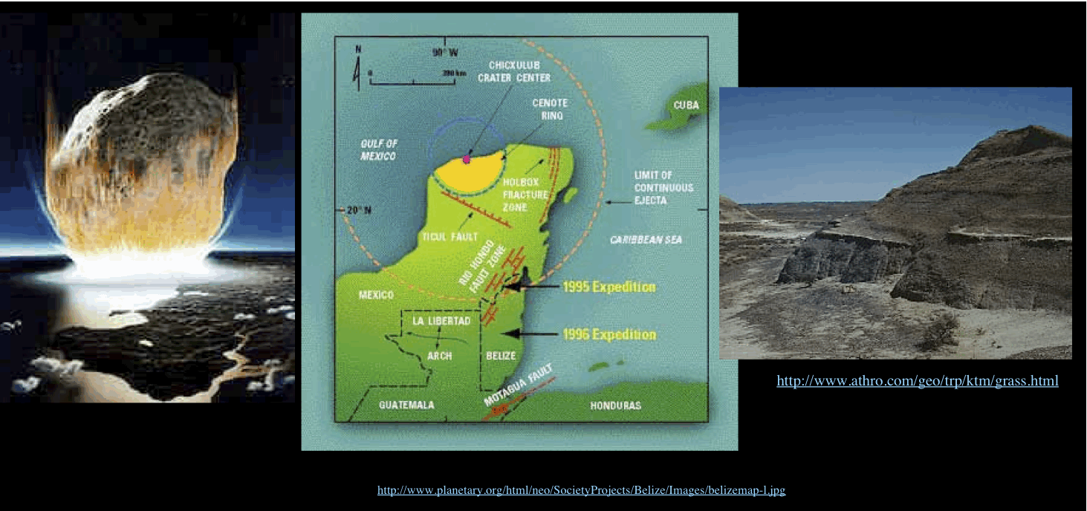

Gerda work disproves Yucatan crater idea?