**What is it?**

**Mercury Background Information**

Mercury is an element that can be found naturally in the environment in the air, water, and soil. It is a heavy metal that is commonly referred to as quick silver. On the periodic table of elements its symbol is Hg. Mercury can be found in nature in three different forms (elemental, inorganic, and organic) all of which are toxic at high enough doses.

***Elemental mercury*** is the pure form of mercury. It is a shiny, silvery white metal that is liquid at room temperature and slowly forms an invisible, odorless, and very toxic vapor in the air that is absorbed through the skin. The amount of vapor formed increases as the temperature rises. This is the form of mercury associated with glass thermometers because the elemental mercury expands and contracts at a uniform rate with changes in temperature. In order to prevent elemental mercury from turning into a vapor it must be sealed off in a container, which is why in a glass thermometer it remains in its liquid state. Elemental mercury is the heaviest known elemental liquid.

Elemental mercury is the least likely of the three types of mercury to be found in nature. Instead, organic and inorganic mercury are more commonly found. Most elemental mercury is processed from ***inorganic mercury***. Inorganic mercury is formed when mercury combines with an inorganic element such as chlorine, sulfur, or oxygen. Often called mercury salts, these combinations have historically been used in medicines. Most inorganic mercury compounds are white powders or crystals. Cinnabar, a mercuric sulfide, however is a red mineral that turns black after exposure to light. Cinnabar ore is the main producer of elemental mercury and the form of mercury that can be found in the Big Bend Area.

***Organic mercury*** forms when mercury combines with carbon. The most common type of organic mercury is methylmercury, which forms naturally in water and soil. This form of mercury is the type found in tuna and other fish and can build up to dangerous levels in these creatures. Organic mercury is absorbed through the digestive tract as well as through vapors and can easily cross the blood brain barrier and placenta.

**Where does it come from?**

Mercury is released in to the environment through both natural processes and human activities. Once it is released into the environment mercury enters the air, water, or soil and moves from one to another eventually finding its way into sediments and landfills. See the mercury cycle below.

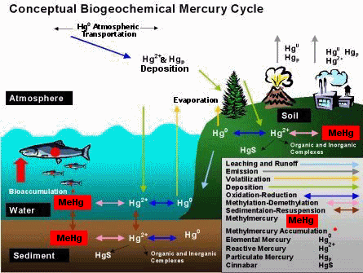

Found at the New England Interstate Water Pollution Control Commission Site: <http://www.neiwpcc.org/mercury/environment.asp>

Mercury can be released ***naturally*** during volcanic eruptions, weathering and evaporation of mercury rich rocks and soils, and forest fires. Organic mercury such as methylmercury is found naturally in soil and water and is absorbed by fish through their gills as well as plankton. This mercury can build up to dangerous levels and enters the food chain when fish eat the plankton and other smaller fish contaminated. Fish that are commonly found with high levels of mercury are shark, swordfish, and tuna. For more information on Mercury in the environment consult the U.S. Geological Survey Fact Sheet at <http://www.usgs.gov/themes/factsheet/146-00/>

Unfortunately, naturally occurring releases of mercury into the environment is beyond our control. The good news is that it is estimated that less than 50 % of total mercury releases come from natural resources. The bad news is that ***human activity*** is responsible for the rest of the mercury being released into the environment. Much of it is released unintentionally from processes where mercury is an unwanted impurity such as in fossil fuel power plants and waste incinerators because coal is being burned releasing mercury into the air. In the past, however, a large cause of mercury in the air was from the Mercury mining industry.

From 1900 to about 1943 mines in the Big Bend Area were responsible for releasing mercury vapors into the air. A mercury sulfide mineral, known as Cinnabar, was found near Mariscal Mountain by Farmer Martin Solis in the 1900’s and mining operations in the Mariscal and Chisos Mountains became abundant in the area. Cinnabar is the main ore from which elemental mercury can be produced. It is most often found near recent volcanic activity but forms at very low temperatures in veins and other porous spaces.

Mining operations in the Big Bend area ended before the 1950’s and Mercury production from mines in general has decreased significantly. In the 80’s and 90’s Mercury production decreased from about 6,000 tons per year to 2,000 tons per year.

**What does it look like?**

Elemental mercury is a shiny silvery white metallic liquid and is the image most commonly associated with mercury.

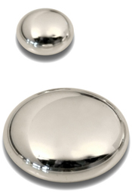 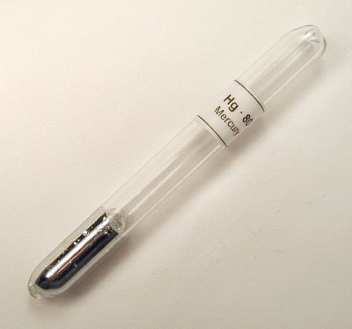

cleanandhealthyme.org helpyourautisticchildblog.com

The mercury samples found in the Big Bend area are in the form of the inorganic mercuric sulfide ore called cinnabar. Cinnabar is a colorful mineral that is bright scarlet, cinnamon, or brick red in color and is generally found in a large, granular, earthy form.

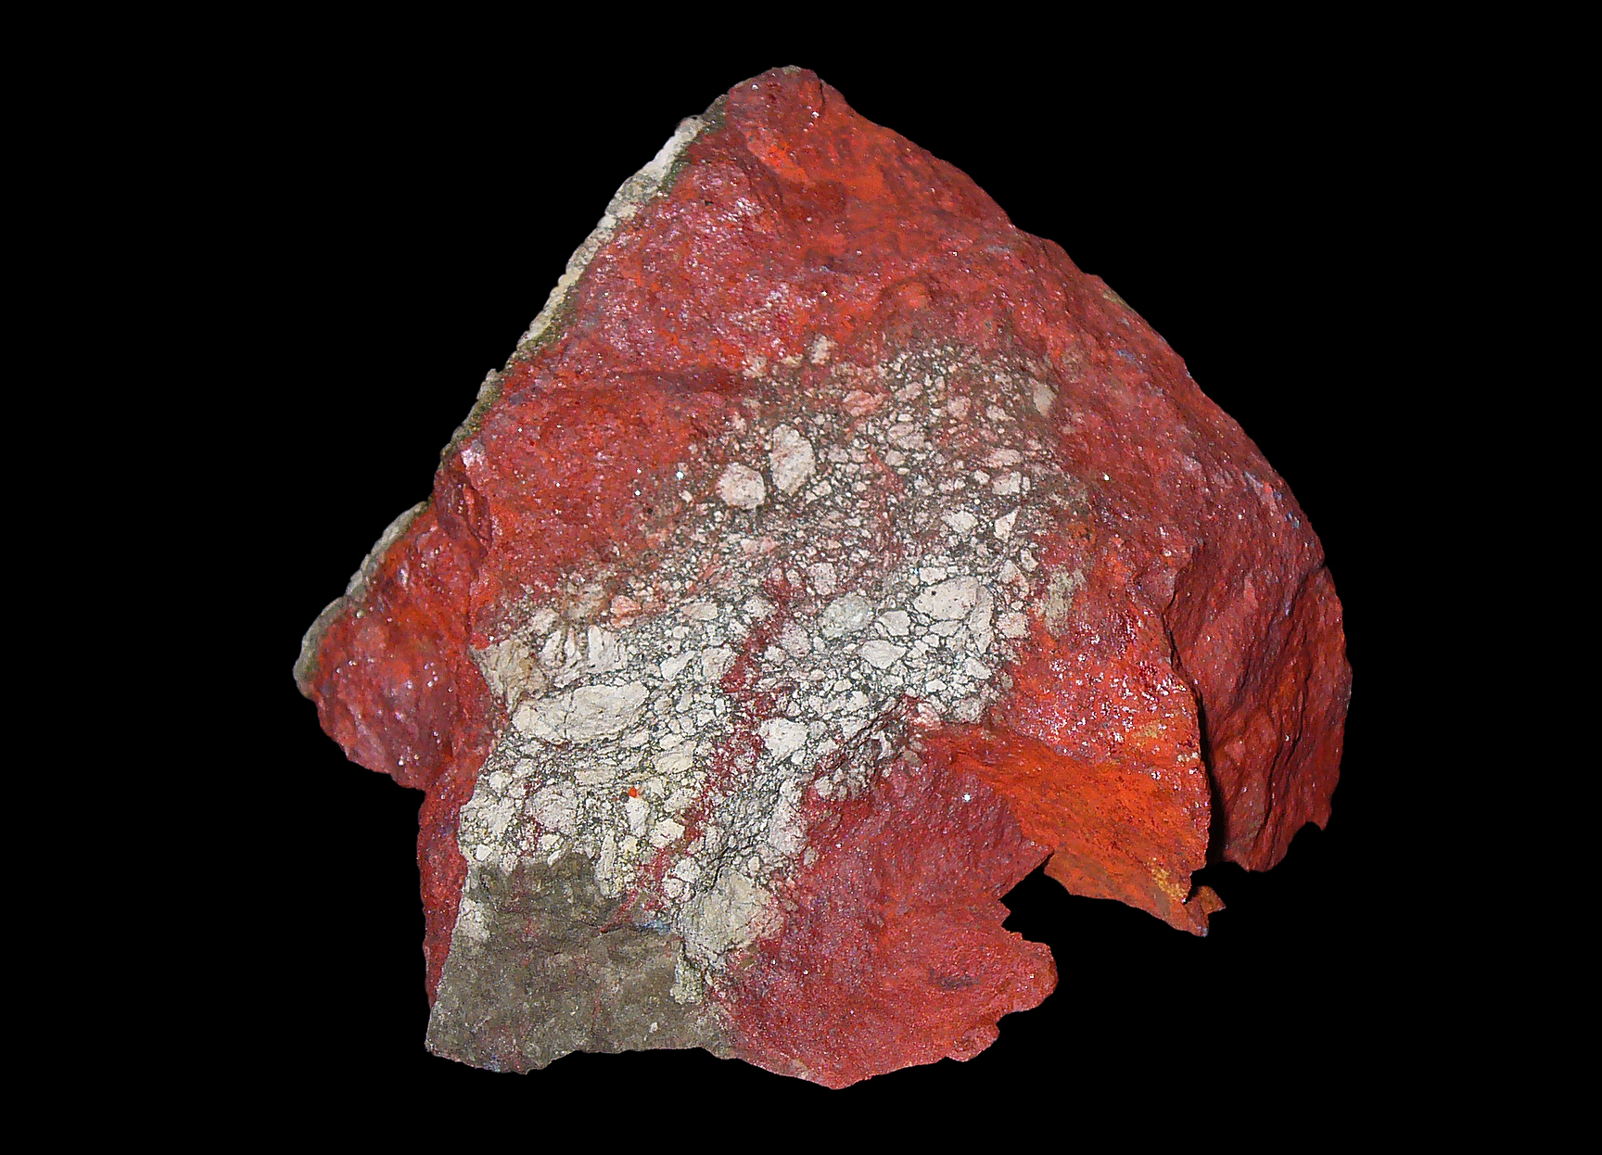

<http://en.wikipedia.org/wiki/File:Cinnabarit_01.jpg>

Cinnabar can also occur in crystals. These crystals resemble quarts in its symmetry and have the highest refractive power of any mineral. The crystals in cinnabar form a distinctive penetration twin pattern. Twins form as a result of an error during crystallization and in the case of cinnabar look like two crystals are growing into each other like a pair of Siamese twins. The crystals of cinnabar are ridged with six ridges surround the point of a pyramid. To see 3-D images of the different cinnabar crystal shapes go to <http://www.mindat.org/min-1052.html>.

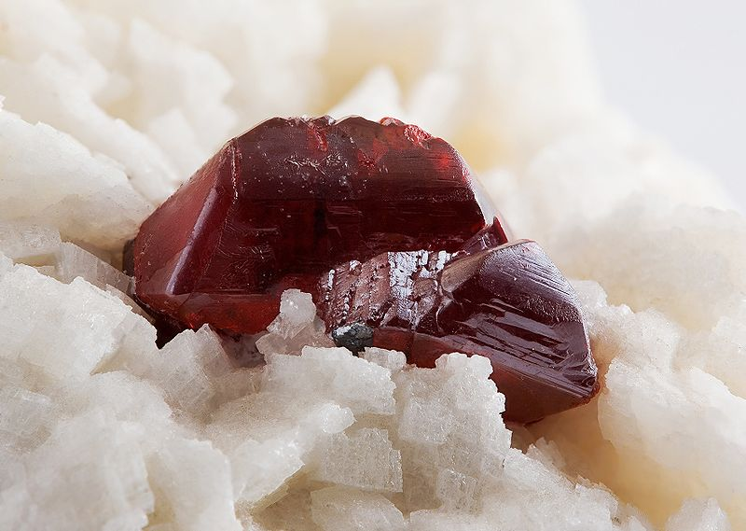 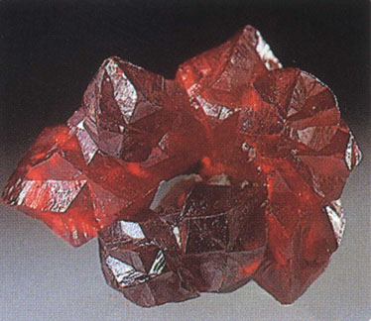 <http://www.mindat.org/photo-16379.html> <http://www.dartmouth.edu/~rpsmith/Heavy_Metals.html>

**How is it mined and processed?**

To produce elemental mercury (the liquid form of mercury known as quicksilver) crushed cinnabar ore is roasted in a rotary furnace at temperatures above 540 degrees Celsius. In 1919 the Mariscal Mining Company used the Scott Furnace to roast the cinnabar. The remains of the furnace stand today in Big Bend National Park as a reminder of this practice.

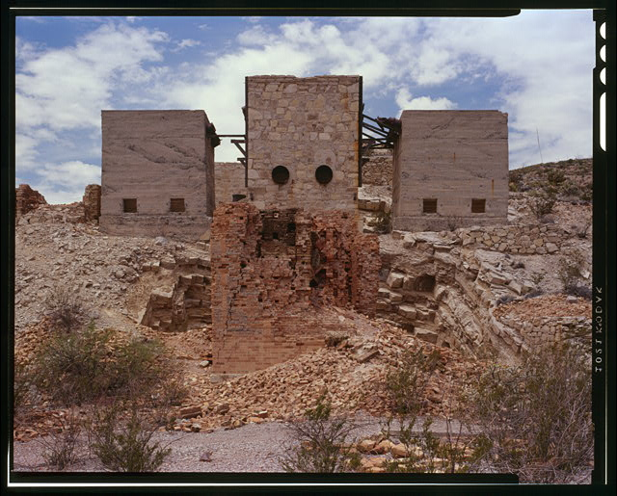

* Source: Library of Congress Prints and Photographs On-Line Catalogue [**http://www.loc.gov/pictures/**](http://www.loc.gov/pictures/)

In this roasting process, the pure mercury separates from the sulfur and easily evaporates. A condensing column is used to capture the vapor and cooled to from liquid metal mercury that is then collected in iron flasks so it can be shipped.

**What effect does Mercury have on humans?**

Mercury poisoning is a toxic condition caused by the ingestion or inhalation of mercury or a mercury compound. There is a difference between ***mercury exposure*** and ***mercury poisoning***. Humans have a threshold that can be built up before symptoms of poisoning are manifested. If a person is around mercury but does not have any symptoms or chemical or physical changes they are considered as having been exposed only. It is not considered mercury poisoning until someone has had physical or chemical changes within his or her body. High exposure to mercury without symptoms is still unsafe because eventually the exposure will lead to symptoms. Exposure to mercury can happen through inhalation, ingestion, or absorption.

Typically inhalation of mercury fumes happens to those who work in an industry that utilizes or produces elemental mercury. Historically this would have happened to those who worked in mercury mines or in the hat industry. The miners in the Big Bend Area that mined cinnabar often came down with mercury poisoning because of the high mercury content in cinnabar but mostly because of the fumes from the furnaces used to process the cinnabar into elemental mercury. Mercuric nitrate was used by the felt-hat industry in the process of curing felt. People in this industry often showed signs of mercury poisoning and came down with a syndrome known as Mad Hatter’s Disease (for more information on this consult the “Mad As a Hatter Fact Sheet”). The lung tissue absorbs 80 % of inhaled vapors and elemental mercury easily penetrates the blood brain barrier.

When elemental mercury is ingested very little is absorbed into the body. Methylmercury is the form of mercury that is typically ingested. This can happen if someone eats food (especially fish) or drink water that has been contaminated by mercury. Small children can ingest mercury if they put objects that contain mercury into their mouths such as batteries and certain types of paint. Mercury can also be absorbed through the skin, which is why it is very important to clean up broken glass thermometers and broken fluorescent lights properly making sure they area is well ventilated.

Although any level of mercury is not ideal, since we are constantly exposed to mercury through air, water, and soil some mercury in our systems is inevitable. Mercury levels can be found by testing hair, blood, and urine samples. Normal levels are 2 ppm in a hair follicle, 3-4 ug/dl in a blood sample, and 25 ug/L in a urine sample. Levels that are found above 50 ppm in a hair follicle is where permanent damage can occur.

Inhaling the vapors associated with elemental mercury can cause neurological and behavioral disorders including tremors, emotional instability, memory loss, headaches, insomnia, difficulty with fine motor skills, anemia, heart palpitations, thyroid problems, tiredness, and issues with smell, vision, and touch. Often the affects of the poisoning show up as an upper respiratory illness like the flu at first. Mercuric salts cause problems with the kidneys including issues with urination and just feeling off due to renal dysfunction. There are some inconclusive studies that methylmercury can cause cancer in humans. The International Agency for Research on Cancer classifies methylmercury as a possibly carcinogenic to humans. There is no evidence that any other form of mercury can cause cancer, but high exposures to any type of mercury can lead to death in some cases.

Mercury poisoning can and is treated by doctors and toxologists. The first order of treatment is to find and stop the exposure. If the poisoning is due to eating fish then the person needs to stop eating fish. Chelating agents make metals, such as mercury, more water soluble so that the kidneys are able to excrete them. Chelating agents work well with the organic salt forms of mercury but not for neurological issues caused by the elemental form of mercury. To treat mercury poisoning due to the elemental and inorganic forms of mercury and old World War II antidote developed by the British is still used. Dimeracaprol is injected into patients and is used against lewisite gas, arsenic, and lead in addition to mercury. For any of the treatments how long the patient will need to be treated for is dependent on exposure length and how high the mercury levels are. Mercury poisoning can be cured if symptoms just started and the exposure has been short. Occupational exposure over many years can cause the nervous system to be physically damaged beyond complete repair. If the nervous system is unable to repair itself the damage to it could be permanent or at the very least residual.

**What are its uses?**

Mercury in the form of Cinnabar ore has been mined since the Neolithic Age 9500 B.C. (also known as the New Stone Age). Cinnabar was mined by the Roman Empire for its mercury content and pigment, and the Chinese were using mercury before 2000 B.C. Even back then it was realized that mercury was toxic and the task of mining the ore and processing the quicksilver was given to slaves and prisoners. Tombs in Ancient Egypt contained vials of mercury and limestone sarcophagus in the royal burial chambers of the Mayan Civilization contained cinnabar decorations partly for decoration but also to keep out grave robbers and vandals because it was a well-known toxin.

Cinnabar has been used for its color since the Olmec Culture (Pre-Columbian Mexico 1500-400 B.C). During the Song Dynasty the bright red color was used as a pigment in Chinese carved lacquerware. The danger of mercury poisoning was reduced in these dishes because the lacquer trapped the powdered pigment but it still could be hazardous if one of the plates was broken or destroyed. In Ancient Rome the faces of statues of Jupiter were colored with the pigment as well as the bodies of triumphant generals in times of celebration.

Throughout many different time periods mercury has also been used in a variety of medicines and herbicides. Indian and Chinese Alchemists traditionally used cinnabar and mercury in their practices. The first emperor of unified China, Qin Shi Huang, died of ingesting mercury pills that were intended to give him eternal life. There is a traditional Chinese medicine called Zhusha made from cinnabar and even Abraham Lincoln took a common medicine in his time called Blue Mass which contained significant amounts of mercury.

In addition to chemical, industrial, and pharmaceutical uses of mercury, the development of ***mercury fulminate*** gave the metal historical and strategic importance. In 1799 the scientist Edward Charles Howard experimented with dissolving mercury in a solution of nitric acid and alcohol creating a compound that when dry formed a crystalline substance. This is the same process still used today to make mercury fulminate. It was found that striking the crystals lightly caused an explosion making mercury a critical component in war and in peace. Mercury fulminate is used as a primer to detonate gunpowder in cartridge shells. In the Big Bend Area, mines that were closed before the war were reopened during wartime because of the economic potential and uses of mercury fulminate.

Even today mercury can be found in batteries, fluorescent light bulbs, thermometers, dental fillings, light switches, and even some toys to name just a few. The dangers associated with mercury and the products that contain them are often discussed and debated. The National Institute of Health states that dental fillings pose no personal health risk even though they contain 50 percent elemental mercury. Vaccines contain the mercury based preservative thiomersal, which is hypothesized to cause autistic behaviors in children while others believe that the risk is outweighed by the benefits of the vaccine. Some skin whitening cosmetics used in Asian that contain mercury have actually been banned in the United States because they can be absorbed through the bloodstream and paints containing Mercury were removed from markets in the 1990’s.

For more information about mercury in the home see the “Mercury in the Home” fact sheet at <http://www.scdhec.gov/environment/lwm/recycle/pubs/mercury3.pdf>

and for more information about consumer products that contain mercury visit [www.epa.gov/mercury/consumer.htm](http://www.epa.gov/mercury/consumer.htm).

**Resources/References:**

* As Mad as A Hatter <http://www.phrases.org.uk/meanings/mad-as-a-hatter.html>
* Cinnabar Crystal Atlas <http://www.mindat.org/min-1052.html>
* Conceptual Biochemical Mercury Cycle: New England Interstate Water Pollution Control Commission <http://www.neiwpcc.org/mercury/environment.asp>
* Flu Vaccines and Mad Hatter’s Disease <http://doctordusty.com/index.php/flu-vaccines-and-mad-hatters-disease/>
* Get the Mercury Out: The Effects of Mercury on the Nervous System <http://faculty.washington.edu/chudler/merc.html>
* Health Risks of Mercury Exposure [www.scdhec.gov/environment/lwm/recycle/pubs/**mercury**4.pdf](http://www.scdhec.gov/environment/lwm/recycle/pubs/mercury4.pdf)
* In Search of the Real Mad Hatter <http://chuckstraub.com/Letterboxing/madhatter.htm>
* Making Sense of Mercury Fact Sheet <http://www.scdhec.gov/environment/lwm/recycle/pubs/mercury1.pdf>
* Mercury and Lead Poisoning—Mad Hatter’s Disease <http://www.chelationtherapyonline.com/technical/p63.htm>
* www.scdhec.gov/environment/lwm/recycle/pubs/**mercury**4.pdfMercury: Elements of the Ancients-Dartmouth Toxic Metals Superfund Research Program <http://www.dartmouth.edu/~toxmetal/toxic-metals/mercury/mercury-history.html>
* Mercury: U.S. Environmental Protection Agency <http://www.epa.gov/mercury/effects.htm>
* Quicksilver Terlingua & the Chisos Mining Company by Kenneth Baxter Ragsdale [http://books.google.com/books?id=aeG1X-19XJAC&pg=PA186&lpg=PA186&dq=Terlingua+Rainbow+Mine&source=bl&ots=T9ChYpfWAS&sig=rJyF7G_Z6y_3i41NwbA6kUlGc8o&hl=en&ei=z9dhTcesJIL78Ab2rqmZDA&sa=X&oi=book_result&ct=result&resnum=4&ved=0CCwQ6AEwAw#v=onepage&q=Terlingua%20Rainbow%20Mine&f=false](http://books.google.com/books?id=aeG1X-19XJAC&pg=PA186&lpg=PA186&dq=Terlingua+Rainbow+Mine&source=bl&ots=T9ChYpfWAS&sig=rJyF7G_Z6y_3i41NwbA6kUlGc8o&hl=en&ei=z9dhTcesJIL78Ab2rqmZDA&sa=X&oi=book_result&ct=result&resnum=4&ved=0CCwQ6AEwAw#v=onepage&q=Terlingua)
* Scientific Facts on Mercury (Green Facts: Facts on Health and the Environment) <http://www.greenfacts.org/en/mercury/mercury-1.htm#1>
* The Mad Hatter Syndrome: Mercury and Biological Toxicity <http://www.naturalnews.com/016544.html>
* The Straight Dope: What Caused the Mad Hatter to Go Mad? <http://www.straightdope.com/columns/read/1897/what-caused-the-mad-hatter-to-go-mad>
* The Mineral Cinnabar <http://www.galleries.com/minerals/sulfides/cinnabar/cinnabar.htm>
* United States Geological Survey Mercury in the Environment Fact Sheet <http://www.usgs.gov/themes/factsheet/146-00/>
* What is Mercury Poisoning? from Scientific America <http://www.scientificamerican.com/article.cfm?id=jeremy-piven-mercury-poisoning>
* World Wide Words: Mad as a Hatter <http://www.worldwidewords.org/qa/qa-mad2.htm>