**VFT - PORTFOLIO**

**Resources for Teacher Knowledge:**

-Links to Google Earth with the pins with explanations at each pin

-Page with links to different types of plate movement, demonstrating those which happened in Big Bend

-with explanations

Timeline of events with pictures and explanations

**Links to plate tectonics and Texas geologic history**

-[Plate Tectonic video](http://www.hippocampus.org/course_locator?course=AP%20Environmental%20Science&lesson=17&topic=2&width=800&height=684&topicTitle=NOAA%3A%20Plate%20Tectonics&skinPath=http://www.hippocampus.org/hippocampus.skins/default) – from NOAA  
 -good for easy intro to plate tectonics and earth structure

-types of plate movement

-has a couple really good activities

-[Fault types animation](http://www.classzone.com/books/earth_science/terc/content/visualizations/es1103/es1103page01.cfm)

-normal, reverse, thrust, strike-slip

-[Additional Fault types animation](http://www.uwsp.edu/geo/faculty/ritter/geog101/textbook/tectonics_landforms/faulting_p2.html)

-normal, reverse, strike-slip, thrust, and horst/graben

-[Fault animation](http://www.iris.edu/hq/programs/education_and_outreach/animations/2)

-many different fault-types, as well as basin and range

-[Pangaea video](http://www.youtube.com/watch?v=NYbTNFN3NBo&feature=related)

This is an example of plate tectonics in a lava lake.  
 http://www.youtube.com/watch?v=PZjPGdXMMso

-Review Google Earth pushpins

**History of formations:**

**Paleozoic Era**

-Pennsylvanian time about 300 MYA the formation of Pangaea occurred and the South American plate collided with the North American plate and a thrust fault occurred

-South American plate material was pushed onto North America forming the Ouachita Mountain

range as well as the Caballos in the Marathon Basin.

-evidence of thrust fault visible at Persimmon Gap

-Maravillas Picture, Haymond Picture - Marathon

**Collision between the North American and South American plates during the formation of Pangea in the late Paleozoic**

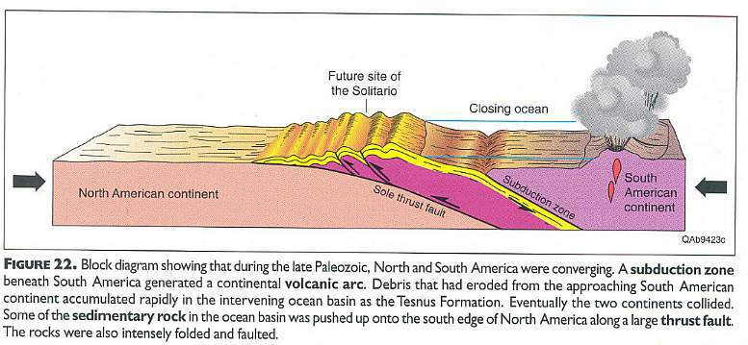

Above figure from Henry, 1998.

http://www.sunstar-solutions.com/sunstar/geology/BigBend/BigBendTX.htm

**Rock formations**

-formations from this time show much folding of the rock layers

-older layers thrust upon newer layers

-Texas was under the ocean so sedimentary rock layers appear as the depths of the ocean varied.

**Late Cretaceous Era**

-70-50 MYA

-North American and Farallon plate collided and the Farallon plate subducted the North American plate

-Also called the Laramide Orogeny

-[Subduction video](http://www.hippocampus.org/course_locator?course=AP%20Environmental%20Science&lesson=10&topic=2&width=800&height=684&topicTitle=NOAA%3A%20Subduction&skinPath=http://www.hippocampus.org/hippocampus.skins/default) – from NOAA

-has activities that correspond

-because the subduction was at a slight angle rather than deep, the mountain-producing

episode was further inland

-caused large folds and faults

-produced Rocky Mountains – tip of which is Mariscal Mountain

also produced Sierra del Carmens

**Continental Volcanic Arcs along western North America and Central America  
Note how volcanic region falls within Basin and Range Province**

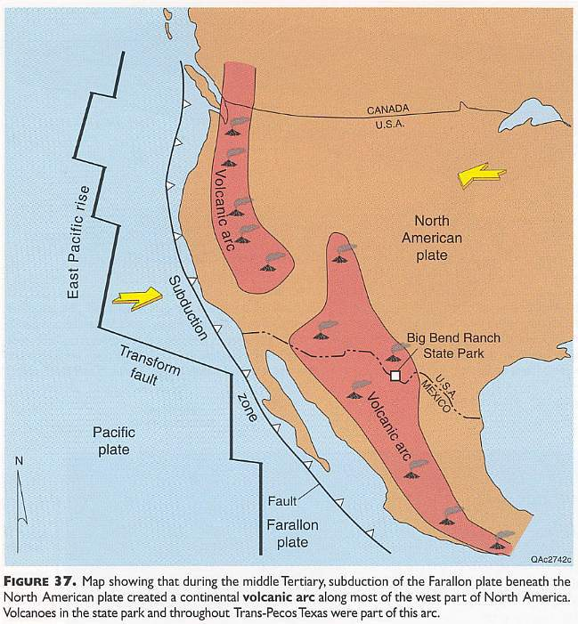

Above figure from Henry, 1998.

<http://www.sunstar-solutions.com/sunstar/geology/BigBend/BigBendTX.htm>

**Cenozoic Era**

-42 MYA

-Volcanic eruptions began caused by the previous subduction

-evidence in the igneous rock throughout Big Bend

-formed Chrismas mountains first - large portions of extrusive igneous rock

-Subsequent eruptions formed the Chisos Mountains, Pine Canyon, and Burro Mesa

-volcanic ash and lava layers

-Link to Baked Pen, Study Butte, and Willow Mountain Plug pictures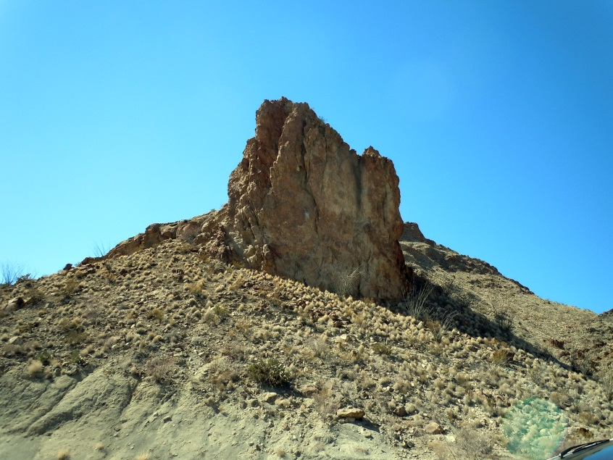Study Butte Volcanics

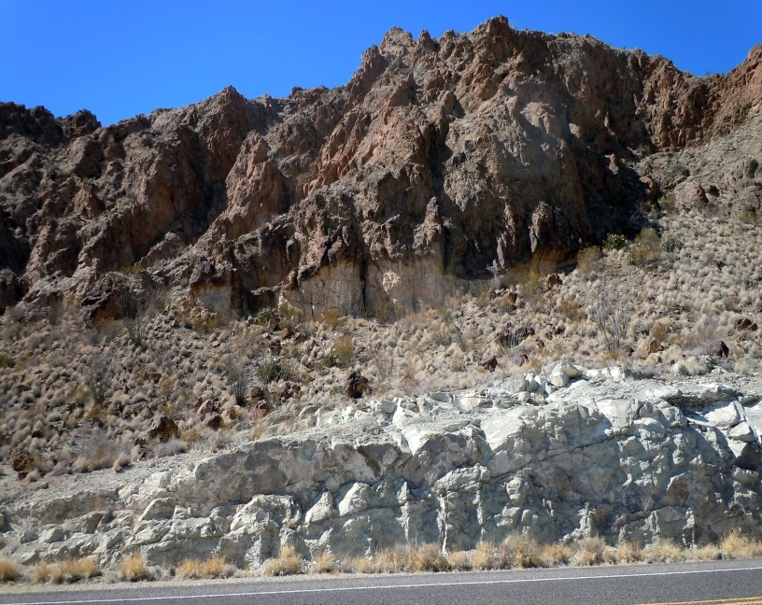 Study Butte Volcanics

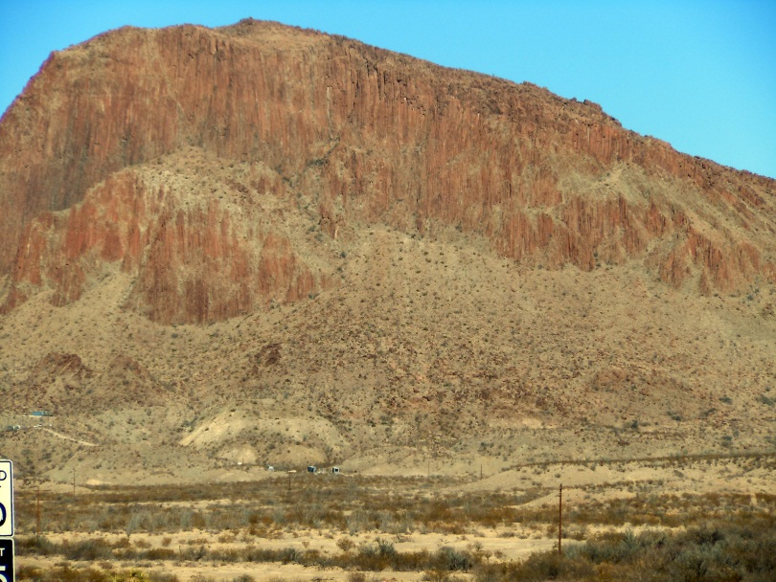 Willow Mountain Plug

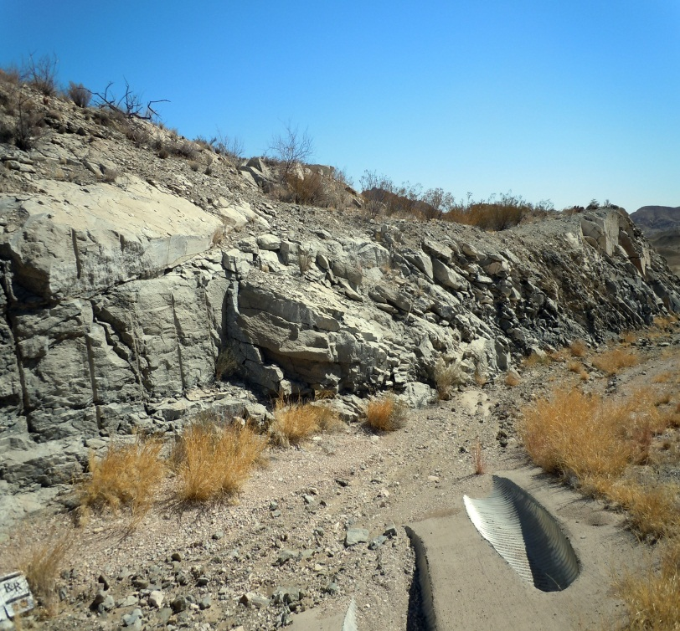 Baked Pen

-Also during this time large amounts of lava failed to reach the surface and produced intrusive igneous rock

which has now been exposed by erosion

-formed Maverick Mountain, Grapevine Hills, Nugent Mountain, and Pulliam ridge

Extrusive igneous rock formed:

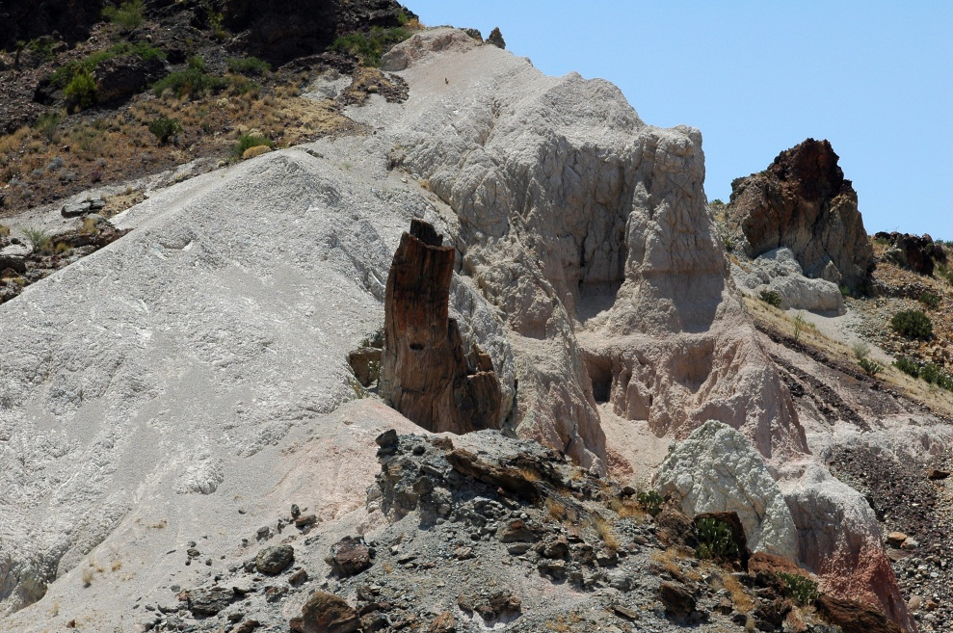

Grey-formation: Extrusive volcanic ash

Tree-like formation: intrusive volcanic vent exposed by erosion

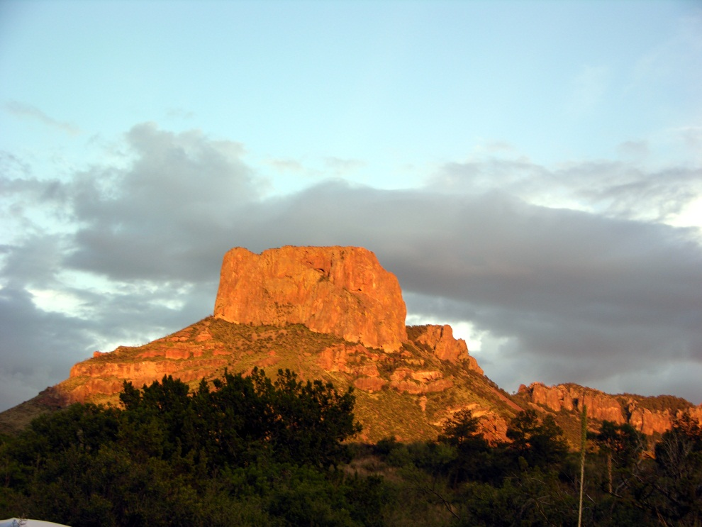 Casa Grande: Top of the Chisos Mountains, extrusive igneous rock

**Rock types**

-sedimentary rock baked by volcanics

-intrusive and extrusive igneous rock

-volcanic tuff

**25 MYA**

-Pacific plate grinding against North American plate caused crustal extension and down drop block,

basin and range

-Tension caused the crust to fracture and a large block of crust sank

-central part of Big Bend – Chisos Mountains – is the graven – or drop down

-the horst to the West is the Mesa de Anguila and Santa Elena Canyon and the East is the Sierra

del Carmen

-Left large active faults - Terlingua Fault

-Burro Mesa Fault

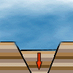

[Basin and Range video](http://www.youtube.com/watch?v=p8wPl7Qc8vg)

**MiniLessons – for Teachers to use with students:**

-Texas Geology Claymation

-Pangea links

-Lava flow to demonstrate plate movement – links

-Google Earth with pins (no information)

-links to different types of faults – animated or not

-links to examples – like car crash for plate collisions

-Photos and hand samples

-decide which to use (perhaps one for each major sites)

-[Subduction video](http://www.hippocampus.org/course_locator?course=AP%20Environmental%20Science&lesson=10&topic=2&width=800&height=684&topicTitle=NOAA%3A%20Subduction&skinPath=http://www.hippocampus.org/hippocampus.skins/default) – from NOAA

-has activities that correspond

-[Plate Tectonic video](http://www.hippocampus.org/course_locator?course=AP%20Environmental%20Science&lesson=17&topic=2&width=800&height=684&topicTitle=NOAA%3A%20Plate%20Tectonics&skinPath=http://www.hippocampus.org/hippocampus.skins/default) – from NOAA  
 -good for easy intro to plate tectonics and earth structure

-types of plate movement

-has a couple really good activities

Big Bend

<http://www.maroon.com/bigbend/time/index.html>

<http://bigbendnationalpark.info/geology_history.html>

<http://www.nature.nps.gov/geology/parks/bibe/>

<http://www.lib.utexas.edu/geo/fieldguides/bigbendgeology.html>

Big Bend video of dinosaur fossils collected

<http://www.youtube.com/watch?v=zNy4pD0Rn1E>

Plate Tectonics

<http://www.youtube.com/watch?v=QDqskltCixA>

Plate Tectonics Fault Normal

<http://www.youtube.com/watch?v=vqWCpo-1jrU>

Plate Tectonics Fault Reverse

<http://www.youtube.com/watch?v=4b81nXSVA34>

Plate Tectonics Fault strike-slip

<http://www.youtube.com/watch?v=MrrLJ4vXHCs>

<http://www.youtube.com/watch?v=6wWcjNM_kRM>