Community development BILL BROWN SUMMARY

IDEA 1 ASSET MAPPING
http://www.atherton.org.au/news/items/2005/08/00703-upload-00001.doc
PUTTING
THE PIECES
TOGETHER
context determines if mapping is geographic or conceptual

befoEre you map
nknow your purpose
ndefine issues
nknow your strategy:
yset up an action committee
yhave a game plan

use data to
n create enthusiasm
n organize community to
y identify informal resources
y increase individual income
y increase individual assets
n increase community
connectedness

use youth to survey and input
data—for assets and employment
OUTREACH
PARTNERSHIPS
b e s t
practice
b r i e f s
THE SEVERAL FORMS OF
“COMMUNITY MAPPING”—2
This second Briefon Community Mapping explores conceptual mapping of ommunity assets, public capital, cultural resources, and relationships.
INTRODUCTION
In addition to visual presentation of data on maps described in the previous issue, the term “Community Mapping” is used conceptually to refer to a process of inventorying the resources or assets available to a specified neighborhood or community. This conceptual approach is identified as “Community Asset Mapping.” It includes the identification of community assets for individual development and the inventorying of public capital and cultural resources.
Community Mapping can also refer to a graphic “abstract” presentation of
relationships within a specific geographic area, but without reference to a
geographic grid. This visual presentation of relationships, generally known as
ecomapping, is identified as “Community Relationship Mapping.”
Considerations
y Community Asset Mapping and Community Relationship Mapping
could be undertaken with a non-geographically based community.
However, in the discussion that follows, “community” is understood to
be a geographic place: a neighborhood, a city, a township, a county, or
other area where there is a need to understand relationships.
y For other considerations, see Things to Think About in best
practice briefs NO. 3
COMMUNITY ASSET MAPPING
Community Asset Mapping is the inventorying of the assets of individuals and
organizations.
As presented by John B. Kretzmann and John L. McKnight (1993),
Community Asset Mapping is a capacity-focused way of redeveloping devastated
communities. This positive approach is proposed as a substitute for
the traditional deficits focus on a community’s needs and problems. Using
problems to formulate human service interventions, the authors maintain,
targets resources to service providers rather than residents, fragments efforts
Processes
Tools
Tools
Models
Concepts
to provide solutions, places reliance on outside resources and outside experts, and leads to a maintenance and survival mentality rather than to community development.
Instead, they propose the development of policies and activities based on an understanding, or “map,” of the community’s resources — individual capacities and abilities, and organizational resources with the potential for promoting personal and community development. This “mapping” is designed to promote connections or relationships between individuals, between individuals and organizations, and between organizations and organizations.The asset-based approach, the authors maintain, does not remove the need for outside resources, but makes their use more effective. The community assets approach
y starts with what is present in the community
y concentrates on the agenda-building and
problem-solving capacity of the residents
y stresses local determination, investment, creativity, and control
In this context, spatial mapping may or may not be used. Within any given neighborhood or community, most assets as defined by Kretzmann and McKnight do
not have a spatial quality. Commu-nity Asset Mapping has very little to do with spatial mapping as outlined in the previous BRIEF, and much more to do with a community survey and the mobilizing of individuals and organizations to make connections and build capacity. The information obtained through the survey process
must be organized and accessed in an inventory format. It can be computerized as a data base inventory. Computer-ized mapping can be used, showing the location of assets on a geographic map, as well as the attributes attached to each asset.
The Community Asset Mapping process as outlined by
Kretzmann and McKnight is intended to initiate a process that will fully mobilize a community to use its assets around a vision and a plan to solve its own problems.
Their guidebook provides considerable detail about how this might be accomplished, with numerous examples of the types of connections that can be developed.
Use of Mapping for Youth Development
While the focus for Kretzmann and McKnight is community economic and social development, the community assets concept has also emerged as an attractive approach for building developmental assets in adolescents to avoid risky behaviors. The Search Institute’s finding, that the number of risky behaviors is related inversely to the number of assets, has initiated efforts in numerous communities to consciously increase the adult connections and learning opportunities available to youth. Emphasis is on energizing parents, other adults, churches, civic organizations, etc. to change practices in a way that will create more caring support from adults, establish boundaries and expectations, and promote social competency skills, positive values, and identity. (SeeBEST PRACTICE BRIEF NO. 2.)
The Center for Youth Development and Policy Research, Academy for Educational Development, uses community asset mapping in a coherent strategy for youth development (although the word “assets” is not mentioned in their materials). Community Youth Mapping uses a community resource survey as a mechanism for youth development providing a small group of youth with employment, and an opportunity to learn skills and become knowledgeable about and be connected to their community. Thus, low-income youth are recruited as staff to survey the neighborhood in teams of 5-8 persons. The purpose of the survey is to identify resources in the community that could be useful to youth—formal services, places to go for recreation, employment possibilities, and adults who can teach skills. This approach requires funding to paythe youth and a staff person to supervise the teams. The formulation of the Center for Youth Development and Policy Research involves a clear game plan for use of the information. The survey results in an information infrastructure, using desktop mapping to organize the survey information on a geographic grid, as well as a computerized inventory. Youth are employed to enter and analyze the data gathered during the mapping process Youth are employed to survey the neighborhood
residents and organizations. The information can then be disseminated in various ways. The Center for Youth Development and Policy Research outlines the following possibilities:
n YouthLine. A round-the-clock, tollfree confidential telephone service, staffed by trained high school and college students to provide information and support. YouthLine links young callers to a peer who is able to listen and to use a computer to locate geographically appropriate crisis intervention services or to identify community
resources and opportunities. Adult supervisors circulate on site.
n YouthStation. Similar to bank automated teller machines, a YouthStation is a conveniently located, user friendly, interactive computer kiosk, where young people can access information concerning services and opportunities for employment, volunteering, education, or recreation.
n YouthLink. Essentially places the YouthStation on a bus.
n Planning documents and reports, generated from the survey informationand census data, can be used to promote community action in support of youth.
This organized community mapping directed at youth development is an
inventorying of individual and organizational resources. And again, the inventorying
is irrelevant unless there are plans for building assets by connecting youth to individuals and organizations.
Mapping Public Capital
Another form of conceptual mapping is referenced in the 1997 report, Back to Basics: Creating New Possibilities for Flint, developed by the Harwood Group for the Mott Foundation. They “mapped public capital” in Flint by bringing together citizens,
civic leaders, and connective leaders (those engaged in a variety of community activities) to review collective insights derived from focus group conversations
and leader interviews. They were asked to fill in gaps and identify action points and obstacles to overcome. Public capital is identified as:
y social gatherings that enable people to learn
about what is happening in the community
y organized spaces for interaction where people can learn about, discuss, and act on community challenges
y catalytic organizations that spur discussion on community challenges and marshall a community’s resource to move ahead;
y safe havens for decision makers to meet for unofficial candid discussions.
The report does not include any spatial maps.
OTHER FORMS OF CONCEPTUAL MAPPING
Cultural Mapping
Cultural mapping—i.e., the documentation of cultural resources in the community—is another example of conceptual mapping. Cultural mapping consists of examining long-term customs, behaviors, and activities that have meaning to individuals and to the community. Information for cultural mapping is gathered by face-to-face interviews. Communities can use cultural mapping as a tool for self-awareness to promote understanding of the diversity within a community and to protect and conserve traditions, customs, and resources. Example: In the absence of cultural mapping, an Upper Peninsula community did not recognize that Indian
basket weavers made nationally-recognized, unique baskets out of sweet grass. Consequently, development of the swamp in which the sweet grass grew was permitted to take place, thus unintentionally destroying resources and a part of Indian culture.
Location of Persons
with Skills
Name: John Smith
Address: 570 N. 8th Street
Skills: Baseball coach,
Electric repair
Misc.: Call after 5
Jefferson Avenue
N
Main Street
Sixth Street
Scale
0 .070 .14 .21
Miles
BEST PRACTICE BRIEFS are a product of OUTREACH PARTNERSHIPS @ Michigan State
University, connecting university resources to the community. Briefs are reviewed by participating
faculty, OUTREACH PARTNERSHIPS staff, and an Advisory Group of potential users. Responsibility is
assumed by Betty Tableman, Editor, at 517-432-7138, or e-mail: tableman@msu.edu.
BEST PRACTICE BRIEFS may be copied within the subscribing office and may be quoted with
citation of the source. Copyright © 2000 Board of Trustees of Michigan State University.
WRITE OUTREACH PARTNERSHIPS, MICHIGAN STATE UNIVERSITY, ROOM 6, KELLOGG CENTER,
EAST LANSING 48824 OR CALL 517-432-2500 FOR BROCHURES ON TRAINING OR INFORMATION ON PAST
ISSUES @ $2.50 EACH.
Processes
Tools
Models
Concepts
References
n Back to Basics: Creating New Possibilities for Flint. (1997). The Harwood
Group. 49915 St Elmo Avenue, Suite 402, Bethesda, MD 20814.
(Tel:301-656-3669).
n Center Connections. A Newsletter of the Center for Youth Development and
Policy Research, Academy for Educational Development. 1875 Connecticut
Avenue N.W., Washington, D.C. 20009. (Tel:202-884-8273).
n FOSTER-FISHMAN, PENNY AND SALEM, DEBORAH A. (1997). Facilitating
Collaboration Among Human Service Delivery Organizations. Michigan
State University, Department of Psychology (unpublished).
n KRETZMANN, JOHN P. AND MCKNIGHT, JOHN L.(1993). Building
Communities from the Inside Out: A Path toward Finding and Mobilizing A
Community’s Assets. ACTA Publications, 4848 North Clark Street,
Chicago, IL 60640. (Tel:800-397-2282).
n LAUFFER, ARMAND. (1982). Assessment Tools for Practitioners, Managers and
Trainers. Newbury Park, CA: Sage Publications.
n Michigan Council for Arts and Cultural Affairs. (1997). Mapping Arts and
Cultural Funding in Michigan. Wayne State University, Center for Arts
and Public Policy.
n STOFFLE, RICHARD, et. al. (1990). Cultural and Paleontological Effects of
Siting a Low-level Radioactive Waste Storage Facility in Michigan. Ann
Arbor: University of Michigan, Institute for Social Research.
n See also references in BEST PRACTICE BRIEF NO. 2.
BEST PRACTICE BRIEF No. 4 was written with assistance from the following Michigan State University faculty: JOHN MELCHER, Community Economic Development
Program; JOANNE G. KEITH, Department of Family and Child Ecology; MARSHA MACDOWELL, Michigan State University Museum; PENNY FOSTER-FISHMAN, Department of Psychology; and
Research Assistants MEGAN BUURMA, Department of Criminal Justice, and JACK L. ROZDILSKY, Community Economic Development Program. Chart developed by JACK L. ROZDILSKY. Photo
from Community Partnership with Muskegon County Health Department.
Cultural Mapping as a community assets assessment is being piloted by Michigan State University faculty through the
Museum and in the Dexter–Elmhurst neighborhood, Detroit, as a Community Partnership.
Community Relationship Mapping
Ecomapping was initially developed as an effective way for a therapist to identify relationships within a family. The mapping of inter-organizational linkages is a form of ecomapping designed to show the relationships that one organization has with other organizations within the community. Relationships with other organizations may relate to funding, referrals, access to resources, joint service planning, collaborative projects with contributed staff or funds, etc. Ecomapping may be undertaken to clarify the place of an organization in the community spectrum, to identify gaps in linkages, to indicate the multiple relationships between organizations, etc.
Example: Penny Foster–Fishman, Assistant Professor of Psychology at Michigan State University, undertook an inter-organizational linkage study of agencies in Calhoun County to assess whether agencies that were involved with the multi-purpose collaborative body had more inter-organizational linkages than those that were not.
concepts
processes
tools
models

IDEA 2 LOGIC MAPS

http://outreach.msu.edu/CapableCommunities/documents/LMProjectClay.pdf
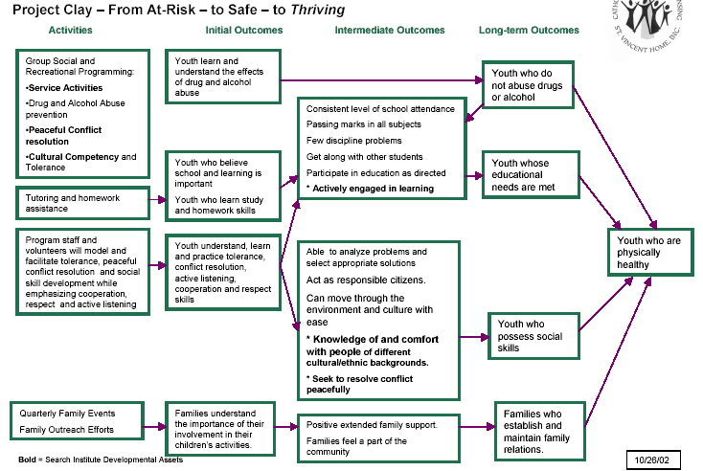
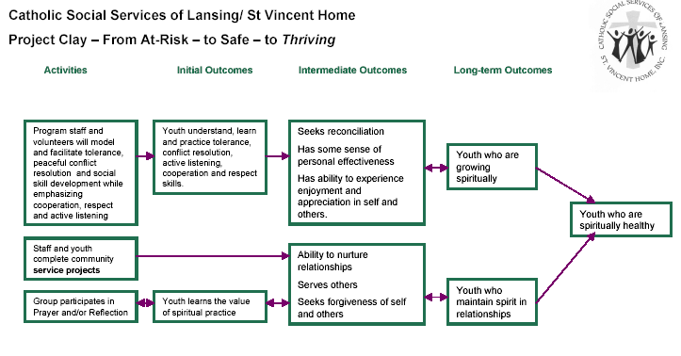
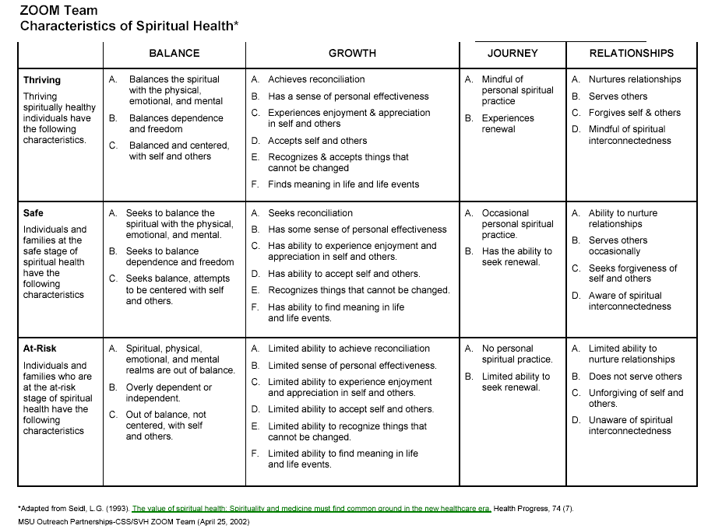

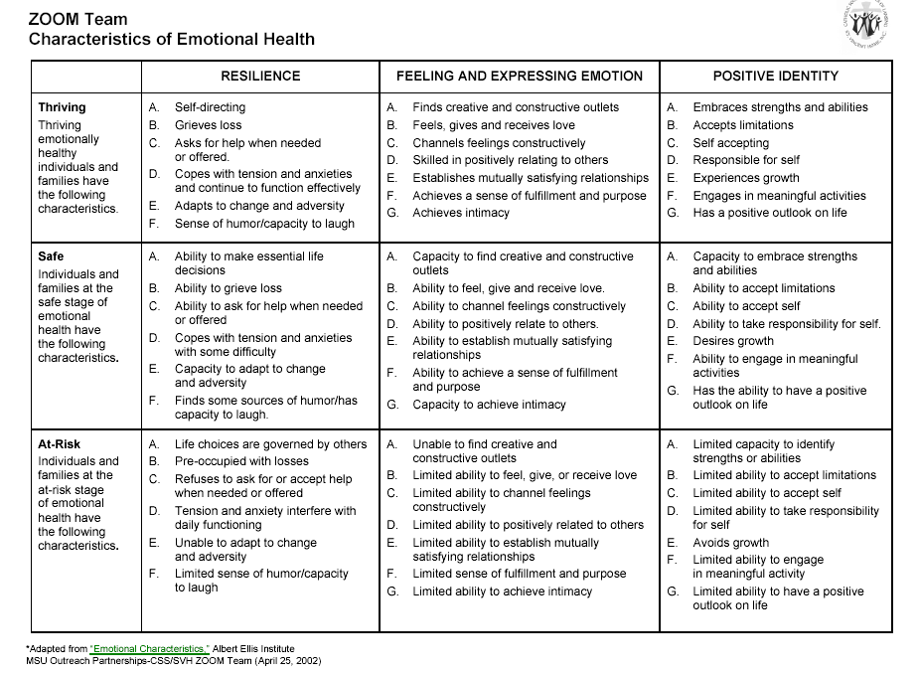

LEARNING COMMU ITIES BACKGROUND RESEARCH

KNOWLEDGE ECOLOGY/ECONOMY-MAKING MEANING

Knowledge management in education –ISKME 2003

Barriers to information use
- Time
- Lack of uniformity in dat collection
- Leadership
- Integration of technology
- Unclear priorities
- Distrust of data use
  - people and systems who use and manipulate data for their own purposes

Evidence based decision making / technology storage and retrieval

KNOWLWDGEMANAGEMENT SYSTEMS
- People (Share what they know and what they are learning)
  - Community of practice
    - Collegial ,professional team work across levels and silos
    - Relationships ,trust and expertise
    - Shared repertoireof resources,tols and artifacts
- Proceses ( get what you need ,when you need it in a form that is useful)
  - Administrative
  - Curriculum development
  - Information sharing protocols and practices ,mechanisms
    - Knowledge assessments ,audits,maps,improvement plans
  - Information silos
- Technology and Information systems
  - Accesibility
  - Tracking across setting/system

KNOWLEDGE MANAGEMENT CONTINUUM
- Data
  - Facts and quantitative measures
- Information
  - Interpretation and presentation
  - Patterns ,causes ,relationships
- Knowledge
  - The private and public understanding that develops as people use available information

PRACTICAL ASPECTS
- Language SETs the scene –collegial ,team work ,topdown/bottom up
- Actions determine success
  - Dysfunctional areas
- People make the difference
  - While higher order goals( help kids ) are important WIIFM factor ( whats in it for me) needs to be clear
- The focus is always kids learning ,
  - Who is
  - Who is not
  - In what areas
  - What feedback loops to inform teachers and their teaching
- Balancing the burden of recording
  - What produces highest levels of frustration and wasted time?
  - Which ones are central to delivering the mission
  - Who does this stuff?
    - Sharing processes and the administrative organisation to achieve this
      - Meetings bloody meetings !!!
      - Who gets to sit around the table /
      - What incentives are there to hoard or share data?
- Technology to automate NOT drive the processes
  - The exchange of information is a social process people either use or don’t use technology
  - Track data over time
  - Quick retrieval and use of data to inform knowledge creation and focussed action

- The cycle never ends .Model data/information /knowledge /action /reflection ad infinitum
  - When the real ownwers of the knowledge get nervous –then we are beginning to use the 80/20 rule ;self management ,collegiate accountability for US –NOT for Them ( whoever they are ??)

Sustaining the Ecology of Knowledge
by John Seely Brown

Leader to Leader, No. 12 Spring 1999
From simply making products and services to making sense. Increasingly, leaders are becoming sensemakers, whether for customers, employees, or investors. How do you interpret the market? How do you sort out the forces reshaping the competitive landscape
From established rules of engagement to self-determined rules. Organizations in every field are seizing opportunities to create
But ecologies cannot be designed; they can only be nurtured. The key to nurturing these ecologies is finding the balance between spontaneity and structure. People need both
Some organizational researchers, for instance, characterize knowledge as sticky (subject to hoarding and difficult to move); others describe it as leaky (inherently mobile and difficult to confine).

NETWORKING AND ALLIANCES

RANJAY GULATI 2001

Routines ,systems,operational procedures,relationships that make an alliance work

- Internet barriers
- Strategic convergence of intent ,processes ,outcomes ,rewards
- Trust
  - Affect based
    - Personal ties
    - Similar values and cultures
    - Company culture
  - Incentive based
    - Reputation
    - Mutual hostage
    - Penalties for cheating
  - Information based
    - Information exchange
    - Signalling intent
  - Process based trust
    - History of positive experiences
    - Testing with progressively larger risks
- Tactics
  - Communication
    - Multilevel,formal,informal
  - Cooperation
    - Joint problem solving,solution developmenyt and implementation
  - Contract
    - Clarity of terms of engagement
    - Vehicle to shareexpectations and assumptions
  - Compliance
    - Flexibility in going beyondwritten contract
    - Periodic review of alliance agreement
  - Conflict
    - Ways to manage
  - Completion
    - Exit strategies

Networking @ work

Wayne Baker
Cohesive and expansive networks
3 degrees of sparation
Tact knowledge social dimensions

Human systems from Union shopper

Strategic Knowledge alliances –Deepak Bhootra
- Nine I’s for successful WE’s
  - Individual excellence to bring something of value
  - Importance fits each others atrategic goals
  - Interdependence we need each other
  - Investment tangible commitment to resources
  - Internaization embed in daily work
  - Information open
  - Integration connect at a number of levels
  - Institutionalisation formal status beyond individuals
  - Integrity

Towards Excellence for effectivealliances Involved in transition from school Celebrating Community Partnerships
Enterprise and career education foundation . The effective alliance transition mix

COMMUNITY DEVELOPMENT

A Community Partnerships Resource:

Supporting young people through their life, learning and work transitions

Learnings from the CAT and POEM Pilots 2004

- All stakeholders in the community are responsible for working in partnership to support young people to make decisions about their futures, and in their transitions from dependency to active community participation;
- Local solutions to local problems are effective because they can be designed to suit the local context. Local ownership of initiatives also encourages participation and commitment;
- Community partnerships work best if they have clearly stated, shared and agreed goals, strategies, outcomes and accountability requirements, with all stakeholders working together to achieve common objectives;
- Bringing about change at the local level requires flexible guidelines in government-funded initiatives, with the provision of assistance, support and ideas for those communities that need it;
- Effective partnerships include young people and their families in decision-making processes;
- Young people are often portrayed in a poor light in media and the community, which can exclude them from participating in their communities. Opportunities are therefore needed for young people to participate in decision-making and to develop leadership skills;
- Learning pathways plans are needed to help young people address transition issues as they arise, and should be developed from age 13 onwards.

The Taskforce also suggested that although there is a range of services available at the local level to assist young people and their families, people often struggled to find relevant services and gain access to them. The report went on to suggest that more effort needed to be directed towards building community partnerships, in order to create sustainable transition support networks that could assist young people at the local community level.
The CAT Pilot projects employed dedicated Career and Transition Advisers to explore methods for enhancing career and transition support to all young people aged 13-19 years. Projects built partnerships to support young people’s transitions, and tested ways of tracking the transitions of young people after they left school.
The POEM Pilot projects trialled new ways of engaging young people (who had become disconnected from mainstream education, and possibly their families and communities as well), in community learning environments. All POEM projects focused on providing education, training and support in settings where vulnerable young people felt comfortable; using approaches that were developed in consultation with young people and their families, and that took into account their preferred learning styles and cultural, social and physical needs.
Both the CAT and POEM Pilots used a community partnership model to work collaboratively with local stakeholders,
In the CAT Pilot, committees were established to facilitate community participation, and these were known as Community Partnership Committees (CPCs). The POEM Pilot called their committees Steering Committees. Local partners included local businesses and industry, schools, TAFE, other education institutions, local government, health and community agencies, Centrelink, Juvenile Justice and Job Network members, to name just a few. Working together, project staff, teachers, youth support workers, and community partners developed a range of successful strategies for meeting young people’s education and career and transition support needs through partnerships.
Both CAT and POEM Pilot sites also employed Learning Pathways Plans (LPPs) to assist young people to articulate their career and transition goals and support needs. such as the young Some projects also incorporated contact information for local service providers so that young people knew where they could go for further assistance.

The Pilot projects worked within an action research framework, which is an innovative model that allowed projects to learn and modify their delivery of programme objectives as they went along, changing and enhancing individual elements as their knowledge and experience grew.
This resource is based on the lessons learned by the CAT and POEM Pilots about creating successful community partnerships to enhance career and transition outcomes for all young people and education outcomes for those young people who have fallen out of school.
Career and Transition Services Framework – Supporting Successful Futures for Young People - endorsed by the Australian, State and Territory Governments. The types of activities and key factors include:
Community partnerships benefit both young people and the local community
Address young people’s personal needs before focusing on their educational needs
- addressing young people’s personal needs so they can concentrate on learning and experience positive educational outcomes;
- building trusting relationships between young people and significant individuals and organisations;
- developing and delivering accredited yet flexible education and training to promote smooth transitions into mainstream schooling, further education and training, employment, or other community activities;
- having dedicated staff with skills to support young people in developing social competence and self-esteem, enhancing their understanding of the value of further learning, and increasing their ability to make informed decisions about their futures;
The Anglicare POEM project in the ACT partnered with Youth in the City , to address the personal needs of young people as a foundation to them making successful transitions. The young people had access to all of the services offered by Youth in the City including information, support, advocacy, referrals, internet café, recreational facilities and holiday programmes.

- providing young people with community resources (such as recreation centres, computer equipment, music and sporting facilities), which allows them to experience new outlets, explore undiscovered talents and develop new skills;

In action
- involving employers and employment services in providing assistance and advice on issues including interview skills, resume writing and employer expectations;
- organising workplace visits and work experience placements;
Link into community events in order to promote the transitions of young people
- facilitating education and training days and visits to universities or TAFE campuses to familiarise young people with future learning environments;
- improving joined-up services between partners, resulting in better case management; and
- linking into other community events that have a youth focus.

Even though the rhetoric of partnerships and collaboration is often strong in organisations, it may be difficult to operationalise on the ground without ‘top-down’ support. While this can be a significant challenge for local projects, the creation of environments which support both ‘top-down and ‘bottom-up’ planning can have great benefits, and the time invested in overcoming these challenges is often time well spent

Community or market: covenant or contract?
Richard Cotter
Senior Fellow, Centre for Organisational Learning and Leadership, University of Melbourne.

CURRICULUM LEADERSHIP Volume 2 Number 29 2004

Community is frequently distinguished from the larger society, which may be an extension of the community but clearly has a different framework organised around a range of corporate organisations and institutions, private and public. In broad terms, community is constituted by relationships and commitment; society operates on laws and enforceable contracts.
The larger society is defined by the contract, with its social, economic and legal dimensions, whereas the ‘covenant’ provides the glue for community. The principle of the contract provides a framework for the modern market economy: we all get what is our due; we pay what we owe and we have recourse to a legal framework to get what we are contractually owed. Basically our obligations under a contract are conditional on what other parties can legitimately claim, and legitimacy is regulated by published rules.

Strengthening Links between Schools and Communities

Jim Cavaye

Cavaye Community Development

School at the Centre in
Queensland.

1. Community as a Source of Student Curriculum Based Learning

Incorporating Learning into School Contribution to Communities
Students contributing to their local community can foster learning. For example, a
community volunteering program allows students to experience community service and
gain skills.

3. Community Involvement in the School
Community members can add to the life of the school and to educational outcomes.
Several schools have established community mentors that participate in classroom
interaction and school activities.
Schools have also been seen as centres for community learning where community
members and organisations can assess school facilities for meetings and learning
activities.

4. The Role of Teachers
Community linkages can help orient new teachers. Community situations can also be
used in the professional development of teachers. Teachers may also play a role in
assisting community organisations or in helping the local community manage local
issues.

Stage 1. Introduction and Scoping

Stage 2. Assessing the Current Situation and Potential Options

Stage 3. Planning and Action

Stage 1. Introduction and Scoping
Initial personal discussions with the school
Identification of key local community members
One on one discussions with key community
members
Scoping/planning meeting
Visit be
Facilitator
Stage 2. Assessing the Current Situation and Potential Options
Community Engagement Activities
Collation of Feedback
Stage 3. Planning and Action
Planning Workshop - school and community
representatives
Formation of working groups
Visit by
Facilitator
Specific Actions
Stage

Cavaye J.M. (2000) The Role of Government in Community

Capacity Building. Department of Primary Industries and Fisheries Information Series

QI99804. Queensland Government. 2000.

Principles
Developing government’s role in community capacity involves the following principles:
• Creating a “vehicle” for local people to express and act on existing concerns,
• Judging appropriate interaction with communities from “consultation” to genuine
partnership and facilitation,
• Personal relationships between local public servants and community members is crucial
to the invitation government can receive from local people, and the role government can
have in community capacity,
• Melding formal “structures” that mediate community involvement with a grassroots
culture of local participation.
• Community members “unlearning” the role of government solely as a “provider” and
government “unlearning” the historical technical assistance approach to communities.

New Approaches
The following new approaches are needed:
• Redefining the “real work” of public servants to not only be the delivery of delegated
services but also a dual “delegation and community” role where delegated work is
achieved in a way that supports community networks, partnership and capacity.
• A dual “delegation and community” role maintains public servants within their field of
expertise or responsibility. It can enhance the value of technical expertise and reduce
3
potential conflict between multiple functions of agencies, e.g. research, extension,
regulation.
• Fostering relationships between community members and government workers by
increasing the “ networking” role of public servants in communities and initiating contact
with a greater diversity of clients.
• Introducing accountability for the process with which government interacts with
communities, and accountability for community capacity outcomes. This involves
established qualitative methods of assessment - appropriate performance indicators and
methods of measurement are given.
• Coordination between agencies based on valuing existing cooperation, common goals
and values, and joint projects.

A dual service delivery/community capacity role obliges government agencies to go through
the same process of capacity-building as the communities they serve.

Governments =Technical assistance is development in or for the community, rather
than development of the community.

Some
government approaches to “ develop” communities using technical assistance can
disempower local people, create dependency, and suppress local organisation and leadership.

High High “ Competent” Community-oriented
economic social community government
development capital

Innovation and the knowledge economy: the potential for learning partnership strategies Heather Peirce 2004-09-23
- there is no consensus on definition of learning partnerships
  - have a strategic purposefulfocus with mutually beneficialrelationships /outcomes
  - linking up resources for social and human capital
  - enterprise =
  - renewal and reskilling
  - learn together work together

LEADERSHIP

A way forward

Michael Fullan “The new meaning educational change /of school reform’
  - making meaning NOT structures
    - coherence
    - connectedness
    - synergy
    - alignment
  - cultural change
    - continuous improvement 3/5 year cycle
    - schools as moral change agents
  - rule of thirds
    - interactive communities of practice –self initiated reconstruction
    - struggle /comply
    - left behind
  - WHAT WE NEED TO DO IS 25% OF THE FOCUS
  - HOW WE DO IT IS 75%
    - Processes and conditions
      - Pressure and support
      - The science of muddling through
      - Ownership and engagement
      - Clarity and commitment
      - Cope with unpredictability,conflict and inconsistency
  - Teachers under unprecedented stress
    - Teaching as a collective not individual enterprise
      - Moral obligation of local group of peers
      - Mutual respect trust and value congruence
    - Teachers make 30 % of variance in student learning
      - Teacher skills
      - Class climate
      - Professional characteristics
        - Hold high expectations
        - Passion for improvement
        - Holding the team of people accountable
    - Principals provide the conditions
      - Clarity of values and intent
      - Relationship centric
      - Individual accountability
      - Forever hopeful

Margaret Wheatley
  - Sponsor thinking
  - Cultivate presence on things they really care about
  - Rely on diversity
  - Apply rationality to what we do
  - Give voice and space to others
  - Invitation extended to many
  - I don’t know what the answers are but together we will figure it out and fix it
  - Focus on the common areas

Principal ship of the future Jenny Lewis 2001
- Platforms
  - Open and professional culture
  - A learning community
  - Systematic practical and theoretical approach to teaching
  - Shared responsibility and acountability

The New Leadership Challenge

Vicki L. Phillips

Pennsylvania Secretary of Education
Practice these understandings in an uncommon way. . .

Keep students at the center of decisions
Take strategic, purposeful risks
Explore new possibilities and thinking
Accept challenges as opportunities
Problem-solve long-standing issues
Act with courage
Build relationships and trust
Know others as learners
Be visible, approachable, emotional
Use the power of “tensions” to leverage and sustain improvement

Demand and support
Proven and innovative practice
The next change and sustained improvement and stability
Equity and diversity
Centralized direction and empowered autonomy
Near term and long-term goals and strategies

SOCIAL CAPITAL
Research Paper No. 31, April 2003

Social capital at work

How family, friends and civic ties relate

to labour market outcomes

Wendy Stone, Matthew Gray and Jody Hughes

Research Paper No. 31, April 2003

Summary of key findings
In terms of the link between social capital and labour force status, using the core
network measures approach, we found that within the informal realm there are
few significant relationships between social capital and labour force status.
Where effects are significant they are small in size. The only exception is the
variable measuring the extent of employment among one’s friends. In contrast,
social capital type is found to be strongly and statistically significantly related to
labour force status. The social capital poor are more likely than any of the other
social capital groups to be not employed, and if employed to be much more
likely to be employed part-time. The informal emphasised social capital group
are the most likely to be employed, and if employed are substantially more likely
to be full-time employed than the other groups.
One of the limitations of this analysis is the difficulty in determining causation.
While we found significant relationships between social capital type and labour
force status, it is impossible to determine to what extent the relationship is causal.
Analysis of the relationship between social capital and job search does allow us to
comment more confidently about the causal relationship between social capital
and labour market outcomes at the individual level. Overall, consistent with
other literature we find both informal and formal channels are important for
successful job search. Additionally, our findings suggest that while it is customary
to divide the channels through which information about job opportunities is
obtained into two categories, formal and informal (Norris 1996), a more finegrained
classification of network types, according to their role in successful job
search that includes “professional contacts” as a key category, is useful.
In terms of network characteristics and relationship quality, we find few
significant relationships between the measures of social capital in the informal
realm and job search, the exception being network diversity which increases the
likelihood of a person gaining work via family or friendship connections.
Similarly we find little relationship between generalised or institutional social
capital variables and job search method – with the important exception that
having a breadth of institutional connections increases the probability that jobs
will be found through professional contacts.
In contrast with the analysis using core measures of social capital, measures of
social capital type are found to be strongly statistically significantly related to
Australian Institute of Family Studies Research Paper No. 31, April 2003 22
job search method, pointing to the usefulness of the typology approach for
explaining outcomes at the individual level. The differences found are striking,
particularly in the differential rates at which jobs are found through professional
contacts and family and friends. The job search methods used by the social
capital poor demonstrate this. Respondents in this type rely on informal
channels to a far greater extent than any other social capital type and are
considerably less likely to gain employment through professional contacts.
Concluding comments
Combined, these findings point to several key conclusions. First, the analysis
indicates that social capital does have some role to play in determining labour
force status, but perhaps not in ways that might be expected. For example, our
second key finding is that whereas trust is often thought to be the aspect of
social capital that is critical to achieving a range of outcomes, we find it is the
characteristics of networks that are more important in predicting labour force
status and job search method.
These findings are in part consistent with the “strength of weak ties” theory
(Granovetter 1973, 1974). Most notably, professional contacts were an important
means of finding employment. However, this was not the case for everyone. In
fact, the paper suggests that the “strength of close ties” is particularly important
for those with limited social capital and more vulnerable ties to the labour market,
where friends and family were relatively important in finding employment.
Restated in terms of the bonding, bridging and linking social capital
classification, these findings point to the important role both bonding and
bridging forms of social capital can play in determining labour force outcomes.
Bonding ties appear more important for those with limited connections,
whereas for others bridging ties (such as professional ties) are useful. An
exception relates to network diversity; here, informal networks comprised of
members with diverse levels of educational qualifications appear to increase the
bridging capabilities of social capital, and increase the likelihood of successful
job search through friends and family.
However, what we also find is that it is not one type of network or network
characteristic that alone predicts labour force outcomes. Rather, our findings
suggest that it is the combination of various types of social capital that is important
in determining labour market outcomes rather than the core dimensions of social
capital in informal, generalised and institutional realms treated separately.
Related to this is a further finding. It is that when we use the social capital
typology, we find an interaction effect between a person’s socio-economic status
and the types of social capital they have, and the impact of these two factors on
labour market outcomes.
Pursuing this argument further, we can draw a final key point. While social
capital does relate to both the labour force status and the job search methods
people use, it does this unevenly. Social capital may act to mirror or exacerbate
existing inequalities or differences between people from higher and lower socioeconomic
circumstances, in terms of their labour force outcomes. As already
mentioned, it is likely that the use of friends and family connections by those
from low socio-economic backgrounds for finding jobs is less likely to result in
high quality work, than for those from higher socio-economic circumstances,
who would be more likely to use professional contacts. Similarly, those out of
the labour force are less likely to have existing ties to paid work.
The extent of these differences and inequalities is a topic worthy of further research.
What this paper has shown is that people’s social capital varies, and that these
different social capital profiles relate to different types of labour force outcomes.
Research Paper No. 31, April 2003 Australian Institute of Family Studies 23

CULTURAL CHANGE

Teachers workplace – The social organization of schools

- School Reform
  - Shared goals
  - Teacher collaboration
  - Teacher learning ( principal the posture of a burrowing animal??)
  - Teacher certainty
  - Teacher commitment
  - District support

The choice is between a professional,egalitarian culture whose visible hands
    - Nourish teachers with technical growth
    - Optimism
    - Spirited inventiveness
    - Liberty from classroom failure
    - OR
      - More unyielding bureaucracy
      - Teacher empowerment as threat

There is reason to doubt that teachers are either willing or preparedto surrender classroom isolation for collaborative relations

A primer in diffusion and innovation theory Roger Clarke
- Knowledge
- Persuasion
- Decision
- Implementation
- Confirmation

Characteristics of an innovation
- Relative advantage
- Compatibility with values ,past experiences and current needs
- Trialibility
- Observability of results
Adopter categories
- Innovators
- Early adopters
- Early majority
- Sceptics
- Laggards

Roles
- Opinion leaders
- Change agents
- Change aides ( may be less compentence but more local trust )

Kirtons adaptive /innovation theory
- Spectrum of creative styles
  - Adaptor /innovator
  - Insiders and outsiders
  - Organisational climate

Spread of irrational behaviours by contagion Derek Gatherer

Quality of life model Centre for health promotion
- Being who one is
  - Physical
  - Psychological
  - Spiritual
- Belonging connecting with ones environments
  - Physical
  - Social
  - Community
- Becoming achieving personal goals,hopes and aspirations
  - Practical
  - Leisure
  - growth

The development of progressive and sustainablehuman complex adaptive systems-Kiersten blair Johnson

Institutions
- legal and political framework
- structural characteristics
  - legitimacy public acceptance and trust
  - Integration cooperation across groups
  - Decentralization
  - Efficient communication
  - Stratification just rewards
  - Differentiation specialization /disintegration
Organisations
  - Organisational theory
    - Systems theory
    - Contingency theory context specific
      - Mechanical
      - Organic

communities

Innovation and best Practice project DEST

What do adults need to learn ?
- WHAT
- HOW
- WHO
- WHEN
- WHY
- THAT

THE 24/7 INNOVATIONS GROUP
- RETHINK
- RECONFIGURE
- RESEQUENCE
- RELOCATE
- REDUCE
- REASSIGN
- RETOOL

Kurt Lewin
- Disconfirmation
- Induction of guilt or survival anxiety
- Create psychological safety to get over inertia above
- Cognitive redefinition
- Imitation of a role model
- Scanning
- Personal refreezing

SCHOOL REFORM
Today, innovations abound in public schools: merit pay, school-site councils, decentralized authority, magnet schools, individual instruction, alternative education, preschool programs, charter schools, before- and after-school interventions, non-graded instruction, team teaching, smaller schools, the hiring of non-traditional superintendents and mentoring programs.
In addition, 49 states have developed new performance standards, and most are on their way to developing assessment systems, tougher definitions for teacher quality, a framework that will disclose more student-performance data than ever before and provisions for communities to hold their schools and policymakers accountable. How much more innovation can we ask public schools to undertake?
Deluged by a torrent of new ideas, school boards and administrators often buy into any innovation that even remotely claims to raise test scores, whether proved or not.
reformers and special-interest groups have an obligation to take each other's ideas seriously and create coherence from the remnants of the many innovations that litter the landscape of school improvement.
The Waltons -- the USA's richest family -- have quietly become top philanthropists in education reform, including controversial charter-school and school-voucher causes. They have donated at least $701 million to education charities since 1998.
That pales beside the $1.05 billion given to education by the Bill & Melinda Gates Foundation. But the Waltons' giving could soar to as much as $1 billion a year as they shift more riches to charity. How much more? John Walton, one of founder Sam Walton's four children, says the family expects to donate as much as 20% of its $100 billion in Wal-Mart stock.

Approaches

- Accelerated Schools
- America's Choice
- ATLAS Communities
- Audrey Cohen College: Purpose-Centered Education
- Basic Schools Network
- Coalition of Essential Schools
- Community for Learning
- Co-NECT
- Core Knowledge
- Different Ways of Knowing
- Direct Instruction
- Expeditionary Learning Outward Bound
- The Foxfire Fund
- High Schools That Work
- High/Scope K-3 Model
- League of Professional Schools
- Modern Red Schoolhouse
- Onward to Excellence
- Paideia
- Roots and Wings
- School Development Program
- Success for All
- Talent Development High School with Career Academies
- Urban Learning Centers

Basic Schools defines five educational goals for students. After receiving a Basic Schools education, students should: 1) be able to communicate effectively; 2) have acquired a core of knowledge; 3) be motivated learners; 4) feel a sense of well-being; and 5) live responsibly.

COMMUNITY FOR LEARNING
Evidence of positive effects on student achievement
Year introduced in schools | 1990
Number of schools | 92
Support developer provides schools
First-year costs  with new staff  with current staff reassigned | $157,000  $82,000

Community for Learning encourages the coordination of classroom instruction with community services (e.g., health, libraries, social services, and law enforcement) in an effort to improve individual student learning. The approach is based on research on the influence of school, family, and community on student learning
Effects on Students. Evidence of positive effects on student achievement is promising, based on the outcomes from five studies
Core Knowledge is based on the premise that people need a common base of knowledge to function well in a democratic society, and that schools are responsible for providing this base to every student.

The goals of Different Ways of Knowing are to raise academic achievement and improve students' attitude toward school. The developer advocates building on the "multiple intelligences" of students, to develop their skills in various domains (e.g., logic and mathematics, language, social skills, and artistic skills). According to the developer, the approach is built around a variety of research bases, including: cognitive research, the effects of early and sustained intervention, and research on motivation and classroom environments

