SWEBOK Chapter 2

Software Requirements
This chapter begins by defining the software requirements knowledge area as” being concerned with the elicitation, analysis, specification, and validation of software requirements.”
A software requirement is a property which must be exhibited in order to solve some problem in the real world.
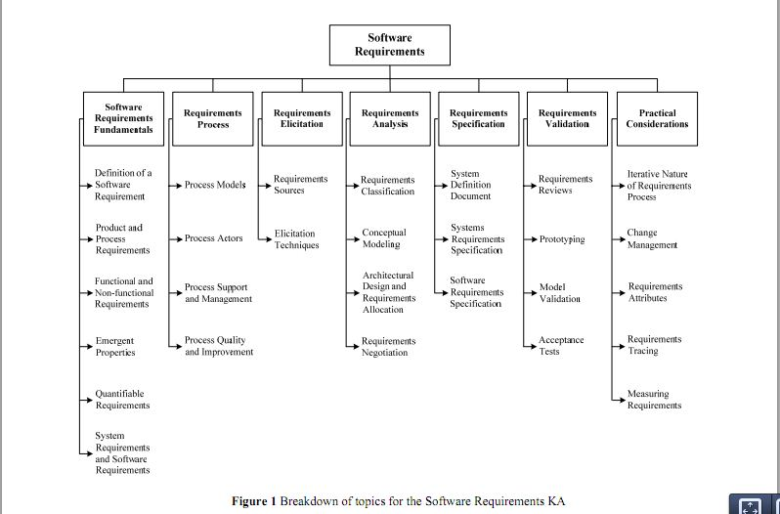
- They are typically a complex combination of different requirements from different people in the developing organization and the user environment.
- Requirements must be verifiable and often have an associated priority rating, status value (for monitoring progress throughout the development process), and unique identifier.
- Software requirements should be stated clearly, quantitatively, and unambiguously.
Requirements can be categorized in different ways.
- Process vs. Product requirements--Product requirements are parameters on software to be developed while process requirements are constraints on the development of the software. Process requirements may be imposed directly by the development organization, their customer, or a third party such as a safety regulator.
- Functional vs. Nonfunctional requirements--Functional requirements describe the functions that the software is to execute, its capabilities. Nonfunctional requirements describe constraints on the solution, its quality requirements—such as performance, maintainability, safety requirements, reliability, or others.
- Emergent properties--Requirements which cannot be addressed by a single component, but which depend on how all the software components interoperate.
- System vs. Software requirements—System requirements are parameters for the system as a whole including hardware, software, firmware, people, information, techniques, facilities, services, and other support elements. Software requirements are derived from system requirements.
The requirements process involves
- Process models--how the activities of elicitation, analysis, specification, and validation are configured for different types of projects and constraints.
- Process Actors-- the stakeholders in the project are identified, the nature of their “stake” analyzed, and their requirements elicited. Stakeholders include:
Users: those who will operate the software.
Customers: those who have commissioned the software or who represent the software’s target market.
Market analysts: those who establish what the market needs and to act as proxy customers for a mass-market product.
Regulators: those who enforce regulatory requirements.
Software engineers: those who develop the software.
- Process Support and Management--the project management resources required and consumed by the requirements process such as funding, human resources, training, and tools.
- Process Quality and Improvement--the assessment of the quality and improvement of the requirements process particularly in terms of the cost and timeliness of a software product, and of the customer’s satisfaction with it.
Steps in the requirements process include:
- Requirements Elicitation--where software requirements come from and how the software engineer can collect them.
Effective elicitation requires good communication between software users and software engineers.
All potential sources (goals, domain knowledge, stakeholders, operational environment, and organizational environment) must be identified and evaluated for impact on the software.
Elicit requirements using interviews, scenarios, facilitated meetings, and observation.
- Requirements Analysis--analyzing requirements to detect and resolve conflicts between requirements, discover the bounds of the software and how it must interact with its environment, and elaborate system requirements to derive software requirements using:
Requirements classification
functional v. nonfunctional
derived from high-level requirement or imposed by stakeholder
product or process requirement
priority
scope (narrow or global)
volatility/stability
Conceptual modeling to aid in understanding the problem. Choice of model will depend on the nature of the problem, the expertise of the software engineer, process requirements of the customer, availability of tools and methods.
Control flow
State models
Event traces
User interactions
Object models
Data models
Architectural design and requirements allocation The point at which the requirements process overlaps with software or systems design. It involves identifying the components that will satisfy the requirements and describing the architecture from multiple viewpoints.

Requirements negotiation Also known as conflict resolution between two mutually incompatible features.
- Requirements Specification—a description of requirements precisely enough to enable the requirements to be validated, their implementation to be verified, and their costs to be estimated.
Complex systems may include system definition, system requirements, and software requirements. Simple systems only require software requirements.
Software requirements:
Define what the software is expected to do and what it is not expected to do
Provide a realistic basis for estimating costs, risks and schedules
Are useful for validation and verification plans
Provide a basis for transferring the software to the customer
Provide a basis for software enhancement
Written with formal or semi-formal descriptions using agreed upon notations (like UML)
- Requirements validation—occurs at one or two points in the requirements process where validation takes place to pick up problems before resources are committed.
Requirements reviews A group of reviewers looks for errors, mistaken assumptions, lack of clarity and deviation from standard practice.
Prototyping Reveals a software engineer’s interpretation of the requirements and elicits new requirements.
Model validation The quality of a model is evaluated.
Acceptance Tests All requirements must be able to be verified.
- Practical Considerations—requirements documentation and change management are key to the success of any requirements process
Iterative nature of the requirements process
Change management
Requirements attributes
Requirements testing
Measuring Requirements

