Subject: ACS 560- Software Engineering
Name: Ekaterina Schwartz
Subject: Guide to SWEBOK- Software Requirements KA
Purpose: Summary of Software Requirements KA
Advisor: Dr. John Tanik
Date: 09/08/2011

The Software Requirements Knowledge Area involves elicitation, analysis, specification and validation of software requirements. As such, they convey the needs and constraints on a software product for the solution of a real-world problem. The Software Requirements KA is closely related to the Software Design, Software Testing, Software Maintenance, Software Configuration Management, Software Engineering Management, Software Engineering Process and Software Quality KAs. The Software Requirements Knowledge Area incorporates seven sections as follows:

- Software Requirements Fundamentals
The Software Requirements Fundamentals section includes the following subsections: Definition of a Software Requirement, Product and Process Requirements, Functional and Nonfunctional Requirements, Emergent properties, Quantifiable Requirements, and System Requirements and Software Requirements.
A software requirement is defined as a property that must be exhibited by the developed software to solve a particular problem. The requirements on software are usually requirements from different people of an organization and the environment in which the software will be used. It is essential that software requirements be verifiable. In addition, software requirements have attributes, such as priority ratings that can aid in decision making in view of finite resources.
The guide defines product parameters as requirements on the software to be developed; whereas, process parameters are a constraint on the development of the software, also known as process requirements.
Functional and Nonfunctional requirements section of the KA describes functional requirements as the capabilities of the software. Nonfunctional requirements are described as constraints or quality requirements, such as: performance requirements, maintainability requirements, safety requirements, etc.
Requirements with emergent properties are described as requirements which cannot be addressed with one component, but are depended on the interoperability of all the software components. Such properties are depended on the system architecture. The last subsection of the Software Requirements and Fundamentals distinguishes between system and software requirements. System requirements are requirements for the whole system. Software requirements are derived from the system requirements.

- Requirements Process
This section introduces the software requirements process and includes the following subsections: Process Models, Process Actors, Process Support and Management, and Process Quality and Improvement.
The subsection of Process Models is concerned with the way elicitation, analysis, specification, and validation are configured for different types of projects and constraints. Process Actors identifies the roles of the people participating in the requirements process. Such include users, customers, market analyst, regulators, and software engineers. The topic of Process Support and Management makes a link between the process activities and issues of cost, human resources, training, and tools. Process Quality and Improvement is concerned with the assessment of the quality and improvement of the requirements process. It stresses the importance of the requirements process in terms of cost, timeliness, and customer satisfaction.
- Requirement Elicitation
The guide identifies requirement elicitation as the first step towards gaining understanding of the problem that the software is needed to solve. It is important to identify and evaluate all possible sources of software requirements. Of importance are:
- obtain the business concern
- gain knowledge about the application domain
- identify, represent and manage viewpoints of stakeholders
- identify operational environment
- identify organizational environment
The Elicitation Techniques subsection is concerned with getting human stakeholders to articulate the software requirements. Such techniques include interview, scenarios, prototypes, facilitated meetings, and observation.

- Requirements Analysis
The Requirements and Analysis includes the following subsections: Requirements Classification, Conceptual Modeling, Architectural Design and Requirements Allocation, and Requirements Negotiation. Requirements can be classified by functionality (functional or nonfunctional), emergent, directly imposed by a stakeholder, product or process requirements. Also, requirements can be assigned a priority, often on a fixed scale. The scope of the requirement refers to the extend the software components are affected by it. Requirements can be classified by their volatility/stability, which is the likelihood that a requirement will change. Conceptual Modeling is identified as the development of models used to assist in understanding the problem. The nature of the problem, the expertise of the software engineer, the process requirements of the customer, and the availability of tools determine the type of model implemented.
Architectural Design and Requirements Allocation subsection defines architectural design as the overlap between requirements process and software or system design. Requirement allocation is the process of assigning to components the responsibility of satisfying requirements. Allocation permits analysis of requirements, to investigate on how the component needs to interact with other components to satisfy the allocated requirements. The Requirements Negotiation subsection is concerned with the resolution of requirement conflicts, such as stakeholders requiring two incompatible features.

- Requirements Specification
The Requirement Specification section of the guide includes subsections on: System Definition Document, System Requirements Specification, and Software Requirements Specification. Requirement specification consists of documentation that is systematically reviewed, evaluated and approved. Three types of documents may be produced: system definition, system requirements, and software requirements. The System Definition Document states system requirements and background information about the objectives for the system. When system requirements are specified, the software requirements are derived from the system requirements. Software requirements specification provides for additional assessment of requirements before design can begin, reducing later redesign. It also provides basis for product costs estimating, risks, and schedules.

- Requirements Validation
The Requirements Validation section includes subsections on Prototyping, Model Validation, and Acceptance tests. Requirement validation is implemented to ensure that the requirements have been understood, thereby preventing waste of resources. There are a variety of prototyping techniques which aid in interpreting the software engineer’s assumptions about the requirements. Model Validation is the validation of the quality of the models developed during analysis.
Acceptance tests are used in validating that the finished product satisfies software requirements.

- Practical Considerations
The requirements process is ongoing through the software life cycle. Because of this span, documentation and change management are essential to the success of the requirements process. The Practical Considerations section includes the following subsections: Iterative Nature of the Requirements Process, Change Management, Requirements Attributes, Requirements Tracing, and Measuring Requirements. Understanding the requirements evolves during the software design stages, leading to the revisions of requirements late in the life cycle.
Change Management is concerned with the procedures that need to be implemented concerning proposed changes, and the analysis that should be applied on them. Requirements should include ancillary information to assist in managing and interpreting the requirements. Most importantly, requirements should be assigned a unique identifier. Requirements tracing is associated with recovering the source of requirements and the effect of requirements.
Measuring Requirements is useful in evaluating the impact of a change in requirements in estimating the cost of a development.

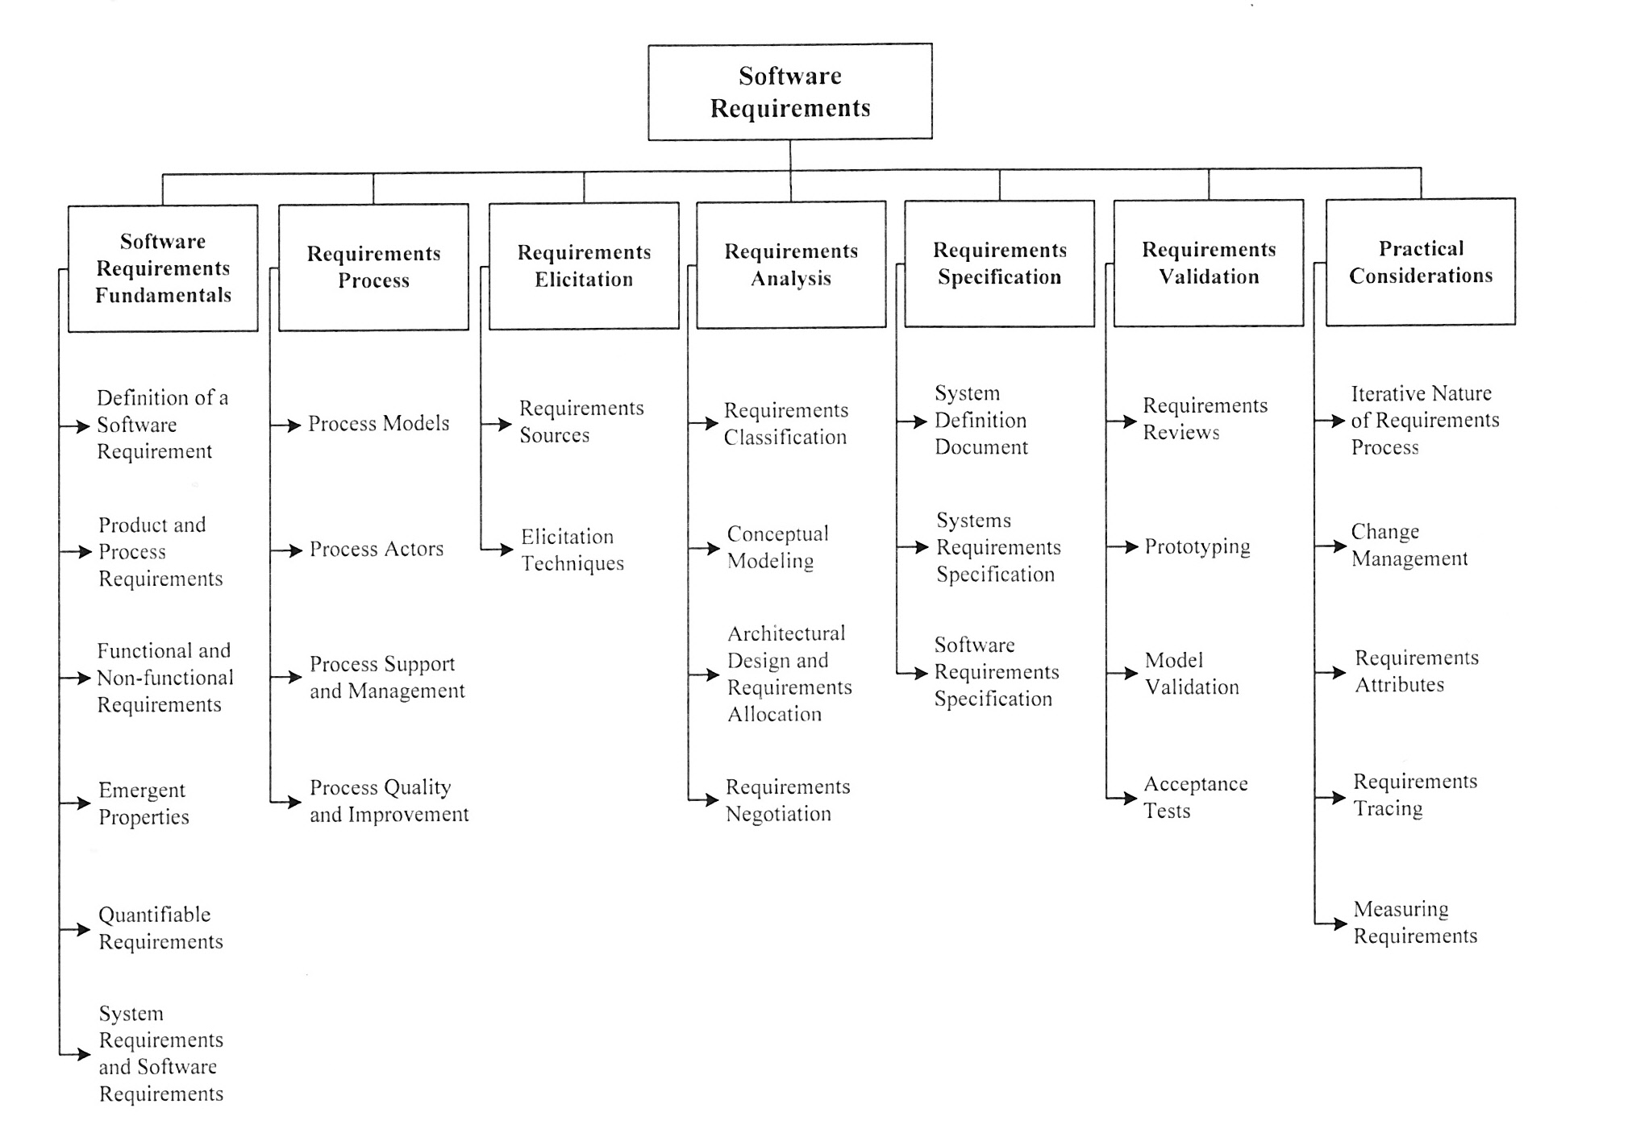
Figure 1 is a breakdown of topics for the Software Requirements from the Guide to SWEBOK.
Figure 1 Topics for the Software Requirements KA.

