Subject: ACS 560- Software Engineering
Name: Ekaterina Schwartz
Subject: Guide to SWEBOK- Software Design KA
Purpose: Summary of Software Design KA
Advisor: Dr. John Tanik
Date: 09/09/2011

The result of Software Design must describe the software architecture, specifically, how the software is decomposed, organized, and the interfaces between those components. Software design must describe each component as to enable its construction. Software design results in the production of various models that are used as input and starting point of software construction and testing. Software design consists of software architectural design and software detailed design. The Software Design KA description is related to Software Requirements, Software Construction, Software Engineering Management, Software Quality, and Related Disciplines of Software Engineering. Following is a breakdown of Software Design topics:
- Software Design Fundamentals
The Software Design section of the guide includes the following subsections: General Design Concepts, Context of Software Design, Software Design Process, and Enabling Techniques.
Design, in general, is a form of problem solving with goals, constraints, alternatives, representations, and solutions. It is imperative to understand the characteristics of software requirements analysis compared to software design, software construction and software testing.
The guide describes Software Design as a two-step process of Architectural Design and Detailed Design. Architectural Design describes how the software is decomposed and organized, whereas Detailed Design describes the specific behavior of each component. Fundamental principles, referred to as enabling techniques, are to be followed in the design process. Such techniques include: abstractions, coupling and cohesion, decomposition and modularization, encapsulation/information hiding, separation of interface and implementation, sufficiency, completeness and primitiveness. Primitiveness refers to software components capturing important characteristics only.

- Key Issues in Software Design
The Key Issues in Software Design section of the KA includes the following subsections: Concurrency, Control and Handling of Events, Distribution of Components, Error and Exception Handling and Fault Tolerance, Interaction and Presentation, and Data Persistence.
Every Software Design approach must address key quality concerns. Software must meet certain quality criteria such as: performance, decomposition, organization and packaging of software components. Aspects of software’s behavior that are not in the application domain but address supporting domains are the properties that affect performance in semantic ways. Such aspects are: concurrency, control and handling of events, distribution of components, error and exception handling and fault tolerance, interaction and presentation, and data persistence.

- Software Structure and Architecture
The Software Structure and Architecture section of the KA includes the following subsections: Architectural Structures and Viewpoints, Design Patterns, and Families of Programs and Frameworks.
The Software Architecture section describes the subsystems and components of the software’s system and their relationships. The rise of different concepts is seen in an attempt to describe and reuse generic design knowledge. Different high-level views are described and documented, which are a partial aspect of a software architecture showing specific properties of the system. Such include: logical view, process view, physical view, and development view. Software design is a multi-faceted artifact composed of independent views. The architecture style is a set of constraints on the architecture. Some of the major architecture styles listed in the guide are: general structure, distributed system, interactive system, and adaptable systems.
The subsection on Design Patterns reveals their use to describe details at the micro-architecture level, in contrast to the architecture styles, which describe the macro-architecture level.
Families of programs and frameworks allow for the reuse of software designs and components. Such are known as product lines, which are based on identifying the commonalities among families and reusing components.

- Software Design Quality Analysis and Evaluation
The Software Design Quality Analysis and Evaluation section of the KA includes the following subsections: Quality Attributes, Quality Analysis and Evaluation Techniques, and Measures.
The Software Design Quality Analysis and Evaluation section of the KA includes the following attributes of importance for the achievement of a good quality design: maintainability, portability, testability, traceability, correctness, robustness and fitness of purpose. A distinction is made between quality attribute discerned at run-time, those not discernable at run-time, and the architecture’s intrinsic qualities. Quality Analysis and Evaluation subsection includes the following techniques: software design reviews, static analysis, and simulation and prototyping. Measures are used to quantify different aspects of designs quality, structure, or size. Two broad categories of measures are: function-oriented and object-oriented design measures.

- Software Design Notations
The Software Design Notations section of the KA includes two subsections: Structural Descriptions and Behavioral Descriptions.
Different notations are used to represent software design artifacts. Certain notations are used mostly during architectural design and others in detailed design. The guide discerns two categories of notations, static and dynamic. Notations describing the structural (static) view are: architecture description languages (ADLs), class and object diagrams, component diagrams, class responsibility collaborator cards, deployment diagrams, entity-relationship diagrams (ERDs), interface description languages (IDLs), Jackson structure diagrams, and structure charts. Notations describing the behavioral (dynamic) view are: activity diagrams, collaboration diagrams, data flow diagrams (DFDs), decision tables and diagrams, flowcharts and structured flowcharts, sequence diagrams, state transition and state chart diagrams, formal specification languages, and pseudo code and program design languages (PDLs).

- Software Design Strategies and Methods
The Software Design Strategies and Methods section of the KA includes the following subsections: General Strategies, Function-Oriented Design, Object-Oriented Design, Data-Structure-Centered Design, Component-Based Design, and Other Methods.
A number of general strategies exist to guide the design process. Software design methods are more specific than strategies, as they provide a set of notations to be used. Some of the general strategies are: divide-and-conquer and stepwise refinements, top-down vs. bottom-up, data abstraction and information hiding, use of heuristic, use of patterns and pattern languages, use of an iterative and incremental approach.
Function-Oriented design is a classical method of software design in which decomposition focuses on identifying software’s major functions and in a top-down manner elaborating and refining them. Other methods include Object-Oriented Design, Data-Structure-Centered Design, and Component-Based Design (CBD) among others.

Figure 1 is a breakdown of topics for the Software Design from the Guide to SWEBOK.

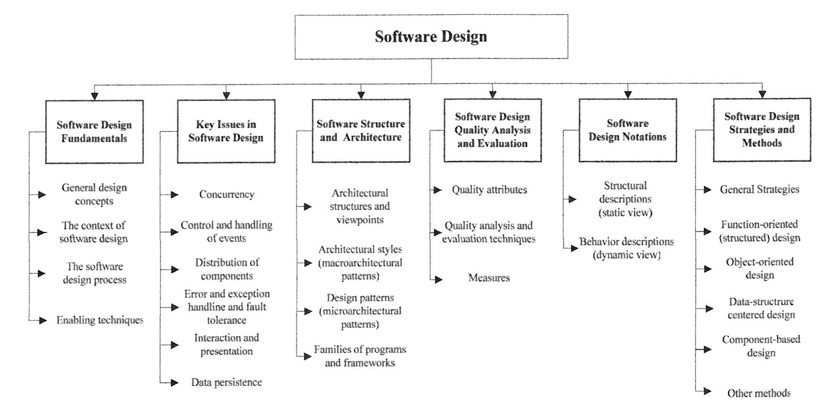
Figure 1. Topics for the Software Design KA.

