Subject: ACS 560- Software Engineering
Name: Ekaterina Schwartz
Subject: Guide to SWEBOK- Software Construction KA
Purpose: Summary of Software Construction KA
Advisor: Dr. John Tanik
Date: 09/027/2011

Software construction refers to the processes of coding, verification, unit testing, integration testing, and debugging, resulting in working and meaningful software. This KA area is strongly linked to Software Design and Software Testing knowledge areas. Software construction implements output of the design process and provides input to the testing process. In addition, much design work is performed within the construction stage as well. Software construction produces configuration items to be managed in the project, such as: source files, content, and test cases. Due to its reliance on tools and methods, the Software Construction KA is also linked to the Software Engineering Tools and Methods KA. Additionally, the Software Construction KA is closely linked to the Software Quality KA, as it produces code which is the deliverable of the project. Following is a breakdown of Software Construction KA topics:
- Software Construction Fundamentals
The Software Construction Fundamentals section of the KA includes the following subsections: Minimizing Complexity, Anticipating Change, Constructing for Verification, and Standards in Construction.
Minimizing the complexity is achieved through aiming at simple and readable rather than clever code. Complexity is also minimized through the use of standards and specific techniques. Change in software is an unavoidable aspect of software construction and is supported by specific techniques as well. Constructing for verification refers to building software such that its faults can be remedied by the engineers writing the code, during testing, or operation. As with anticipating change and minimizing complexity, specific techniques and standards are to be followed in the construction for verification process.
Standards in construction consist of external and internal standards. External standards are construction languages, tools, interfaces, and interactions between Software Construction and other KAs. Internal standards can be organizational or for minimizing complexity, anticipating change, and constructing for verification.

- Managing Construction
The Managing Construction section of the KA includes the following subsections: Construction Models, Construction Planning, and Construction Measurement.
The guide points out numerous construction models that can be implemented to develop software. Such models span from linear, such as the waterfall, to iterative, such as Extreme Programming. Management of construction is dependent on the model implemented. The choice of construction method is vital to construction planning. Construction planning defines the order of component creation, software quality management, task assignments and others. Construction measurement includes measurement of code developed, modified, reused, destroyed, the complexity of code, inspection statistics, fault-fix, fault-find rates, effort and scheduling.

- Practical Considerations
Practical Considerations section of the Software Construction KA includes the following subsections: Construction Design, Construction Languages, Coding, Construction Testing, Reuse, Construction Quality, and Integration.
Details of construction design are Software Design KA specifications on a smaller scale. Construction languages include configuration language, toolkit language, and programming languages.

Figure 1. is a breakdown of topics for the Software Construction from the Guide to SWEBOK.
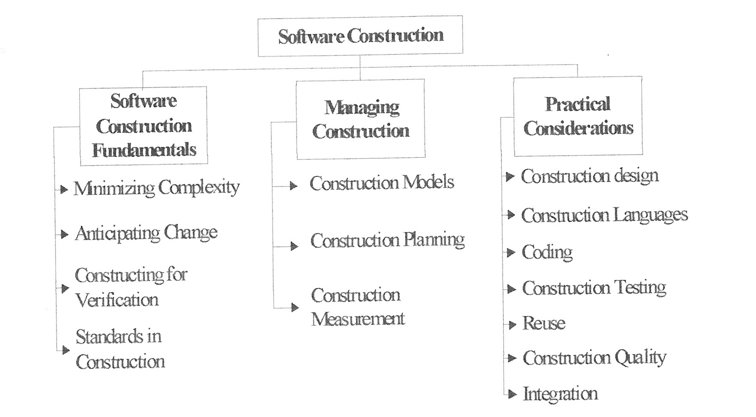

Figure 1. Topics for the Software Construction KA.

