Subject: ACS 560-Software Engineering
Name: Ekaterina Schwartz
Subject: Guide to SWEBOK- Software Testing KA
Purpose: Summary of Software Testing KA
Advisor: Dr. John Tanik
Date: 10/04/2011

The purpose of software testing is to identify software defects and problems for the purpose of improving its quality. Software testing consists of dynamic verification of behavior of a program on a finite set of test cases, selected from infinite executions domain, against expected behavior. Software testing spans through the development and maintenance processes and is a part of software construction, rather than an activity performed after the coding phase is complete. The Software Testing KA is related to Software Quality, Software Maintenance, and Software Construction KAs. Following is a breakdown of topics for the Software Testing KA:

- Software Testing Fundamentals
The topic of Software Testing Fundamentals includes Testing-related terminology, discussion of Key issues, and the Relationships of testing to other activities. Testing-related terminology reveals the distinction between faults vs. failures. Fault, or defect, is defined as the cause of a malfunction; failure is defined as an undesired effect observed in the system’s delivered service. The purpose of testing is to reveal failures and remedy faults. Key issues discussed in the Software Testing Fundaments are test selection criteria, testing effectiveness, testing for defect identification, the oracle problem, theoretical and practical limitation of testing, and testability. The Relationships of testing to other activities reveals the relationship of Testing vs. Static Software Quality Management techniques, Testing vs. Correctness Proofs and Formal Verification, Testing vs. Debugging, Testing vs. Programming, and Testing and Certification.

- Test Levels
The topic of Test Levels includes subtopics on The target of the test and Objectiveness of testing. As software testing is performed during the development and maintenance processes, the target of testing can vary. Unit, Integration, and System are distinguished as the three test stages, with neither holding greater importance than the other. Unit testing refers to testing of separately testable software pieces. Integration testing is used to verify interaction between software components, whereas system testing covers the behavior of the whole system. Testing is conducted in terms of a specific objective. Such objectives include Acceptance/qualification testing, Installation testing, Alpha and beta testing, Conformance testing/Functional testing/Correctness testing, Reliability achievement and evaluation, Regression testing, Performance testing, Stress testing, Back-to-back testing, Recovery testing, Configuration testing, Usability testing, and Test-driven development. Test-driven development is not a test technique, but rather an independent check that the software has correctly implemented the requirements.

- Test Techniques
The goal of testing is to reveal as much potential for failure as possible. As such, many testing techniques exist, including: Based on the software engineer’s intuition and experience, Specification-based techniques, Code-based techniques, Fault-based techniques, Usage-based techniques, and Techniques based on the nature of the application.
Techniques based on the software engineer’s intuition and experience can be Ad hoc testing or Exploratory testing. Exploratory testing is simultaneous learning, test design, and test execution. Specification-based techniques can implement tools such as Equivalence partitioning, Boundary-value analysis, Decision tables, Finite-state machine modeling, Testing from formal specifications, and Random testing. Code-based testing techniques include the use of Control-flow-based criteria, Data-flow-based criteria, and Reference models for code-based testing (flow graph). Fault-based testing techniques include Error guessing and Mutation testing. Usage-based techniques include Operational profile (reproduced operational environment) and Software Reliability Engineered Testing. Specialized testing techniques are based on the nature of the application. Such include Object-oriented testing, Component-based testing, Web-based testing, GUI testing, Testing of concurrent programs, Protocol conformance testing, Testing of real-time systems, and Testing of safety-critical systems.

- Test-related Measures
The Test-related measures section reveals the distinction between measures that provide Evaluation of the program under test and measures that provide Evaluation of the tests performed. Evaluation of the program under test includes:
- Program measurement to aid in planning and designing testing
- Fault types, classification and statistics
- Fault density
- Life test, reliability evaluation
- Reliability growth models
Evaluation of the tests performed includes Coverage/thoroughness measures, Fault seeding, and Mutation score. Studies have been conducted to compare the effectiveness of different test techniques.

- Test Process
The test process supports testing activities and provides guidance from test planning to test output evaluation as to assure that the test objectives are met cost-effectively. The Test process section of the KA includes Practical considerations and Test Activities.
Practical Considerations involves the topics of Attitudes/Egoless programming, Test guides, Test process management, Test documentation and work products, selection of Internal vs. independent test team, Cost/effort estimation and other process measures, Termination, and Test reuse and test patterns. Management of Test activities strongly depends on the Software Configuration Management process. Test activities include: Planning, Test-case generation, Test environment development, Execution, Test results evaluation, problem reporting/Test log and Defect tracking.

Figure 1. is a breakdown of topics for the Software Testing from the Guide to SWEBOK.
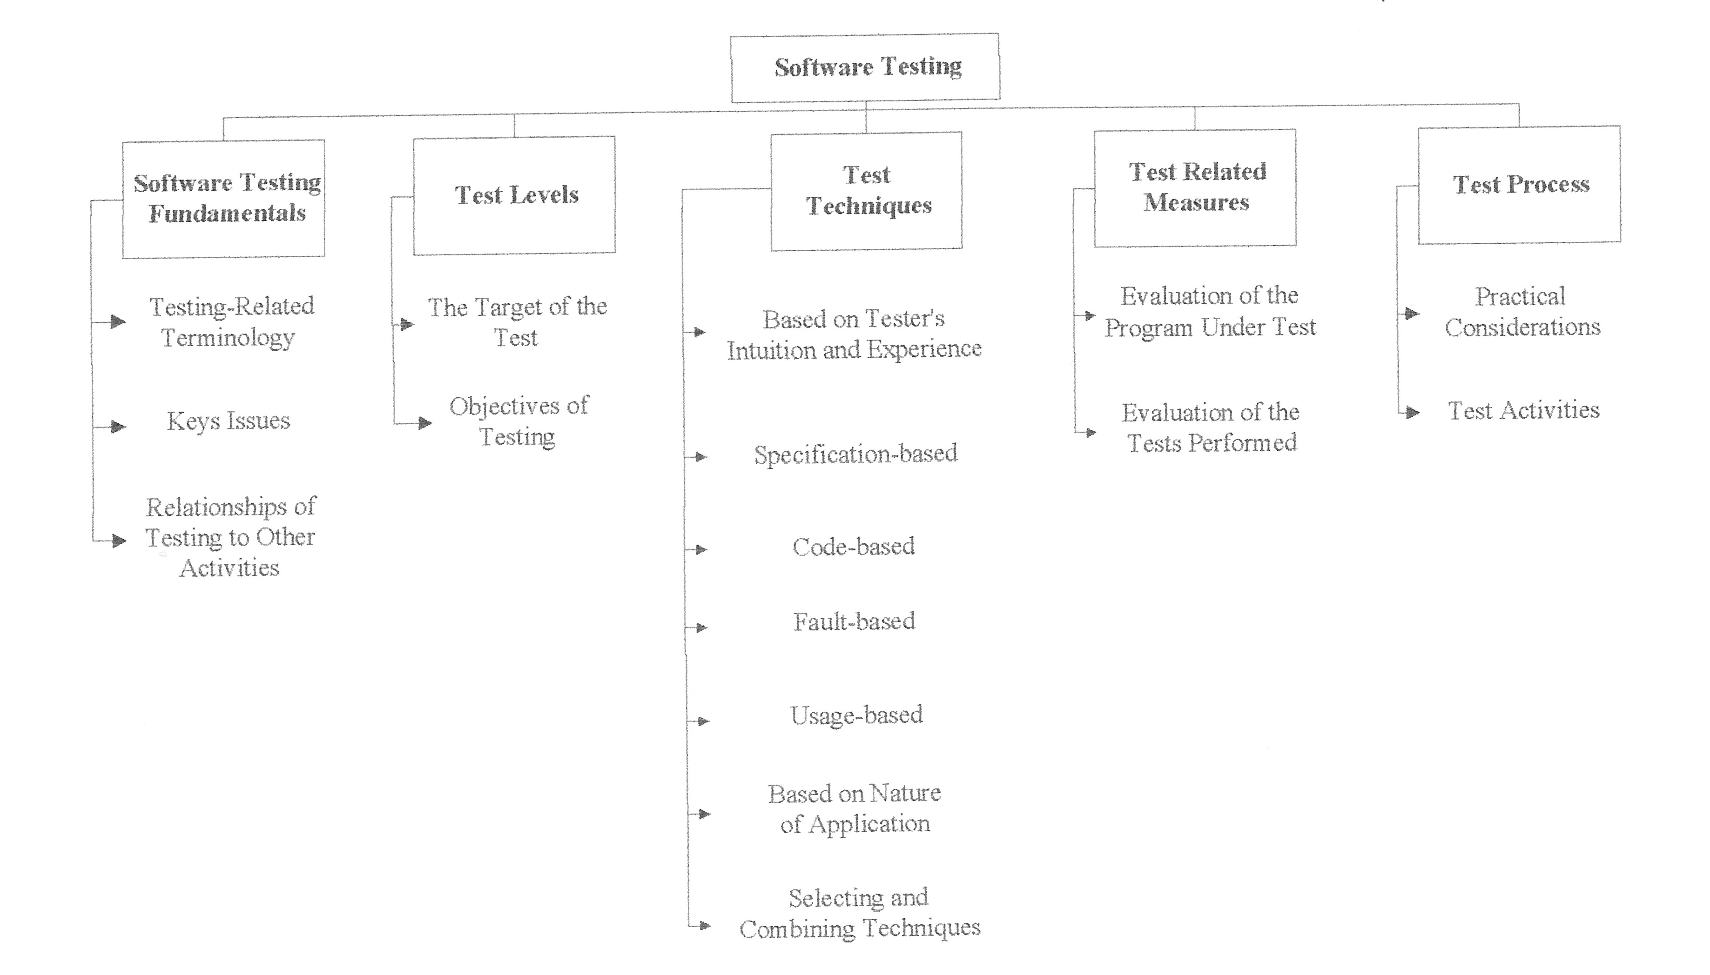

Figure 1. Topics for the Software Testing KA.

