Subject: ACS 560- Software Engineering
Name: Ekaterina Schwartz
Subject: Guide to SWEBOK- Software Maintenance KA
Purpose: Summary of Software Maintenance KA
Advisor: Dr. John Tanik
Date: 10/06/2011

Software Maintenance is defined as the totality of activities required to provide cost-effective support to software. Maintenance activities are performed during the pre-delivery stage and post-delivery stage. Pre-delivery activities include planning for post delivery operations, maintainability, and logistics determination for transition activities. Post-delivery activities include software modification, training, and operating or interfacing to a help desk. The Software Maintenance KA is related to all other aspects of software engineering. Following is a breakdown of topics for the Software Maintenance KA:

- Software Maintenance Fundamentals
The Software Maintenance Fundamentals section of the KA includes a subsection on Definitions and Terminology, Nature of Maintenance, Need for Maintenance, Majority of Maintenance Costs, Evolution of Software, and Categories of Maintenance. IEEE 1219 and IEEE/EIA 12207 standards are referenced for the definition of software maintenance. Primary activities of software maintenance are identified as: process implementation, problem and modification analysis, modification implementation, maintenance review/acceptance, migration, and retirement. Maintenance is necessary in order to:
- Correct faults
- Improve the design
- Implement enhancements
- Interface with other systems
- Adapt programs so that different hardware, software, system features, and telecommunications facilities can be used
- Migrate legacy software
- Retire software
The Majority of Maintenance Costs section includes results from studies revealing that over 80% of the software maintenance effort is used for non-corrective actions. The Categories of Maintenance subsection lists several maintenance categories including:
- Corrective maintenance
- Adaptive maintenance
- Perfective maintenance
- Preventive maintenance

- Key Issues in Software Maintenance
This section of the Software Maintenance KA lists challenges presented by software maintenance. Such are grouped under Technical issues, Management issues, Cost estimation, and Software Maintenance Measurement. Technical issues listed are due to the limited understanding of the software, the cost and coordination of testing, the need for implementation of impact analysis, and lack of specified maintainability sub-characteristics during the development process. Management Issues include alignment of maintenance with organizational objectives, attracting and keeping software maintenance staff, implementing unique processes not implemented during development, identifying which organization is responsible for the maintenance of the software, and deciding whether to outsource maintenance. The guide lists parametric models, expert judgment, or both, as most popular models for cost estimation. Suggested software maintenance measures are: analyzability, changeability, stability, and testability.

- Maintenance Process
This subarea provides references and standards to implement the software maintenance process. Maintenance Activities subtopic distinguishes maintenance from development and shows its relationship to other software engineering activities. Activities unique to maintenance include:
- Transition
- Modification
- Modification Request and Problem Report Help Desk
- Impact Analysis
- Service Level Agreements
- Supporting activities
Other maintenance activities include: supporting activities, maintenance planning activities, software configuration management, and software quality.

- Techniques for Maintenance
The section Techniques for Maintenance introduces generally accepted techniques used in software maintenance, such as: Program Comprehension, Re-engineering, and Reverse engineering. Program Comprehension refers to studying the program in order to implement changes. Re-engineering is defined as the examination and alteration of software to reconstitute it in a new form, and includes the subsequent implementation of the new form. Reverse engineering is the process of analyzing software to identify the software’s components and their interrelationships in order to create representations of the software in another form. Reverse engineering does not change the software, or result in new software.

Figure 1. is a breakdown of topics for the Software Maintenance from the Guide to SWEBOK.
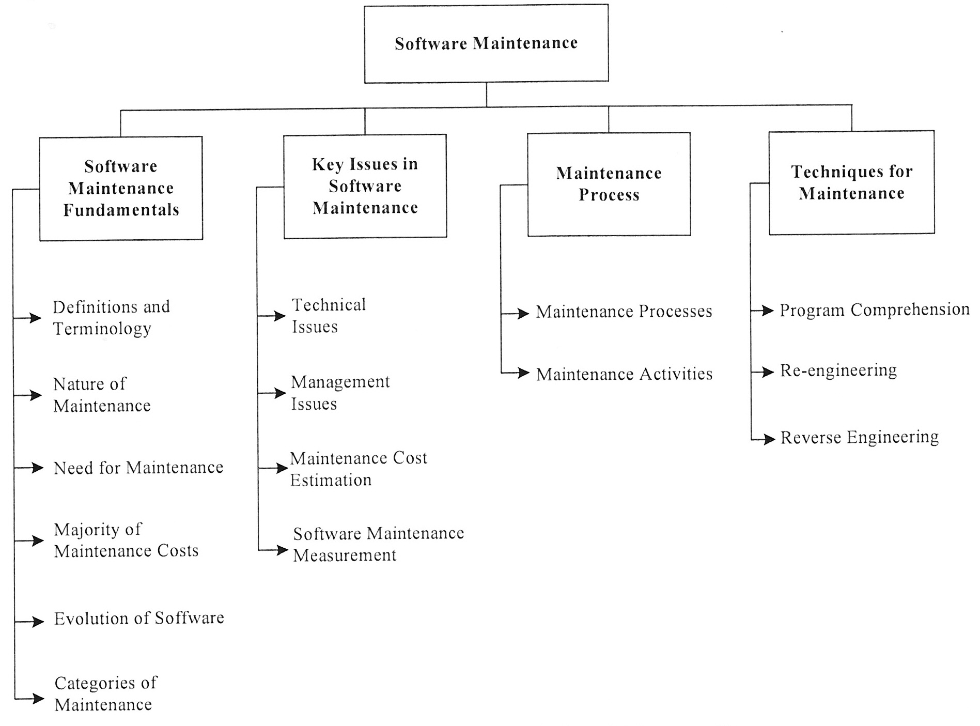

Figure 1. Topics for the Software Maintenance KA.

