Subject: ACS 560- Software Engineering
Name: Ekaterina Schwartz
Subject: Guide to SWEBOK- Software Configuration Management KA
Purpose: Summary of Software Configuration Management KA
Advisor: Dr. John Tanik
Date: 10/06/2011

The Software Configuration Management KA defines configuration of a system as the collection of specific versions of hardware, firmware, or software items combined according to specific procedures for a particular purpose. Configuration management is defined as the discipline of identifying the configuration of a system at distinct points in time for the purpose of systematically controlling changes to the configuration, and maintaining the integrity and traceability of the configuration throughout the system life cycle. Software configuration management (SCM) benefits project management, development and maintenance activities, assurance activities, and customers. The Software Configuration Management KA is related to all other KAs. Following is a breakdown of topics for the Software Configuration Management KA:

- Management of the SCM Process
The Management of the SCM Process topic of this KA includes the following sub-sections: Organizational Context for SCM, Constraints and Guidance for the SCM Process, Planning for the SCM, SCM Plan, and Surveillance of SCM.
The Organizational Context for SCM section points out the necessity to understand the relationships among organizational elements for the development of a SCM process, and identifies the software development and maintenance organizations as its closest relationship. The Constraints and Guidance for the SCM Process section identifies policies and procedures at organizational levels, external regulatory bodies, and software’s life cycle process to affect the design and implementation of SCM process. Planning for SCM involves the identification of tasks, identification of organizations, assignment of responsibilities, identification of resources and schedules, selection of tools and implementation, and determination of vendor/subcontractor control and interface control. The results of SCM planning are documented in a Software Configuration Management Plan (SCMP), which is a reference to the SCM process. The Surveillance of Software Configuration section of the guide discusses measurements of the SCM processes for monitoring the effectiveness of SCM activities and in-process audits of SCM that provide formal mechanism for monitoring aspect of the process.

- Software Configuration Identification
The Software Configuration Identification section of the KA includes subsections on Identifying Items to be Controlled and Software Library. In the Identifying Items section, software configuration and software configuration item, software version, revision, variant, and software baseline are defined and discussed. The section also includes a discussion on the relationships of software configuration items (SCI) and acquiring software configuration items. As relationships among SCIs affect SCM activities, proper tracking and identification of such is important. The Software Library section defines a software library as a controlled collection of software and related documentation designed to aid in software development, use, and maintenance.

- Software Configuration Control
Software configuration control involves managing changes during the software life cycle. It includes the process for determining what changes to make, authority for approving changes, support for implementation of those changes, and the concept of formal deviations from project requirements. The Software Configuration Control section of the guide covers the following topics:
- Requesting, Evaluating, and Approving Software Changes
- Implementing Software Changes
- Deviation and Waivers

- Software Configuration Status Accounting
Software Configuration Status Accounting (SCSA) is defined as the recording and reporting of information needed for effective management of the software configuration. The Software Configuration Status Accounting section of the guide includes sub-sections on Software Configuration Status Information and Software Configuration Status Reporting. Types of information reported is: approved configuration identification, as well as the identification and current implementation status of changes, deviations, and waivers. Such information is reported for the use of various organizational and project elements.

- Software Configuration Auditing
A software audit is defined as an activity performed to independently evaluate the conformance of software products and processes to applicable regulations, standards, guidelines, plans, and procedures. A software configuration audit determines the extent to which an item satisfies the required functional and physical characteristics. The Software Configuration Auditing section of the guide includes brief discussions on Software Functional Configuration Audit, Software Physical Configuration Audit, and In-process Audits of a Software Baseline.

- Software Release Management and Delivery
The software library is identified as a key element in software release and delivery tasks. The Software Release Management and Delivery section of the guide includes sub-sections on Software Building and Software Release Management. Software building is the activity of combining the correct versions of software configuration items, using appropriate configuration data, into an executable program. Software Release Management includes the identification, packaging, and delivery of the elements of a product.
Figure 1. is a breakdown of topics for the Software Configuration Management KA from the Guide to SWEBOK.

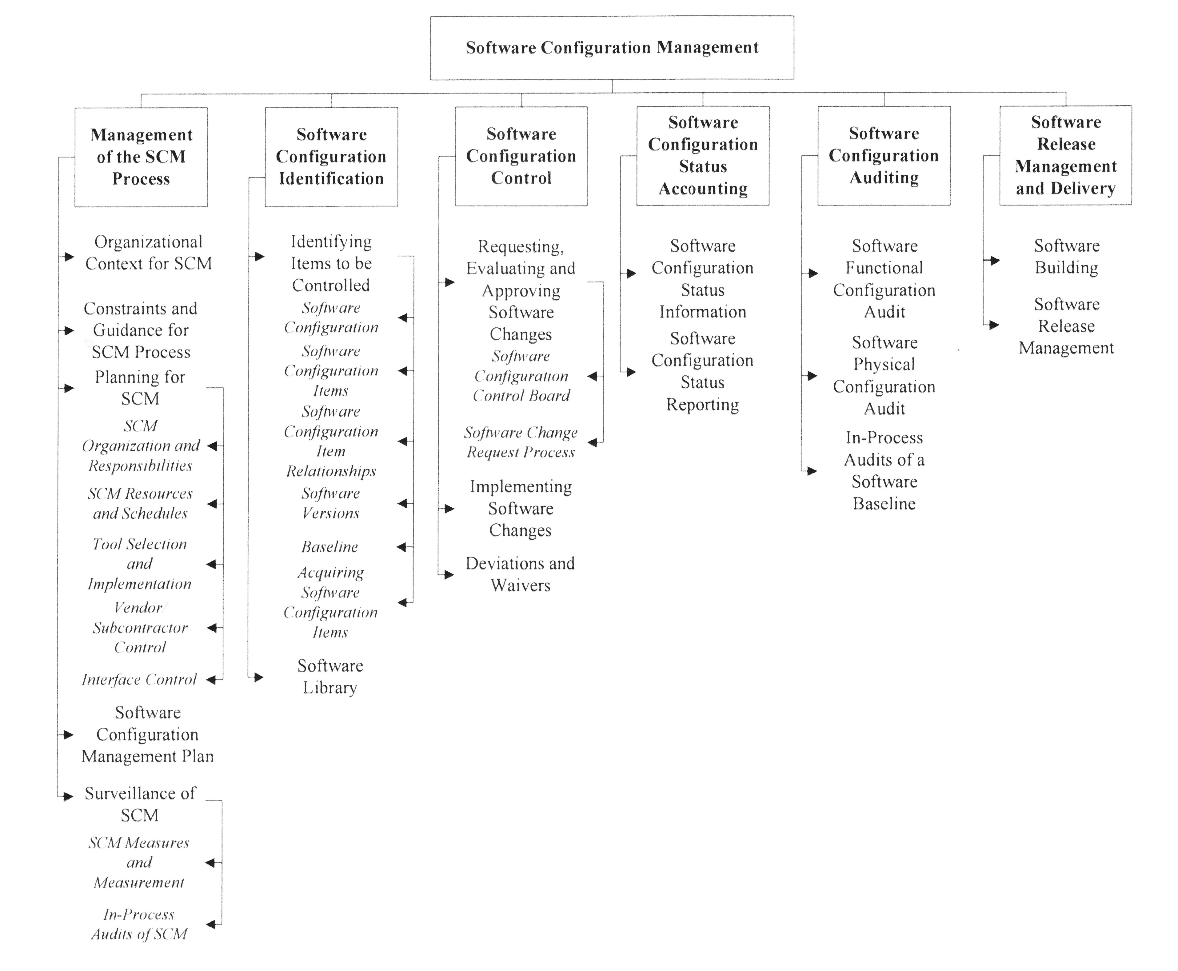
Figure 1. Topics for the Software Configuration Management KA.

