Subject: ACS 560-Software Engineering
Name: Ekaterina Schwartz
Subject: Guide to SWEBOK- Software Engineering Management KA
Purpose: Summary of Software Engineering Management KA
Advisor: Dr. John Tanik
Date: 10/08/2011

The Guide defines Software Engineering Management as the application of management activities - planning, coordinating, measuring, monitoring, controlling, and reporting- to ensure that the development and maintenance of software is systematic, disciplined, and quantified. The Software Engineering Management KA addresses the management and measurement of software engineering. The Software Engineering Management KA is closely related to the Software Requirements, Software Configuration Management, Software Engineering Process, and Software Quality KAs of the Guide. Following is a breakdown of Software Engineering Management KA topics:
- Initiation and Scope Definition
The Initiation and Scope Definition section of the KA includes the following subsections: Determination and Negotiation of Requirements, Feasibility Analysis, and Process for the Review and Revision of Requirements.
Software requirement methods for requirement elicitation must be selected and applied for the determination of project scope, objectives, and constraints. The Feasibility Analysis subsection reveals the need for assurance that adequate capability and resources are available for the completion of the project. The last subsection reveals the vitality of an agreement among stakeholders as to the means by which scope and requirements are to be reviewed and revised.

- Software Project Planning
The Software Project Planning section of the KA includes the following subsections:
- Process Planning
- Determine Deliverables
- Effort, Schedule, and Cost Estimation
- Resource Allocation
- Risk Management
- Quality Management
- Plan Management
Process planning includes the undertaking of an appropriate software life cycle model and the adaptation of appropriate software life cycle processes pertaining to the scope and requirements of the project. Appropriate methods and tools are used to decompose the project into tasks. Deliverables are determined by specifying and characterizing the product of each task. Deliverables decisions include reuse of software components, off-the self software products, and third party selections. This KA reveals the use of a calibrated estimation model for the determination of expected effort range based on tasks, inputs, and outputs. Resource requirements are further translated into cost estimates. Activities associated with effort, schedule, and cost estimation are described as highly iterative which must be negotiated and revised. The Resource Allocation subsection of the KA discusses the association of equipment, facilities, and people with the scheduled tasks, and reveals potential constrains by the availability of resources. Risk Management includes risk identification and analysis, critical risk assessment, risk mitigation and contingency planning. Plan Management is concerned with detailing how the project and the plan will be managed, in particular: reporting, monitoring and control.

- Software Project Enactment
The Software Project Enactment section of the KA includes the following subsections: Implementation of Plans, Supplier Contract Management, Implementation of measurement process, Monitor Process, Control Process, and Reporting.
Software Project Enactment requires the implementation of the plans, by focusing on adherence to the plans, with the expectation that such will lead to the successful achievement of the project objectives. Implementation of Plans includes the utilization of resources and production of deliverables. The Supplier Contract Management subsection lists the following supplier related tasks: prepare and execute supplier agreements, monitor supplier performance, accept and incorporate supplier products.
Process is monitored at predetermined intervals to ensure adherence to plans. In addition, outputs and completion conditions are analyzed. The outcomes of the process monitoring activities provide basis for process control. At predetermined periods, adherence to plans is reported, internally and externally, to stakeholders. The Reporting subsection distinguishes such reports from the detailed reporting required frequently within the project team.

- Review and Evaluation
The Review and Evaluation section the KA includes two subsections: Determining Satisfaction of Requirements, and Reviewing and Evaluating Performance.
On achievement of project milestones, progress towards stakeholder satisfaction is formally assessed and variances from expectation are identified, resulting in appropriate actions being taken. The subsection of Reviewing and Evaluating Performance refers to performance reviews of personnel involved in the project. Such provide insights to the likelihood of adherence to plans, as well as areas of difficulty.

- Closure
The Closure section of the Software Management KA includes two subsections: Determining Closure and Closure Activities.
The Closure stage of the project is reached when all plans and processes have been enacted and completed. The Determining Closure subsection of the KA further lists the delivery of products with acceptable characteristics, confirmation of satisfactorily met requirements, and determination of achieved project objectives, as factors in determining closure. Closure activities include storing of project materials, updating of organization’s measurement database with project data and post-project analyses, and undertaking a project post mortem.

- Software Engineering Measurement
The Software Engineering Measurement section of the KA includes the following subsections: Establish and Sustain measurement Commitment, Plan the Measurement Process, Perform the Measurement Process, and Evaluate Measurement.
Measurement commitments are established by accepting measurement requirements with a defined scope of measurement and management/staff commitment. In addition, sustaining measurement commitment requires commitment of resources for measurement. The Plan the Measurement Process subsection of the KA includes the following activities:
- Characterize the organizational unit
- Indentify information needs
- Select measures
- Define data collection, analysis, and reporting procedures
- Define criteria for evaluating the information products
- Review, approve and provide resources for measurement tasks
- Acquire and deploy supporting technologies
Performing the measurement process includes activities such as:
- Integrate measurement procedures with relevant processes
- Collect data
- Analyze data and develop information products
- Communicate results
The Evaluate Measurement subsection of the KA includes:
- Evaluate information products
- Evaluate the measurement process
- Identify potential improvements

Figure 1 is a breakdown of topics for the Software Engineering Management KA from the Guide to SWEBOK.
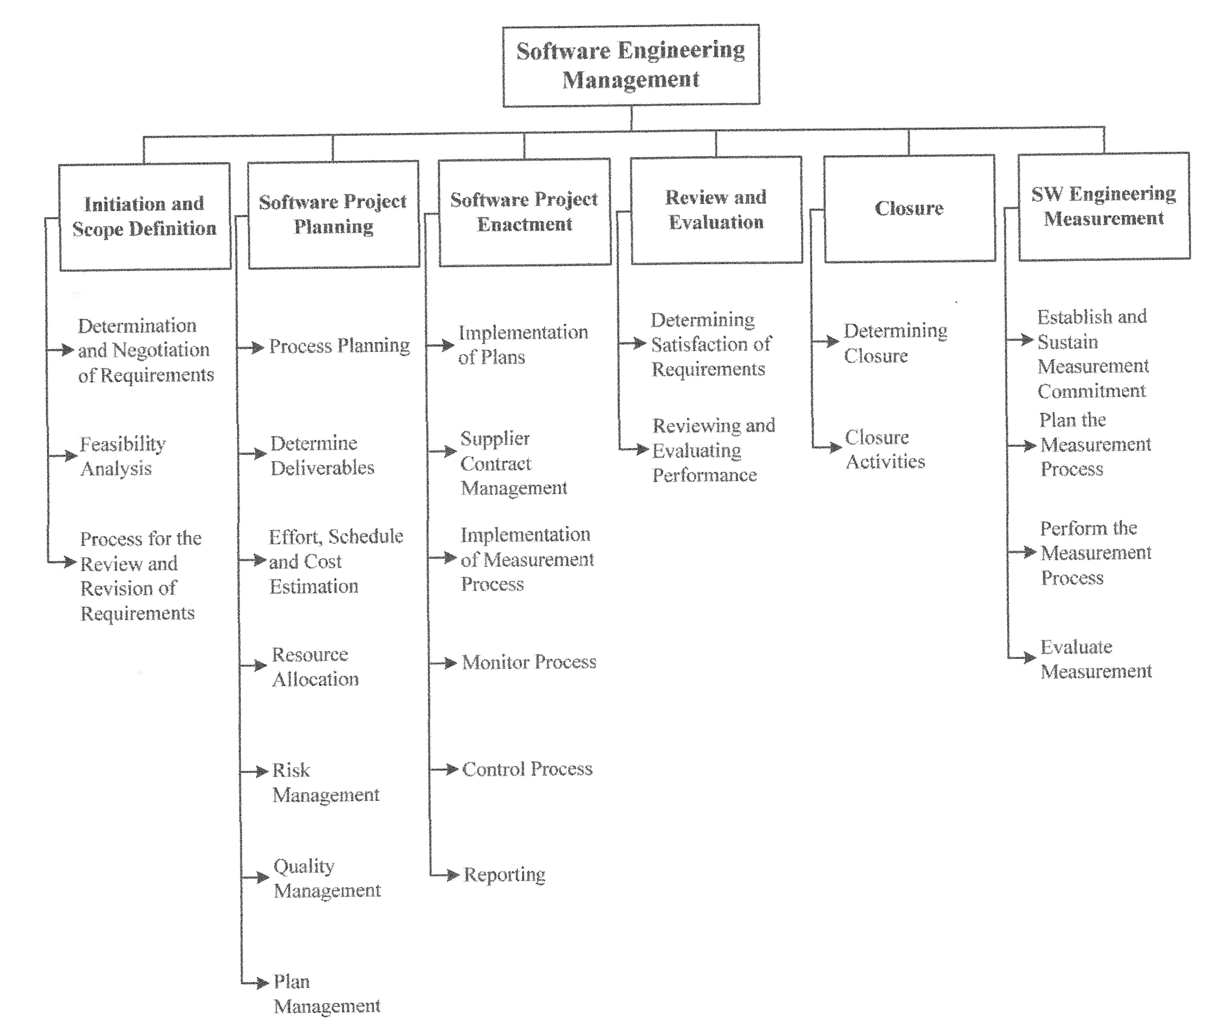
Figure 1 Topics for the Software Engineering Management KA.

