Subject: ACS 560- Software Engineering
Name: Ekaterina Schwartz
Subject: Guide to SWEBOK-Related Disciplines of Software Engineering KA
Purpose: Summary of Related Disciplines of Software Engineering KA
Advisor: Dr. John Tanik
Date: 10/10/2011

This chapter of the Guide identifies disciplines with which software engineering shares a common boundary (Related Disciplines). Following is the List of Related Disciplines and their Knowledge Areas:

Computer Engineering
Knowledge Areas for computer engineering:
- Algorithms and Complexity
- Computer Architecture and Organization
- Computer Systems Engineering
- Circuits and Systems
- Digital Logic
- Discrete Structures
- Digital Signal Processing
- Distributed System
- Electronics
- Embedded Systems
- Human-Computer Interaction
- Information Management
- Intelligent Systems
- Computer Networks
- Operating Systems
- Programming Fundamentals
- Probability and Statistics
- Social and Professional Issues
- Software Engineering
- Test and Verification
- VLSI/ASIC Design

Computer Science
Knowledge Areas for computer science:
- Discrete Structures
- Programming Fundamentals
- Algorithms and Complexity
- Architecture and Organization
- Operating Systems
- Net-Centric Computing
- Programming Languages
- Graphics and Visual computing
- Intelligent Systems
- Information Management
- Social and professional Issues
- Software engineering
- Computational Science and Numerical Methods

Management
Knowledge Areas for Management:
- Accounting
- Finance
- Marketing and Sales
- Operations Management
- Information Systems Management
- Law
- Human Resource Management
- Economics
- Quantitative Analysis
- Business Policy and Strategy

Mathematics
Knowledge Areas for mathematics:
- Linear Algebra
- Differential and Integral Calculus
- Differential Equations
- Probability
- Statistics
- Numerical analysis
- Discrete Mathematics

Project Management
Knowledge Areas for project management:
- Project Integration Management
- Project Scope Management
- Project Time Management
- Project Cost Management
- Project Quality Management
- Project Human Resource Management
- Project Communications Management
- Project Risk Management
- Project Procurement Management

Quality Management
Knowledge Areas for quality management:
- Management and Leadership in Quality Engineering
- Quality Systems Development, Implementation And Verification
- Planning, Controlling, and Assuring Product and Process Quality
- Reliability and Risk Management
- Problem Solving and Quality Improvement
- Quantitative Methods

Software Ergonomics
Knowledge Areas for software ergonomics:
- Cognition
- Cognitive AI I: Reasoning
- Machine Learning and Grammar Induction
- Formal Methods in Cognitive Science: Language
- Formal Methods in Cognitive Science: Reasoning
- Formal Methods in Cognitive Science:
  - Cognitive Architecture
- Cognitive AI II: Learning
- Foundations of Cognitive Science
- Information Extraction from Speech and Text
- Lexical Processing
- Computational Language Acquisition
- The Nature of HCI
  - (Meta-)Models of HCI
- Use and Context of Computers
  - Human Social Organization and Work
  - Application Areas
- Human-Machine Fit and Adaptation
- Human Characteristics
  - Human Information Processing
  - Language, Communication, Interaction
  - Ergonomics
- Computer System and Interface Architecture
  - Input and Output Devices
  - Dialogue Techniques
  - Dialogue Genre
  - Computer Graphics
- Dialogue Architecture
- Development Process
  - Design Approaches
  - Implementation Techniques
  - Evaluation Techniques
  - Example Systems and Case Studies

Systems Engineering
First-level competency areas in preliminary versions of Systems Engineering Body of Knowledge:
- Business Processes and Operational Assessment (BPOA)
- System/Solution/Test Architecture (SSTA)
- Life Cycle Cost & Cost-Benefit Analysis (LCC & CBA)
- Serviceability / Logistics (S/L)
- Modeling, Simulation, & Analysis (MS&A)
- Management: Risk, Configuration, Baseline (Mgt)

Figure 1. is a graphical representation of disciplines related to software engineering.
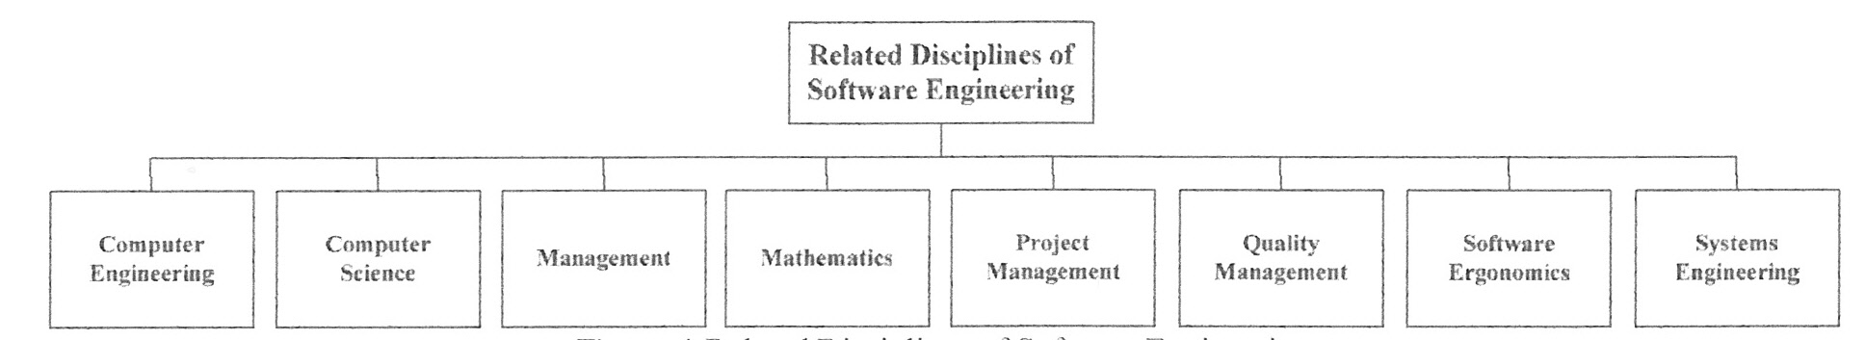

Figure 1. Related Disciplines of Software Engineering.

