SWEBOK Chapter 8

Software Engineering Process
The chapter begins with the definition of software engineering processes as the definition, implementation, assessment, measurement, management, change, and improvement of the software life cycle processes themselves. The objective of managing software life cycle processes is to implement new or better processes in actual practices, be they individual, project, or organizational.

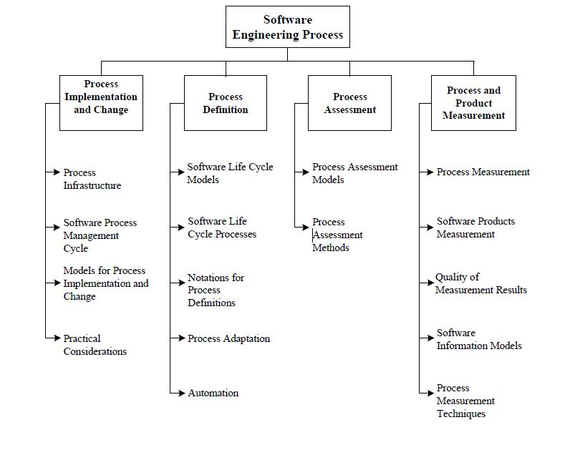
Process Implementation and Change
This subarea focuses on organizational change—when processes are first deployed and where current processes are changed. Also termed process evolution, this subarea requires a process infrastructure including a software engineering process group and experience factory.
The management cycle consists of four activities:
- Establish process infrastructure
- Planning
- Process implementation and change
- Process evaluation

Process Definition
A process definition can be a procedure, a policy or a standard. Predefined processes must be adapted to local needs.
Software lifecycle models serve as a high level definition of the phases that occur during development. Some examples include:
- Waterfall model
- Throwaway prototyping model
- Evolutionary development
- Incremental/iterative delivery
- Spiral model
- Reusable software model
- Automated software synthesis model

Process Assessment
Process assessment models capture what is recognized as good practices. Process assessment may be continual or staged and organizations should evaluate which would be most pertinent to their needs.
Process assessment methods are specific methods that can be followed to produce a quantitative score which characterizes the capability of the process.

Process and Product Management
Process measurement is defined as the collection of quantitative information about the process which is then analyzed and interpreted. The process is assumed to have an impact on the project outcome. Not every process has a positive effect on the project outcome.
Software product measurement includes size measurement, structure measurement, and quality measurement.
Quality of measurement results is essential for the measurement programs to provide effective and bounded results.
Software information models are useful for classification, analysis and prediction.
Process measurement techniques may be used to analyze software engineering processes and to identify strengths and weaknesses. They are classified into analytic or benchmarking techniques.
Analytical techniques rely on quantitative evidence to determine where improvements are needed and whether an improvement initiative has been successful. Techniques may include:
- Experimental studies and process simulation
- Process definition review
- Orthogonal defect classification (mapping fault types and fault triggers)
- Root cause analysis
- Statistical process control
- Personal software process
Benchmarking techniques depend on identifying an excellent organization in a field and documenting its practices and tools. If a less-proficient organization adopts the practices of the excellent organization, it will also become excellent.

