Matthew Rasler
CS360 Fall 2011
11/16/2011
Cyber-Physical Systems
The National Science Foundation defines the subject of Cyber-Physical Systems as the subject that “refers to the tight conjoining of and coordination between computational and physical resources (1).” They state that the importance of directing research into this field lies with the potential impact that it has on the future of domestic security, aerospace, automotive, chemical production, energy, healthcare, manufacturing, etc… To further express the importance of this Cyber-Physical Systems and detailed in “Cyber-Physical Systems - Are Computing Foundations Adequate?,” Lee argues that current computational and network systems do not possess the same concurrency that real life exhibits, nor do they relate to the passage of time as biological entities do; the result hinders the growth of current technologies embedded in real-time applications (2). Many considerations will be made to dictate the growth, organization, and direction of this exciting new merging field. This paper will elaborate on the past, the present, and the future of the emerging field of Cyber-Physical Systems, as well describe my personal future in the field and aspects that I find personally interesting.

Past
It can be said that the field of Cyber-Physical Systems largely grew from the foundation set by the 20th century technology boom that defined the field of embedded systems. Embedded systems made possible: automotive electronics, home appliances, more accurate weapons, and more. But these applications were limited by their connectivity to both the real world and to outside influence. This was of course a constraint imposed by then current technological standards; if a device can be “black-box” abstracted, it has marginal technological standards and the output can be defined for all of its states. To accommodate smarter systems that are more aware, predictability becomes more of an issue (2).
During the early years, embedded systems were predominately considered in the industrial setting; mechanisms employed to actively improve the functionality or quality of the end product (3). But as the capability of technology has increased, so has the complexity of products produced, in such the idealism of extremely networked components have rose as well. For example, automobile manufacturers have created specific communication protocols that have allowed for the foundation of CPSs (Cyber-Physical Systems) to be incorporated in passenger vehicles (CAN busses, FlexRay); many modern automobiles have utilized these technologies for over a decade to communicate between constantly changing components, and interacting with the driver and his world.
Present
The CPS summit report exemplifies the DARPA challenge in describing a success story of applications of CPS in society. Though, they state, that such examples of true CPSs are rare at current, even though many examples of highly embedded systems exist in modern society, the level of networked connectivity is limited in most applications (5). This world is advancing heavily, and quickly though, and modern examples become more apparent by the day. Such examples emerging are:
The BMW dash express:
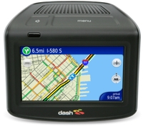
Though recently rescinded, the dash connects continuously through GPS, the cell-network, and WIFI to offer real time GPS navigation, traffic analysis, and fuel consumption by tracking all BMW devices on its network
Smart Bridges:
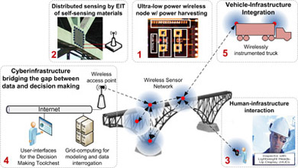
Being developed nationally with a grant from the NSF.
River Sensors:
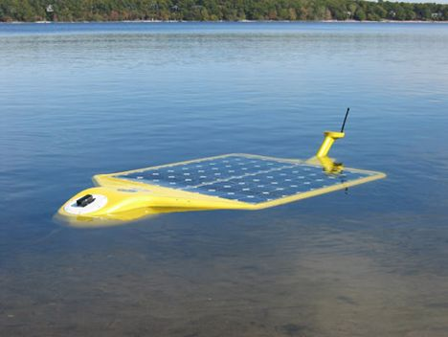
Monitor the Hudson river to determine and catalogue pollution levels in real time.
Paro the Therapeutic Robot:
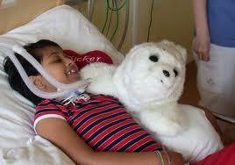
Acts as an interactive companion to aid in the healing process.
Future
The CPS Summit Report (5) states that the NSF is interested in furthering research in the following areas:
• redefining mass production, e.g., components built to looser initial tolerances that adjust to each other upon assembly;
• a worldwide sensing utility (with web browser for the physical world);
• food and clean water to everyone in the world;
• pervasive sensor networks that never need to have the batteries replaced;
• VLSI-like tool chains for autonomous robots;
• climate monitoring and control for global warming;
• make it possible for elderly people to live independently;
• robots truly interacting with people (nurse bots actually examining people, robots playing soccer with people);
• context-aware personal tutors for all types of skills;
• automated farming using farmbots and sensor networks;
• 24/7 robotic personal assistant;
• optimal harvesting of solar and wind power;
• net-zero energy buildings and homes;
• energy efficient cars;
• persistent ocean-observing systems;
• integrated medical device systems: lab-on-a-chip to doctor-on-a-chip;
• tele-presence/tele-operation of assistive devices;
• neural prosthesis for people with paralysis using the control signals from the motor cortex;
• sensor-actuator networks at the cellular level—hundreds or thousands of sensors/actuators in explants and in vivo implants to advance our understanding of biology, and in the long run improved health care;
• zero medical deaths from metabolic disorders through ubiquitous monitoring and control.

The document goes on to label the importance of research into transportation systems, to limit the overstressed infrastructure that exists today, to limit unnecessary fuel consumption and wasted productivity. It states that the future of CPSs should incorporate both manned and unmanned vehicles into the domain. The summit also stressed the importance of making Energy Systems that provided for an increased limit on fossil fuel consumption, and ideally assisting in the creation of Zero Net Power Grid (5).

Your future in CPS and/or how it will impact the world
As our group has learned through the semester, the involvement of hardware components into a system from a software point of view increases the complexity of that software and requires the Software Engineer to be aware of the details of that hardware in order to interact with it, benchmark it, test it, debug it, and so forth. Adding in the complexity that real-time interaction, networking, and input from the ever changing real world, it becomes increasingly more important for the Software Engineer to be ever growing in their knowledge base of new programmatic trends. This ever changing environment makes a formidable albeit ever interesting world for the future of the Computer Scientist.
It is my career goal to assist in pushing the limits of what Computer Science can accomplish in the real world. I wish to study Artificial Intelligence in the pursuit of a Doctoral Degree, and of all career fields that are intricately tied to the field of Cyber-Physical Systems, I would argue that AI is of the top. I am very excited to see the technology base expand to accommodate certain Artificial Intelligence paradigms that have been to date impractical because of the same reasons that CPSs have been impractical.
Pick a topic in CPS that interests you and explain why
I would love to be a part of the pursuit of a Zero Net Energy Grid, and would be very interested in the AI systems that would influence the research, design, and foundation of such a solution to the destructive impact human civilization imparts unto this planet. I have always been a lover of natural beauty and spend my off-time climbing mountains, white water rafting, backpacking, biking, and trail running. Things I wish to give to all generations to come. It is obvious that massive energy and intellect must be fussed to curb the impact that fossil fuel consumption has had on our environment.
Bonus #1: What did you learn in class, from your project, and teamwork?
I recently prepared a resume for a local software development firm that required knowledge of Rational/IBM’s Rational Unified Process iterative development process; I felt confident that I have learned enough of this process to confidently be integrated into a firm that utilized this process; this knowledge was acquired through education required of this class. Additionally, the software tools that we have utilized, including Microsoft Visio, Aclarro’s Axiomatic Design Software, Microsoft Project, and Basecamp, will be important in my future in the software world.
The project itself has allowed me to research interesting topics, of which I have acquired a tremendous amount of knowledge, these topics include: communication protocols (USB, RS232, RS485, general serial communication, CSMA, TDMA) and how to interact with them from a software standpoint, specific embedded chips and their corresponding programming languages (PBASIC), computer graphics and analyzation(Webster agrees with me that this is actually a word) techniques, and general information about automation and egg farming.
From teamwork, I have learned effective communication techniques and effective delegation techniques as a Project Manager. Also I have come to appreciate CMAPs as a communication mechanism.

Bonus #2: What is the Society for Design and Process Science (SDPS) and how can it relate to Cyberphysical systems?
The Society for Design and Process Science (SDPS) is an organization that promotes and fosters the advancement of design and process science in all engineering disciplines by encouraging the exchange of ideas of people involved, utilizing conferences and the organization itself as a communication mechanism (6). The SDPS holds conferences that are centric to transdisciplinary (word they use on their flier) engineering study (7), which will be pivotal to the growth of the field of CPSs, in that in order for the field to become formidable, organization, communication, and engineering standards will need to be exchanged across the diverse set of fields that Cyber-Physical Systems are made up of.

References:
- http://www.nsf.gov/pubs/2011/nsf11516/nsf11516.htm
- http://ptolemy.eecs.berkeley.edu/publications/papers/06/CPSPositionPaper/Lee_CPS_PositionPaper.pdf
- http://citeseerx.ist.psu.edu/viewdoc/download?doi=10.1.1.156.1012&rep=rep1&type=pdf
- http://www.cs.mcgill.ca/~xueliu/publications/2008_SUTC.pdf
- http://iccps2012.cse.wustl.edu/_doc/CPS_Summit_Report.pdf
- http://www.sdpsnet.org/sdps/
- http://www.ic2.utexas.edu/images/events/sdps%20workshop%20flyer%2009.pdf

