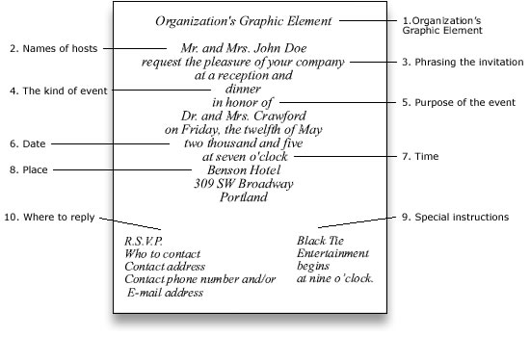

This is an example of an INVITATION . If you want to look at more models just type formal invitation in you Google text box.

