ACS 560

Exam II

Cyber-Physical Systems:
Past, Present, Future, and their Impact on the World

Prepared by:
Ekaterina Schwartz

Date:
December 1, 2011

Cyber-physical systems (CPS) are integrations of computation and physical processes [3]. Cyber-physical systems are not created by simply adding computing and communication equipment to conventional products with both sides maintaining separate identities, but rather by merging computing and networking with physical systems to create new capabilities and improved product quality [6]. This paper discusses topics of the past, present, and future related to cyber-physical systems and CPS’s expected impact on the world.
Past
The evolutionary advancement of personal computers is well recognized and undisputable. When in the 70’s computers were mainly used by government, business institutions, and universities, today, through the advancement of microprocessors, personal computers are conventional household items. Such technological advancements apply to the ‘invisible’ computers as well. Embedded computers are no longer restricted to military and space applications. Though not obvious, embedded computers can be found in nearly every aspect of everyday life, such as:
- Automotive/Transportation
- Consumer Electronics
- Industrial Automation
- Medical Devices
- Military/Aerospace
- Mobile Phones
Embedded systems are computer systems designed to perform specific functions, often incorporating real-time computing. Generally, such systems are held to a higher reliability and predictability standard than general-purpose computing [3] due to the nature of their implementation. Figure 1 shows some examples of existing embedded system products.
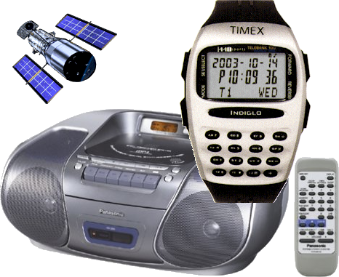
Figure 1 Examples of existing embedded system products. [8]
Though embedded computers enable product designers to provide complex functionality that can adapt to changing needs, today’s embedded computers are just information processors with dedicated and limited in flexibility hardware [4]. Cyber-physical systems (CPS) are an extension of the notion of embedded and critical systems [7]. Embedded systems are considered a predecessor to the cyber-physical systems. In the transition from embedded to cyber-physical systems, the standard of reliability and predictability must be met, even exceeded, for its implementation in automotive, medical, aviation, and other critical sectors. Figure 2 shows the overlap of embedded, real-time, and cyber-physical systems.
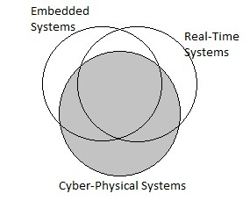
Figure 2 Overlap of Embedded, Real-time and Cyber- Physical systems [11].
Where did the notion of CPS originate? Norbert Wiener from Massachusetts Institute of Technology (MIT) invented the field of cybernetics, the study of control and communication in the animal and the machine, which stimulated scientists to think of computer technology as a means to extend human capabilities [2].
Present
Though much research and advancement is to be completed, cyber-physical systems are already in use today. Such systems include the ATM machines, monitoring and physical control of water, electricity, food, finance, transportation, and emergency response [2].
We all are familiar with ATM machines. Upon user’s input, an ATM machine dispenses cash as controlled by the computer, and user’s account balances are updated.
In the sector of automobile safety, sensors are implemented to monitor and warn drivers of unintentional lane drifts and impending collisions. The Electric Stability Control system is implemented to assists drivers maintain control of the vehicle during extreme maneuvers [9]. When the system detects a difference between the vehicle’s motion and the drivers input, it applies braking to correct the vehicle’s motion.
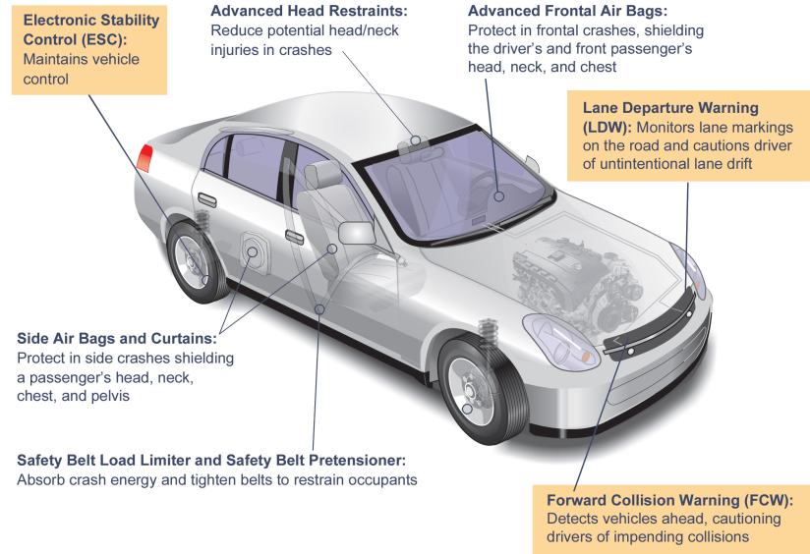
Figure 3 Car Safety Technology [9].
An example of today’s emergency response application is the OnStar vehicle safety system.
It provides its users, among other things, with GPS navigation and a sensor that upon detection of impact automatically places an emergency call.
Government institutions realize the potential impact that CPS has on the country’s economy and future development. Presently, the National Science Foundation (NSF) awards funding for CPS research projects. The CPS program accepts proposals that address research challenges in the following areas: Foundations; Methods and Tools; and Components, Run-time Substrates, and Systems [13]. Most recently, the foundation has funded sixty five research projects through the CPS program.

Future
Though cyber-physical systems are in use today, CPS is an emerging field requiring dedication of future research and resources. Following are some of the challenges and advancements that CPS research is to address:
- Building concurrent models of computation that are deterministic, predictable, and understandable [3].
- Implementing accurate and timely information queries and retrieval, implementing unified namespace for information location, maintaining consistent view of data during disconnected operation, incorporating data reliability, availability, survivability, and security [5].
- Realigning abstraction layers in design flows, developing semantic foundations for composing heterogeneous models and modeling languages, developing understanding of compositionality in heterogeneous systems, achieving predictability in partially compositional properties, developing a foundation for system integration, developing methods for compositional certification, developing infrastructure for agile design automation, developing open architecture for cyber-physical systems, developing architectures and tools for reliable and resilient CPS systems [6].
As an emerging field, CPS will require investment and development in all levels of education, from elementary to graduate, to ensure that future generations of scientists are equipped to exploit the field of cyber-physical systems.
The future of CPS not only includes research pertaining to the challenges of the CPS’s functional implementations, but also research pertaining to the materialization of innovating advanced applications that can change our day-to-day life. An example of such research is the implementation of claytronics, a cyber-physical system which changes its physical properties as a direct result of computation, which can be used as a means of implementing a new 3D telecommunication medium [4].
How will CPS impact the World
The expected impact of the implementation of cyber-physical systems on the world is at least comparable to the impact of the recent information technology evolution. Implementation of cyber-physical systems will provide among others:
- increased safety in air and highway travel
- efficient highway traffic and airspace
- efficient vehicle and building operation
- higher reliability power grids
- reliable home medical care
- improved medical diagnostic tools
- effective medical prosthetics
- new telecommunication
Figure 4 depicts aspects of an intelligent cyber-physical power and energy system, an example of one sector of CPS’s impact on the world. As CPS research and implementations progress, opportunities for implementation and innovation will become more clear, and so will their impact on the world.
Ultimately, further progress and advancement in the cyber-physical field will undoubtedly sustain industrial growth in CPS affected sectors and further economic development.

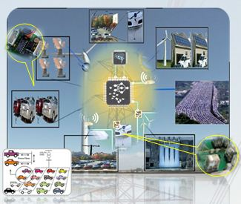
Figure 4 Intelligent Cyber-Physical power and energy systems [12].
What is the Society for Design and Process Science (SDPS)
Cyber physical systems design is based on process science. The society that studies design and process science is the Society for Design and Process Science (SDPS) [2].
The vision and scope of the Society for Design and Process Science is to be a catalyst for change, enabling the discovery of new approaches that lead to alternative solutions for the increasingly complex problems that face civilization [1].
Following are the objectives of SDPS as stated on their website [1]:
- Promote the development of design and process science as applied to all traditional disciplines of engineering by sponsoring conferences and participation in other appropriate activities.
- Encourage and foster research and development to advance the discipline of design and process science.
- Provide leadership and resources to foster cooperation among organizations in establishing meaningful international standards. Distribute, promote, and encourage the use and application of these standards for universal improvement.
- Encourage an interchange of ideas among engineers, scientists, managers, decision makers and organizations by:
- Disseminate information through publishing and other means.
- Organizing conferences and programs for presentations and demonstrations to advance the state of knowledge.
- Cooperating with other professional organizations and committees with respect to standards, interdisciplinary research, and technical meetings.
- Providing a liaison between the Society and Codes and Standards Committees.
- Providing an atmosphere of fellowship between members that recognizes those professional needs of society membership which can best be supplied by association with peers.
- Supporting continuing education activities
- Developing international cooperation and understanding.
- Recognize achievement in the field of design and process science.
- Provide long-range planning activities to insure that the Society achieves its objectives and provides quality service to its members.
- Develop and promote membership in the Society.
- Support student activity.
- Support other appropriate objectives.
References:
[1] The Society for Design and Process Science. (2009). Vision and Scope [Online]. Available: http://www.sdpsnet.org/sdps/index.php?option=com_content&view=article&id=89&Itemid=57
[2] J. Brazell. (2011, November 16). Internet 2.0- Androids in the House [Online]. Available: http://www.theartofthefuture.net/internet-v2/
[3] E. A. Lee. (2008, January 23). Cyber Physical Systems: Design Challenges [Online]. Available: http://www.eecs.berkeley.edu/Pubs/TechRpts/2008/EECS-2008-8.pdf
[4] J. Campbell, S. Goldstein, T. Mowry. Cyber-Physical Systems [Online]. Available: http://varma.ece.cmu.edu/cps
[5] J. Chandy. (2006, September 8). Managing Information and Storage in Networked Cyber-Physical Systems [Online]. Available: http://varma.ece.cmu.edu
[6] CPS Steering Group. (2008, March 6). Cyber-Physical Systems Executive Summary. [Online]. Available: http://varma.ece.cmu.edu
[7] Center for Hybrid and Embedded Software Systems. (2008, April 21). Work Shop: From Embedded Systems to Cyber-Physical Systems: A review of the State-of-the-Art Research Needs [Online]. Available: http://chess.eecs.berkeley.edu/conferences/08/StLouis/
[8] EEE307W: Embedded Systems. (2010). Define: Embedded Systems [Online]. Available: http://rrsg.ee.uct.ac.za/courses/EEE3074W/EmbeddedSystems.html
[9] US Department of Transportation. Technology: Driving the Development of Safe Cars [Online]. Available: http://www.safercar.gov/staticfiles/safetytech/factsheets/fs_safety_tech.pdf
[10] On Star. [Online]. Available: http://www.onstar.com/web/fmv/faq
[11] S. Mohan. (2010, February 6). Cyber-Physical Systems: The New Wave in Computer Systems Research [Online]. Available: http://technorati.com/technology/it/article/cyber-physical-systems-the-new-wave/page-2/
[12] Real-time and Intelligent Systems Laboratory (2009, September 27). Intelligent Cyber-Physical Power and Energy Systems [Online]. Available: http://rtpis.org/intelligent-cyber-physical-power-and-energy-systems/
[13] National Science Foundation (2011, October 26). Cyber-Physical Systems [Online]. Available: http://www.nsf.gov/funding/pgm_summ.jsp?pims_id=503286

