Matthew Rasler
9/26/2011
CS 360
SWEBOK Knowledge Area 4- Software Testing
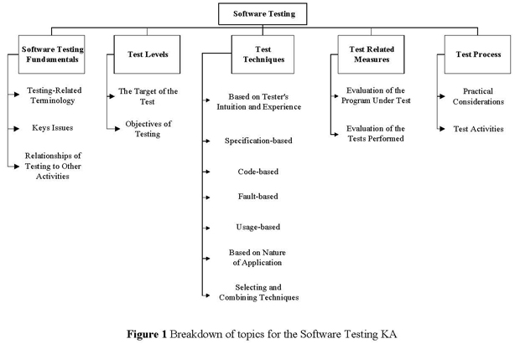
The software testing knowledge area deals with instances of selecting appropriate tests that measure the effectiveness utilizing a variety of means under which constraints of feasibility sometimes need to be considered, in the product lifecycle. Testing is similar but different to debugging, design, and development. There are different levels to testing depending on the target of the test including: unit testing, integration testing, and system testing. There are different objectives for testing including: qualification testing, installation testing, conformance testing, regression testing, and so on. Each test varies in the information it reveals, and as such, there are various testing techniques, and each test should be evaluated for thoroughness; these evaluations are formally designated test-related measures, and SWEBOK identifies various important measures. The knowledge area also contains discourse on testing processes, and considerations there-of.
As a group, we have yet to utilize the information contained in this knowledge area.

