Matthew Rasler
9/26/2011
CS 360
SWEBOK Knowledge Area 5 – Software Maintenance
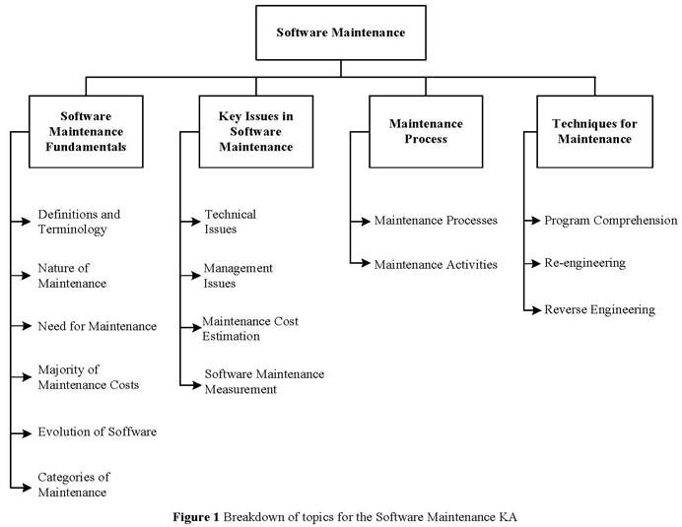
The software maintenance knowledge area discusses the nature and need for software maintenance by describing the cost associated with the development life-cycle of the software; categorizing the types of maintenance in to corrective, adaptive, perfective, and preventative maintenance types.
 | Correction | Enhancement
Proactive | Preventive | Perfective
Reactive | Corrective | Adaptive
Table 1: Software maintenance categories
Key issues in software maintenance include technical issues, management issues, cost estimation, and measures.
Maintenance processes can be described by the following illustration, including their relations to other software activities:
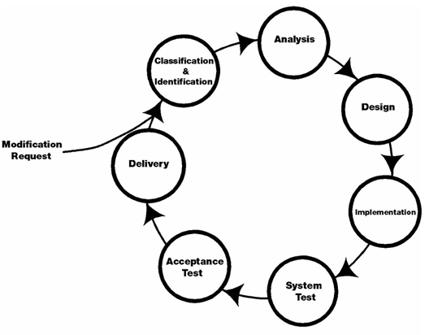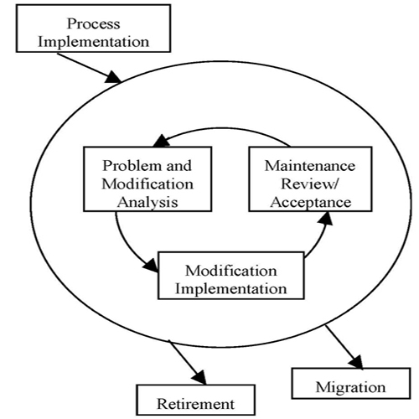
Techniques for maintenance include: program comprehension, reengineering, and reverse engineering.
As a group, the knowledge area devoted to software maintenance is yet to be utilized.

