English Worksheet
English Department
Miss Débora Pinto P.

Name:_______________________________ Grade: 2° A Date: November, 2011
Unit 4: Whatever you do or make-make it and do it well
Extra Material: Going To…______________________________
GOING TO…

Going to future expresses a conclusion regarding the immediate future or an action in the near future that has already been planned or prepared.
Form of going to Future
 | positive | negative | question
I | I am going to speak. | I am not going to speak. | Am I going to speak?
you / we / they | You are going to speak. | You are not going to speak. | Are you going to speak?
he / she / it | He is going to speak. | He is not going to speak. | Is he going to speak?

Use of going to Future
- an action in the near future that has already been planned or prepared
example: I am going to study harder next year.
- a conclusion regarding the immediate future
example: The sky is absolutely dark. It is going to rain.
Signal Words
- in one year, next week, tomorro

EXERCISES
I. Put the verbs into the correct form of going to.
- It(rain) __________________________________________________
- They(eat) __________________________________________________stew.
- I(wear) ________________________________________________blue shoes tonight.
- We(not / help) ________________________________________________you.
- Jack(not / walk) ________________________________________________home.
- (cook / you) ________________________________________________dinner?
- Sue(share) ________________________________________________her biscuits.
- (leave / they) ________________________________________________the house?
- (take part / she) ____________________________________________in the contest?
- I(not / spend) _______________________________________my holiday abroad this year.

II. Complete the following sentences using going to in negative.
1) He ___________________________________his friend. (not phone)
2) We ___________________________________a new computer game. (not play)
3) My sister ___________________________________TV. (to watch)
4) You ___________________________________a picnic next Tuesday. (not have)
5) Jane ___________________________________to the office. (not go)
6) They ___________________________________to the bus stop this afternoon. (not walk)
7) His brother ___________________________________a letter to his uncle today. (not write)
8) She ___________________________________her aunt. (not visit)
9) I ___________________________________my homework after school. (not do)
10) Sophie and Nick ___________________________________her friends. (not meet)

III. What is going to happen? Look at the picture and write what is going to happen in each situation.

__________________________________ _________________________________

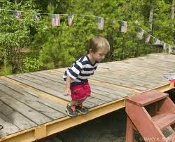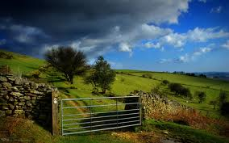

__________________________________ _____________________________________

It's gonna be me – N´SYNC
You might been hurt, babe
That ain't no lie
You've seen them all come and go, oh..
I remember you told me
That it made you believe in
No man, no cry
Maybe that's why
Chorus: Every little thing I do
Never seems enough for you
You don't wanna lose it again
But I'm not like them
Baby, when you finally,
Get to love somebody
Guess what,
It's gonna be me..
You've got no choice, babe
I've got to move on, and you know
There ain't no time to waste
You're just too blind (too blind), too see
But in the end, ya know it's gonna be me
You can't deny
So just tell me why
(Chorus)
There comes a day
When I'll be the one, you'll see..
It's gonna-gonna-gonna-gonna-gonna
All that I do
Is not enough for you
Don't wanna lose it
But I'm not like that
When finally (finally)
You get to love
Guess what (guess what)
(Chorus X 2)

