Teen´s Bulletin
Source: http://www.teendiariesonline.com/blog/?cat=8

November 30th, 2011
HOLIDAY GIFT GUIDE: 50 Cool Gifts Under $50
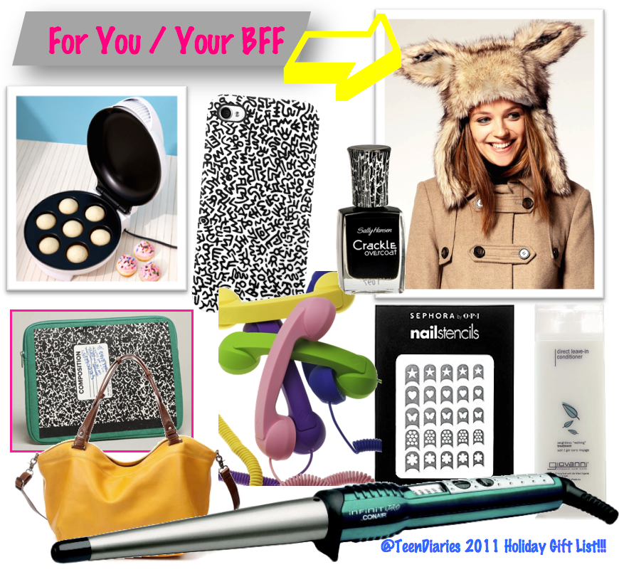
Christmas time is suppose to be magically filled with holiday cheer, but finding the perfect gift for a loved one can painfully bring on the holiday blues. To help alleviate holiday shopping stress, we’ve done all of the hard work for you and scoured the web to find not only the coolest, but the most affordable gifts for your family and friends. Take a look at our top 50 gifts under $50 and thank us later. Happy Shopping ➫Read the rest of this entry »
You might also like:

BACK 2 SCHOOL CONTEST: 30 Gifts in 30 Days!!!!WIN A KODAK ...

